|  |
| --- |
| **Archives of Ontario** |
| Research Guide 226  Military and Militia Records  Last Updated: March 2023 | |

Image is: Victorious Canadians celebrating after fighting on Vimy Ridge
C 224-0-0-9-41 


Victorious Canadians celebrating after fighting on Vimy Ridge

C 224-0-0-9-41

In this guide 2

Where do I find these records? 3

What do I need to get started? 3

The Records 3

1. Military records collection 3

2. Pre-World War I records 4

2.1 Militia records 4

2.2 Loyalist and War of 1812 records 5

2.3 British military records 5

2.4 Royal Hamilton Light Infantry (Wentworth Regiment) records, 1863 to 1953 6

2.5 Crown Land records, 1780’s to 1860’s 6

2.6 Fenian and South African land grant records, 1901 to 1922 6

3. World War I records 6

3.1 Canadian Expeditionary Force personnel records 6

3.2 World War I war diaries 7

3.3 T. Eaton Company records 7

3.4 World War I photographs and art 7

3.5 Other World War I records and resources 8

4. World War II records 9

4.1 World War II service files 9

4.2 Registrations of Ontario deaths overseas, 1939 to 1947 9

4.3 Other World War II records and resources 10

Are there related records? 10

How do I get to the online descriptions? 10

Contact us 12

# In this guide

This guide has information on records about the militia and the military at the Archives of Ontario. It also has information about related records at Library and Archives Canada. The Library and Archives Canada website is [www.collectionscanada.gc.ca](http://www.collectionscanada.gc.ca).

Beginning in 1793, all able-bodied citizens between the ages of 16 and 50 (with the exception of religious pacifists and some public officials) were required to enrol in the militia. Militia units were organized on a county basis. This system was replaced in 1855 with an active volunteer militia.

Units of the British Army were stationed in Canada until 1871. A permanent Canadian army was created following the departure of the British troops. Militia units were also raised as needed.

Some members of the militia and veterans of the British Army received free grants of land.

*Please note: this guide contains links to information found in our online Archives and Information Management System (AIMS).  On our website, this database is found under “Access Our Collections”.  If you are using a print copy of this guide, go to page 10 for more information on how to find the online descriptions.

# Where do I find these records?

Many of the records mentioned in this guide are on microfilm, and you do not need to order them in advance to view them in our reading room. Libraries that offer interloan services may also borrow most of the reels for you.

Some of the records are microfilm copies of records held by Library and Archives Canada. You can view these reels in our reading room, but they are not available through interloan. Some of these records are available online. The Library and Archives Canada website is [www.collectionscanada.gc.ca](http://www.collectionscanada.gc.ca).

Some records are not on microfilm. You will need to request them in advance to view them in our reading room. You may also obtain copies if there is sufficient information to locate and retrieve those records.

# What do I need to get started?

If you are searching for militia or military records about a given person, you will need to know when they served. You should also know the area of the province where they lived (for the militia) or the military unit they served in.

# The Records

## Military records collection

Our Military Records Collection consists of miscellaneous records pertaining to the militia and the military, from 1702 to 1983. It includes militia and military muster rolls (lists of enrolled personnel), casualty lists, general orders and commissions, scrapbooks, newspaper clippings, pamphlets and correspondence on various topics related to the military. For information about these records and how to access them, including an item list, [click here to view the description for F 895](https://aims.archives.gov.on.ca/scripts/mwimain.dll/144/DESCRIPTION_WEB/WEB_DESC_DET?SESSIONSEARCH&exp=sisn%20485).

## Pre-World War I records

### Militia records

**Muster rolls**

Muster rolls are lists of men reporting for militia (or military) duty. We have muster rolls for various militia units. They may include the men’s name, address and age. To find muster rolls in our collections:

* search the Manuscript Card Catalogue on microfiche, in our reading room, under “militia”, “military” or the name of the county; if you find an entry, write down the full information, then speak to the reference staff about retrieving the records
* [click here to view the description for the militia lists and assessment rolls accumulated by William D. Reid, 1779 to 1932 (F 280-3)](https://aims.archives.gov.on.ca/scripts/mwimain.dll/144/DESCRIPTION_WEB/WEB_DESC_DET?SESSIONSEARCH&exp=sisn%2022931)
* [click here to view the description of the York militia rolls, 1858 (F 4146)](https://aims.archives.gov.on.ca/scripts/mwimain.dll/144/DESCRIPTION_WEB/WEB_DESC_DET?SESSIONSEARCH&exp=sisn%20811)
* [click here to view the description of the Essex County militia rolls, 1864 to 1868 (RG 22-1880)](https://aims.archives.gov.on.ca/scripts/mwimain.dll/144/DESCRIPTION_WEB/WEB_DESC_DET?SESSIONSEARCH&exp=sisn%207652)
* [click here to do an advance search of the Archives and Information Management System (AIMS), "Archives Repository" using keywords militia roll*](http://aims.archives.gov.on.ca) (the asterisk is a wildcard)
* [click here to view the description and an item list for the Military records collection, F895](https://aims.archives.gov.on.ca/scripts/mwimain.dll/144/DESCRIPTION_WEB/WEB_DESC_DET?SESSIONSEARCH&exp=sisn%20485).

Library and Archives Canada and some local libraries and archives also have militia muster rolls. The collections at Library and Archives Canada includes a province-wide roll taken in 1828 and 1829. Publication Men of Upper Canada: militia nominal rolls, 1828-1829 (Toronto: Ontario Genealogical Society, 1995) is a full transcript of that roll. It also includes information from other rolls and assessment rolls for counties where the information is incomplete or missing. There is a copy of this book in our reading room.

**Militia general orders, 1812 to 1852**

These records include orders regarding the general management of the militia, as well as officers’ appointments, promotions and retirements. You can view a microfilm copy of these records and a finding aid in our reading room. The originals are with Library and Archives Canada. For more information about these records, [click here to view the description for D 385](https://aims.archives.gov.on.ca/scripts/mwimain.dll/144/DESCRIPTION_WEB/WEB_DESC_DET?SESSIONSEARCH&exp=sisn%2010686).

**Lincoln militia records, 1838 to 1840**

These records consist of lists and regimental orders for the 5th Regiment, Lincoln militia, for the years 1838 to 1840. You can view these records on microfilm reel MS 34, in our reading room. For more information about these records, [click here to view the description for F 911](https://aims.archives.gov.on.ca/scripts/mwimain.dll/144/DESCRIPTION_WEB/WEB_DESC_DET?SESSIONSEARCH&exp=sisn%20363).

**First battalion, Incorporated militia records, 1838 to 1843**

Following the 1837 Rebellion, four battalions of incorporated militia were raised in 1838. Its members were drawn from militia ranks and they volunteered for a two-year extended service. All four regiments were disbanded in 1843.

You can view microfilmed copies of records from the First battalion (Gore District) in our reading room. These include attestations (enrolment papers) for the 1840 to 1842 volunteers and administrative records. For more information, see Inventory D 15 First battalion, Incorporated Militia collection in our reading room.

The originals are with the Hamilton Military Museum. The Museum website is <https://www.hamilton.ca/attractions/hamilton-civic-museums/hamilton-military-museum>.

### Loyalist and War of 1812 records

Our records related to United Empire Loyalists contain information about military service during the American revolution. For more information [click here to view Research Guide 227, United Empire Loyalist records](http://www.archives.gov.on.ca/en/access/research_guides.aspx).

Our records related to the War of 1812 include military and militia records, records of various government offices, and the private records of participants in the War. For information about these records, [click here to view Research Guide 213, War of 1812 records](http://www.archives.gov.on.ca/en/access/research_guides.aspx).

### British military records

**British military records, “C series”, 1757 to 1796**

These records document the activities of the British military in North America. Records include military and militia rolls and pay lists, correspondence, administrative records, reports, orders and engineering records.

You can view microfilmed copies of these records and a finding aid in our reading room. Microfilm also includes an index by individuals’ names and topic. For more information about these records, [click here to view the description for D 2](https://aims.archives.gov.on.ca/scripts/mwimain.dll/144/DESCRIPTION_WEB/WEB_DESC_DET?SESSIONSEARCH&exp=sisn%208124).

Originals are with Library and Archives Canada. The microfilm is digitized on the Library and Archives Canada website.

**Regimental order book, 1771 to 1786**

This regimental order book contains military orders given to various units of the British Army in Niagara and at locations in Quebec and Great Britain. For information about these records and how to access them, [click here for the description for F 4578](https://aims.archives.gov.on.ca/scripts/mwimain.dll/144/DESCRIPTION_WEB/WEB_DESC_DET?SESSIONSEARCH&exp=sisn%2016075).

**Penetanguishene Military Establishment collection, 1823 to circa 1930**

These records are copies of miscellaneous to the Penetanguishene Military Establishment, a British military and naval base on the south shore of Georgian Bay. For information about these records and how to access them, [click here to view the description for F 893](https://aims.archives.gov.on.ca/scripts/mwimain.dll/144/DESCRIPTION_WEB/WEB_DESC_DET?SESSIONSEARCH&exp=sisn%20612).

### Royal Hamilton Light Infantry (Wentworth Regiment) records, 1863 to 1953

This regiment was established in 1863 as the 13th Battalion Volunteer Regiment and was mostly comprised of volunteers from Hamilton and Wentworth County. You can view copies of records from this regiment on microfilm in our reading room. They include various lists of volunteers, administrative records and records documenting the regiment’s involvement in local community life. For more information, see Inventory D 18 Royal Hamilton Light Infantry (Wentworth Regiment) collection in our reading room.

The originals are with the Royal Hamilton Light Infantry Heritage Museum. The Museum website is <http://www.rhli.ca/archives/museum/museum.html>.

### Crown Land records, 1780’s to 1860’s

The Crown granted land to veterans who had served in the militia during conflicts, as well as veterans of the British Army and Navy. In most cases, these individuals were exempted from administrative fees.

For information about Crown Land records on militia and military grants, [click here to search the Archives and Information Management System (AIMS), "Archives Repository" using title keywords militia or military and reference code RG 1-*](http://aims.archives.gov.on.ca). For more information about land records, [click here to view Research Guide 225: Researching Crown Land Records](http://www.archives.gov.on.ca/en/access/research_guides.aspx).

### Fenian and South African land grant records, 1901 to 1922

In 1901, Ontario enacted legislation to grant land to veterans of the Fenian Raids (1865, 1866 and 1870) and the South African (Boer) War (1899 to 1901). Successful applicants received 160 acres of land in Kenora, Sudbury, Timiskaming or Thunder Bay District. For information about our records that document the applications and grants, [click here to view the description for RG 1-99](https://aims.archives.gov.on.ca/scripts/mwimain.dll/144/DESCRIPTION_WEB/WEB_DESC_DET?SESSIONSEARCH&exp=sisn%206246).

Library and Archives Canada has service files, pay lists, and other records about soldiers who served during the South African War. We do not have a copy of these records. For more information, visit the Library and Archives Canada website, [www.collectionscanada.gc.ca](http://www.collectionscanada.gc.ca).

## World War I records

### Canadian Expeditionary Force personnel records

Library and Archives Canada has the files of Canadian Expeditionary Force members (CEF), which include those of soldiers, nurses and chaplains. These files consist of documents dealing with enlistment, training, medical and dental history, hospitalization, discipline, pay, medal entitlements and discharge or notification of death.  These records are digitized on the Library and Archives Canada website. [www.collectionscanada.gc.ca](http://www.collectionscanada.gc.ca). We do not have a copy of these records.

### World War I war diaries

Units in the Canadian Expeditionary Force were required to keep a daily account of their "Actions in the Field”, called a war diary. The diaries document mostly activities on the front, and they rarely contain information about individual soldiers. To search the diaries, you need to know the regiment and the theatre of war.

You may see a microfilm copy of these records and a finding aid in our reading room. The originals are with Library and Archives Canada, and the Library and Archives Canada website has digitized copies. For more information about these records, [click here to view the description for D 24](https://aims.archives.gov.on.ca/scripts/mwimain.dll/144/DESCRIPTION_WEB/WEB_DESC_DET?SESSIONSEARCH&exp=sisn%208157).

### T. Eaton Company records

Retailer T. Eaton Company supported Canada’s effort during both World Wars, This included paying employees who enrolled their salary in full or in part. During World War I, the company also outfitted an armoured car unit, known as the T. Eaton’s Machine gun battery.

Records pertaining to Eaton’s World War I and World War II contribution include lists of enrolled personnel, financial and administrative records, photographs, and drawings for the T. Eaton’s Machine Gun Battery. For information about these records and how to access them:

* [click here to do a general keyword search of the Archives and Information Management System (AIMS), "Archives Repository" using keywords Eaton's and military, World War I, World War II, or machine gun](http://aims.archives.gov.on.ca)
* [click here to view the description and a file list for the T. Eaton Archives subject files, F 229-162](https://aims.archives.gov.on.ca/scripts/mwimain.dll/144/DESCRIPTION_WEB/WEB_DESC_DET?SESSIONSEARCH&exp=sisn%202471)
* [click here to view the description and a file list for the Eaton's Archives photographic and documentary art subject files, F 229-308](https://aims.archives.gov.on.ca/scripts/mwimain.dll/144/DESCRIPTION_WEB/WEB_DESC_DET?SESSIONSEARCH&exp=sisn%203455)
* [click here to view the description for Eaton's employee magazines, F 229-141](https://aims.archives.gov.on.ca/scripts/mwimain.dll/144/DESCRIPTION_WEB/WEB_DESC_DET?SESSIONSEARCH&exp=sisn%203656)

For more information about the contribution by the T. Eaton Company and its employees during World War I, [click here to view our online exhibit, "Eaton's Goes To War"](http://www.archives.gov.on.ca/en/explore/online/soldiers/remembrance_day.aspx). For more information about our T. Eaton Company records, [click here to view the description for F 229](https://aims.archives.gov.on.ca/scripts/mwimain.dll/144/DESCRIPTION_WEB/WEB_DESC_DET?SESSIONSEARCH&exp=sisn%201019).

### World War I photographs and art

**Canadian War Memorials Fund records**

The records consist of prints and reproductions of paintings commissioned by the Canadian Memorials Fund. Some of the war artists followed the troops to the front and captured the scenes they encountered. Others documented work at manufacturing plants involved in the war effort. For information about these records and to view digital copies, [click here to view the description for C 334](https://aims.archives.gov.on.ca/scripts/mwimain.dll/144/DESCRIPTION_WEB/WEB_DESC_DET?SESSIONSEARCH&exp=sisn%20127). For more information about the Canadian War Memorials Fund and the war artists, [click here to view our online exhibit, "War Artists of the First World War"](http://www.archives.gov.on.ca/en/explore/online/war_artists/index.aspx).

Original paintings are at the Canadian War Museum. The Museum website is [www.warmuseum.ca](http://www.warmuseum.ca).

**Panoramic photographs of military units**

We have panoramic photographs of military units, taken before their departure for Europe. For information about these photographs and a sample of our collection, [click here to view our online exhibit Panoramic photographs from the First World War](http://www.archives.gov.on.ca/en/explore/online/war_panoramas/index.aspx). To find if we have a panoramic photograph of a unit, contact us with the name of that unit.

Library and Archives Canada, as well as some libraries and museums, also has panoramic photographs of World War I units.

**Photograph albums**

We have photographic albums containing photos taken by unknown military personnel. Images depict battle scenes, life in the trenches, political and military leaders, weapons manufacturing, devastation, parades, and royal family members.

For information about these records and how to access them:

* [click here to view the description for C 224-8, Canadian Expeditionary Force photograph albums](https://aims.archives.gov.on.ca/scripts/mwimain.dll/144/DESCRIPTION_WEB/WEB_DESC_DET?SESSIONSEARCH&exp=sisn%2021845)
* [click here to view the description to C 224-13, Camp Borden photograph album](https://aims.archives.gov.on.ca/scripts/mwimain.dll/144/DESCRIPTION_WEB/WEB_DESC_DET?SESSIONSEARCH&exp=sisn%2021895)

**War posters**

We have posters produced by the federal government during the two World Wars. Topics include recruitment, war bonds, support for the Red Cross and families of soldiers, and food production. For information about these records, [click here to view the description for C 233-2](https://aims.archives.gov.on.ca/scripts/mwimain.dll/144/DESCRIPTION_WEB/WEB_DESC_DET?SESSIONSEARCH&exp=sisn%2013976).

You may view most of these posters online:

* [click here to view our online exhibit, Canadian Posters from The First World War](http://www.archives.gov.on.ca/en/explore/online/posters/index.aspx)
* [click here to view a selection of poster on the Wikimedia Commons](https://commons.wikimedia.org/wiki/Category:Images_from_Archives_of_Ontario_%E2%80%93_C_233_Archives_of_Ontario_poster_collection); the Wikimedia Commons website is <https://commons.wikimedia.org/wiki/Main_Page>

### Other World War I records and resources

For information about other World War I records that we have, as well as online exhibits and educational resources, [click here to view our World War I resource page](http://www.archives.gov.on.ca/en/ww1/index.aspx). On our website, this page is under “Access Our Collection”.

Visit the Library and Archives Canada website for information about other World War I records in its collections.

## World War II records

### World War II service files

Library and Archives Canada has the service files for World War II military personnel. These include information about enlistment, the military unit (Army), ship (Navy) or squadron (Air Force) the individual served in, medical and dental records, evaluation reports, medal entitlement, and discharge or death. We do not have a copy of these records.

Service files for military personnel who died in service between 1939 and 1947 are open to the public:

* The Library and Archives Canada website, [www.collectionscanada.gc.ca](http://www.collectionscanada.gc.ca) has a database listing this personnel. Some entries have a link to the file.
* The Ancestry website, [www.ancestry.ca](http://www.ancestry.ca) has “genealogical packages” for military personnel who died in service between 1939 and 1947. These include key documents from the service file. You can access this website for free in our reading room and at all Ontario public libraries.
* For information on how to get the full file, visit the Library and Archives Canada website.

For information on how to access service files of World War II military personnel who did not die in service between 1939 and 1947, visit the Library and Archives Canada website.

### Registrations of Ontario deaths overseas, 1939 to 1947

We have registrations of deaths of Ontario residents overseas (mostly during military operations) during and immediately after World War II. You may search these records online, on [www.familysearch.org](http://www.familysearch.org) and [www.ancestry.ca](http://www.ancestry.ca).

You may also view these records on microfilm in our reading room, and libraries that offer interloan services can order the reels for you. [Click here for a microfilm list, in the Ontario Vital Statistics page of our website](http://www.archives.gov.on.ca/en/microfilm/v_appa11_t.aspx). On our website, you will find this page under “Tracing Your Family History”. To search a microfilm list in our reading room, see the Deaths binder of Inventory 80 Records of the Office of the Registrar General.

These records are indexed in Overseas Death of Ontario Servicemen and Servicewomen, 1939-1947 (Toronto, Ontario Genealogical Society, 2006, 2 volumes). There is a copy in our reading room.

### Other World War II records and resources

For information about retailer T. Eaton Company’s World War II records and World War II posters, see section 3 of this guide. For information about the home front during World War II and related records, [click here to view our online exhibit "The Archives of Ontario remembers the home front"](http://www.archives.gov.on.ca/en/explore/online/d_day/index.aspx).

Visit the Library and Archives Canada website for information about other World War II. records in its collections.

# Are there related records?

We have records from many individuals, families, businesses and organization that document their militia or military service, or their participation in military conflicts. For information about these records, [click here to search the Archives and Information Management System (AIMS), "Archives Repository" by group of archival records](http://aims.archives.gov.on.ca).

Our Miscellaneous collection contains militia commissions, muster rolls and orders, mostly from the 1800’s. For a list of the records in this collection, contact us to get a pdf copy of the finding aid for F 775.

The Hiram Walker Museum Collection militia commissions and military records of individuals in the Windsor and Detroit area, mostly from the 1800’s. For a list of the records in this collection, contact us to get a pdf copy of the finding aid for F 378.

For information on how to access the service records of military personnel after World War I, visit the Library and Archives Canada website, [www.collectionscanada.gc.ca](http://www.collectionscanada.gc.ca).

# How do I get to the online descriptions?

1. On our website’s main page, click on “Access Our Collections”, and click on “Archives and Information Management System”, as shown in the image below:

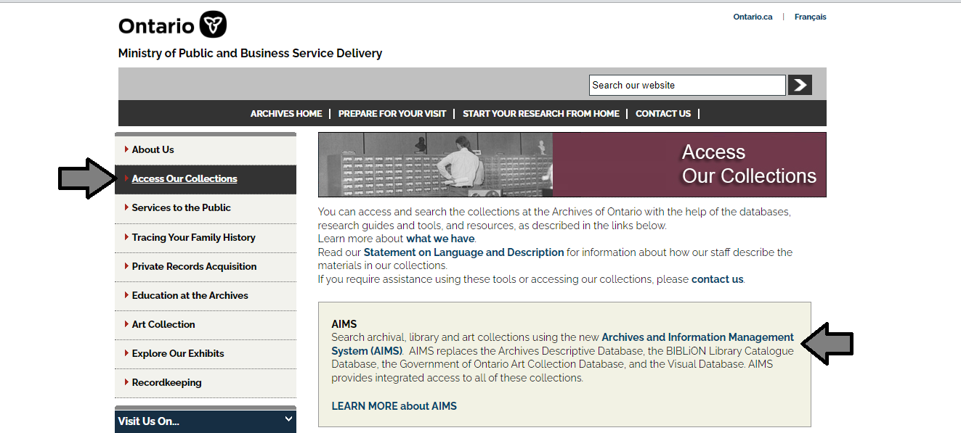

1. In the Archives and Information Management System (AIMS), click on “Archives repository (only)” button:

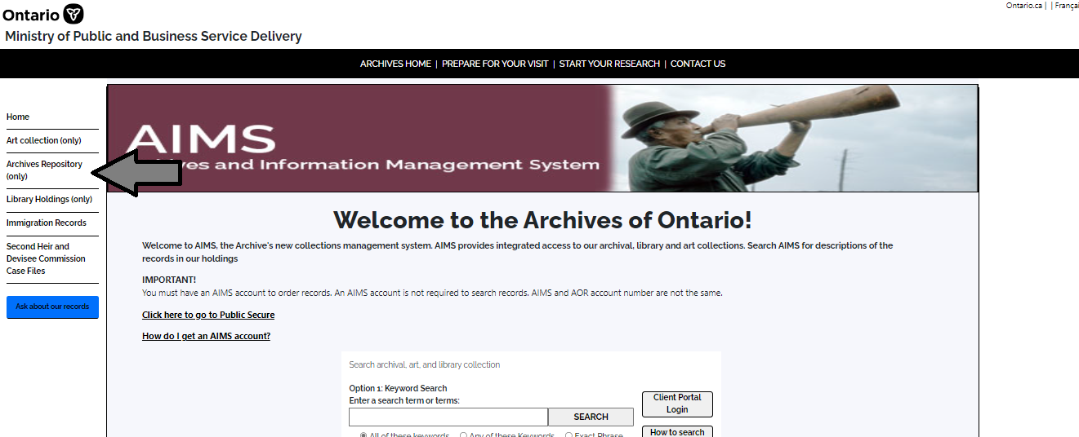

1. On the “Welcome to the Archival Collection” search page, click “Advanced Search”:

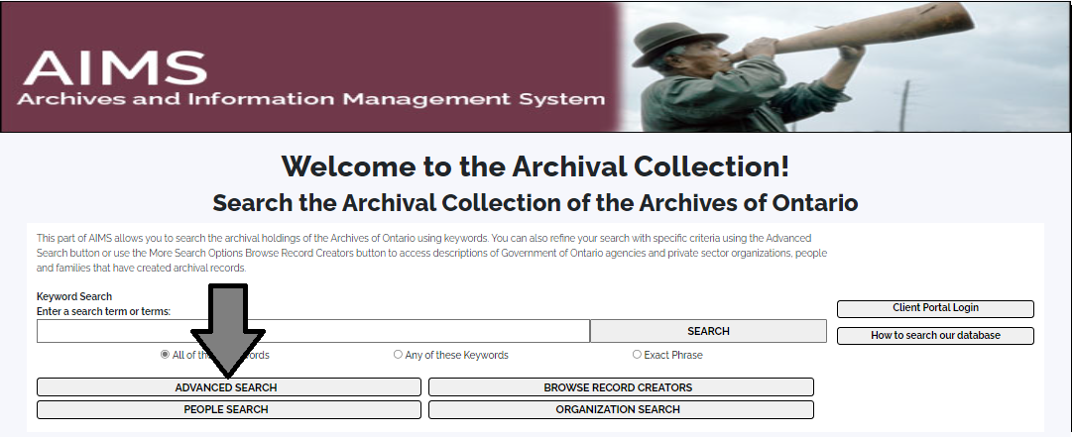

1. On the “Archives Advanced Search” page enter the reference code (that’s the number starting with C, F or RG) in the Reference Code field and click “Search” (at the bottom of the page.

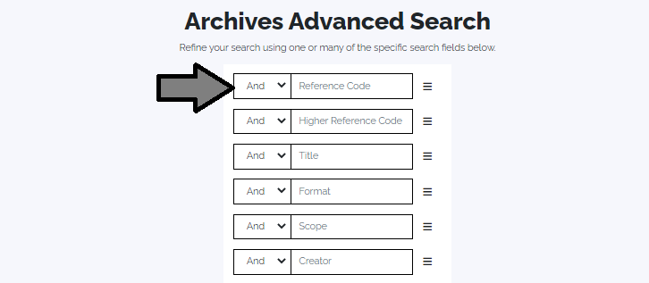

# Contact us

Although unable to do your research for you, our reference archivists are waiting to assist you.  You may call or write to them by mail or email or — best of all — visit the Archives of Ontario.

**Telephone: 416-327-1600 Toll free (Ontario): 1-800-668-9933**

**Email:** [Click here to email the Archives of Ontario](mailto:reference@ontario.ca).  The e-mail address is [reference@ontario.ca](mailto:reference@ontario.ca)

**Address: Archives of Ontario, 134 Ian Macdonald Blvd., Toronto, ON M7A 2C5**

**Website**

Visit our website for information about our collections and our services, our online exhibits and education programs, and links to our social media accounts. [Click here to visit our website](http://www.ontario.ca/archives).  The website is [www.ontario.ca/archives](http://www.ontario.ca/archives).

**Customer Service and Research Guides**

Our guides contain information about our services, freelance researchers available to do research for you, and some of most popular records.  [Click here to view our guides](http://www.archives.gov.on.ca/en/access/research_guides.aspx).  To find the “Research Guides and Tools” on our website, click on “Access our Collections”.

______________________________________________________________________

© King's Printer for Ontario, 2023

This information is provided as a public service.  Last update is shown at the beginning of this guide.  Readers should where possible verify the information before acting on it.