| **Archives of Ontario** | Ontario Logo |
| --- | --- |
| Research Guide 230  Bankruptcy Records  Last Updated: March 2023 | |

Photograph is: Ottawa Courthouse [ca. 1900], RG 15-90-0-0-59, Public buildings – oversized photographs


Ottawa Courthouse [ca. 1900]

RG 15-90-0-0-59

Public buildings – oversized photographs

In this guide 2

Where do I find these records? 2

What do I need to get started? 3

The Records 3

1. What is in a bankruptcy file? 3

2. Insolvency records, before 1920 3

3. Bankruptcy records, 1920 to 1976 3

3.1 Bankruptcy files and indexes 4

3.2 Local bankruptcy records 4

4. Bankruptcy records, 1977 to 1995 5

Contact information – Superintendent of Bankruptcies and courthouses 6

How do I get to the online descriptions? 7

Contact us 9

# In this guide

This guide has information on how to find bankruptcy records at the Archives of Ontario.

*Please note: this guide contains links to information found in our online Archives and Information Management System (AIMS).  On our website ([www.archives.gov.on.ca](http://www.archives.gov.on.ca) ), this database is found under “Access Our Collections”.  If you are using a print copy of this guide, go to page 7 for more information on how to find the online descriptions.

*Please note: The Archives of Ontario **will not send original files** to the courthouses when records are requested for court proceedings. We can photocopy bankruptcy files or specific documents, certify them upon request, and send them to you, for a fee.

For further information about getting copies, [click here to consult our Customer Service Guide 105, Reproduction services and fees](http://www.archives.gov.on.ca/en/access/documents/customer_service_guide_105_reproduction_services_and_fees.pdf). On our website, this and other customer service and research guides are on the “Research Guides and Tools” page, under “Access Our Collections”.

The Archives’ staff cannot give advice as to what documents you may need for a bankruptcy proceeding, whether the documents need to be certified, or the current status of a bankruptcy. Please contact a bankruptcy trustee or lawyer if you have any questions of a legal nature.

# Where do I find these records?

We have bankruptcy records from 1920 to 1995 (some records between 1990 and 1995 may still be with the courthouse that processed the bankruptcy). We also have some records documenting insolvencies before 1920.

You may view these records in our reading room. You will need the bankruptcy file number before you can arrange to view bankruptcy files or obtain copies. See The Recordssection for information on how to find that number. You may arrange to obtain copies from a distance if there is enough information to locate the records.

To find bankruptcy files after 1995, and some files between 1990 and 1995, you will need to contact the courthouse where the bankruptcy hearings took place. You will need to contact the Superintendent of Bankruptcies first if you do not have the file number. There is a list of contact information for the courthouses and the Superintendent of Bankruptcies at the end of this guide

# What do I need to get started?

To find bankruptcy files, you need the name of the bankrupt, the year and location where the bankruptcy took place, and the bankruptcy file number.

# The Records

## What is in a bankruptcy file?

Bankruptcy files may contain a statement of affairs outlining the bankrupt’s assets and liabilities, a list of creditors, documents and reports filed by the bankrupt’s trustee with the court, and orders discharging the bankrupt and the trustee.

## Insolvency records, before 1920

Before 1920, people could apply to the local District Court (before 1849) or the County or District Court (from 1849 to 1920).

We have some insolvency records. For information about these records and how to access them, conduct a keyword search of our online [Archives and Information Management System (AIMS), "Archives Repository"](http://aims.archives.gov.on.ca) in Advance Search use the name of the county or district and the word insolvency (Example: Simcoe insolvency).

For more information on how to access our online database, consult the How do I get to the online descriptions section of this guide on page 7.

## Bankruptcy records, 1920 to 1976

Starting in 1920, individuals and corporations seeking bankruptcy could file their initial application with their local courthouse. Court proceedings, including discharge, took place in the Supreme Court in Toronto.

### Bankruptcy files and indexes

We have court files from the Toronto courthouse for all bankruptcies that took place in Ontario from 1920 to 1976.

To find the files, you must first search the procedures books or index to find the file number. You may search these on microfilm in our reading room. For more information, including microfilm lists:

* [click here to view the description for RG 22-5821, Supreme Court at Toronto bankruptcy procedure books, 1921 to 1969](https://aims.archives.gov.on.ca/scripts/mwimain.dll/144/DESCRIPTION_WEB/WEB_DESC_DET?SESSIONSEARCH&exp=sisn%201743)
* [click here to view the description for RG 22-5918, Supreme Court at Toronto bankruptcy index, 1968 to 1981](https://aims.archives.gov.on.ca/scripts/mwimain.dll/144/DESCRIPTION_WEB/WEB_DESC_DET?SESSIONSEARCH&exp=sisn%2012373)

*Note: Starting in 1968, the Superintendent of Bankruptcy assigned a file number to each bankruptcy file in Canada. However, the Toronto courthouse continued to use its own index and file numbers until 1981. Because of this, you will need to search the index, as mentioned above.

Once you have the file number, contact us and include the name of the bankrupt, the file number and year and reference code RG 22-5822.

### Local bankruptcy records

In addition to the official bankruptcy files mentioned above, we have records filed with various local courthouses throughout the province at the initial stages of the bankruptcy from 1920 to 1976.

For information about records for the counties and districts below, conduct a title search of our online [Archives and Information Management System (AIMS), Archives Repository,](http://aims.archives.gov.on.ca)  using the name of the county or district noted below and the word bankruptcy (Example: Carlton bankruptcy)

* Carleton County
* Cochrane District
* Frontenac County
* Grey County
* Lambton County
* Simcoe County
* Sudbury District
* Wentworth County
* York County

We also have copybooks containing copies of bankruptcy documents, and related indexes, that were kept at the local land registry offices. For information about the records for the counties and districts below, contact an archivist:

* Algoma District
* Brant County
* Dufferin County
* Dundas County
* Durham County
* Elgin County
* Glengarry County
* Grenville County
* Haliburton County
* Hastings County
* Middlesex County
* Muskoka District
* Nipissing District
* Norfolk County
* Northumberland County
* Oxford County
* Perth County
* Prince Edward County
* Simcoe County
* Stormont County
* Victoria County
* Waterloo County
* Wellington County
* York County

## Bankruptcy records, 1977 to 1995

After 1976, courts in the following cities could process bankruptcies and issue discharges to the bankrupt or trustee. File numbers assigned by the Superintendent of Bankruptcies correspond to these locations:

* Toronto: file numbers starting with 31 (for example: 31-123456)
* Hamilton (beginning in 1982): file numbers starting with 32
* Ottawa (beginning in 1981); file numbers starting with 33
* Sudbury (beginning in 1981): file numbers starting with 34
* London (beginning in 1977): file numbers starting with 35

In addition, files from the Winnipeg courthouse (file numbers starting with 21) for northwestern Ontario bankruptcies were transferred to the Toronto courthouse after the procedures had been completed.

To access post 1976 files, you first need the file number. To get it and confirm the year of the bankruptcy, contact the Superintendent of Bankruptcy, information noted below.

To access the file once you have the file number:

* files starting with 31 (up to 1980): follow the instructions for the 1920 to 1976 files above;
* files starting with 31 (after 1980), and files starting with 32, 33, 34, 35 or 21: contact us with the name of the bankrupt, and the bankruptcy file number and year.

# Contact information – Superintendent of Bankruptcies and courthouses

**Superintendent of Bankruptcies**

Phone: 1-866-941-2863 (toll free)

Fax: 613-941-9490

Website**:** <https://www.ic.gc.ca/eic/site/bsf-osb.nsf/eng/home>

Ontario office addresses

Hamilton: Federal Building

55 Bay Street N, 9thFloor

Hamilton, Ontario L8R 3P7

London: Federal Building

451 Talbot Street, Suite 303

London, Ontario N6A 5C9

Ottawa: Place Bell Building

160 Elgin Street, 11thFloor, Suite B-100

Ottawa, Ontario K2P 2P7

Toronto: 151 Yonge Street, 4th Floor

Toronto, Ontario M5C 2W7

**Courthouses**

Hamilton: Superior Court of Justice  
45 Main Street East  
Hamilton, Ontario L8N 2B7

Phone: 905-645-5252

London: Superior Court of Justice   
80 Dundas Street  
London, Ontario N6A 6A3  
Phone: 519-660-3000

Ottawa: Superior Court of Justice   
161 Elgin Street, 2nd floor  
Ottawa, Ontario K2P 2K1  
Phone: 613-239-1054

Sudbury: Superior Court of Justice   
155 Elm Street  
Sudbury, Ontario P3C 1T9  
Phone: 705-564-7600

Toronto: Superior Court of Justice   
330, University Avenue  
Toronto, Ontario M5G 1R7  
Phone: 416-327-5044

# How do I get to the online descriptions?

1. On our website’s main page, click on “Access Our Collections”, and click on “Archives and Information Management System”, as shown in the image below:

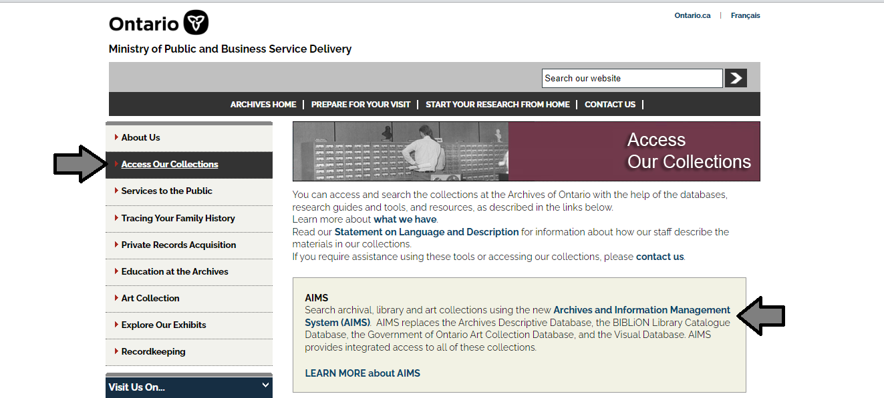

1. In the Archives and Information Management System (AIMS), click on “Archives repository (only)” button:

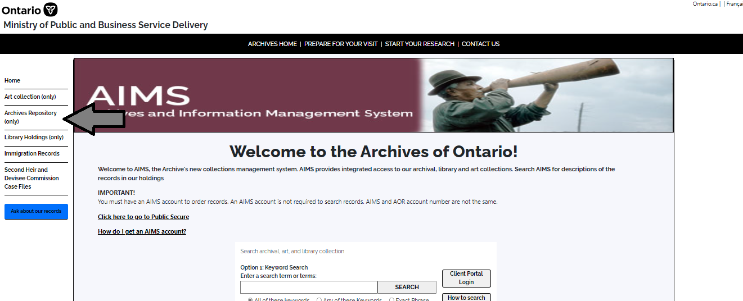

1. On the “Welcome to the Archival Collection” search page, click “Advanced Search”:

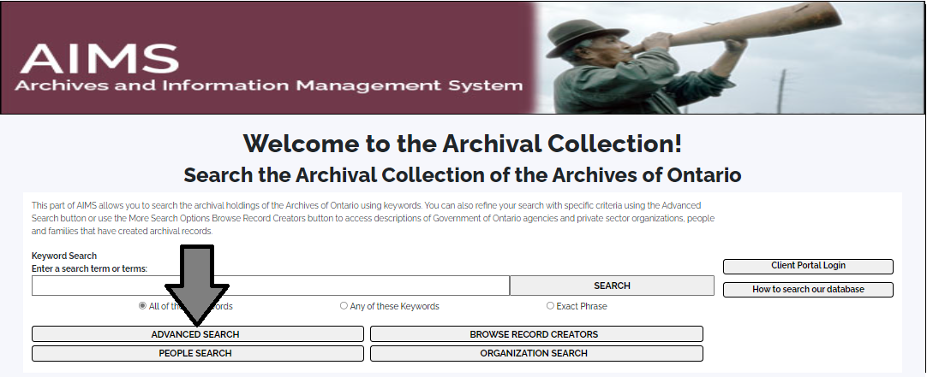

1. On the “Archives Advanced Search” page enter the reference code (that’s the number starting with C, F or RG) in the Reference Code field and click “Search” (at the bottom of the page.

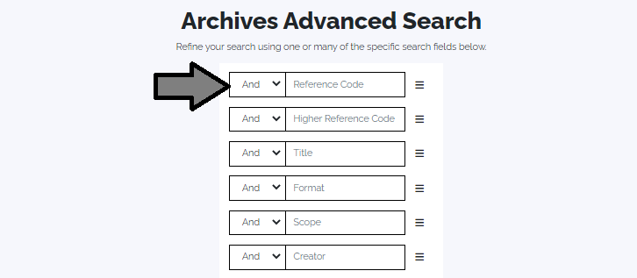

# Contact us

Although unable to do your research for you, our reference archivists are waiting to assist you.  You may call or write to them by mail or email or — best of all — visit the Archives of Ontario.

**Telephone: 416-327-1600 Toll free (Ontario): 1-800-668-9933**

**Email:** [Click here to email the Archives of Ontario](mailto:reference@ontario.ca).  The e-mail address is [reference@ontario.ca](mailto:reference@ontario.ca)

**Address: Archives of Ontario, 134 Ian Macdonald Blvd., Toronto, ON M7A 2C5**

**Website**

Visit our website for information about our collections and our services, our online exhibits and education programs, and links to our social media accounts. [Click here to visit our website](http://www.ontario.ca/archives).  The website is [www.ontario.ca/archives](http://www.ontario.ca/archives).

**Customer Service and Research Guides**

Our guides contain information about our services, freelance researchers available to do research for you, and some of most popular records.  [Click here to view our guides](http://www.archives.gov.on.ca/en/access/research_guides.aspx).  To find the “Research Guides and Tools” on our website, click on “Access our Collections”.

______________________________________________________________________

© King's Printer for Ontario, 2023

This information is provided as a public service.  Last update is shown at the beginning of this guide.  Readers should where possible verify the information before acting on it.