| **Archives of Ontario** | Ontario Logo |
| --- | --- |
| Research Guide 231  Land Registration Records  Last Updated: March 2023 | |

Image is: Regstry Office, Toronto, 1926
Creator: M.O. Hammond, F 1075-13, I0001594

Registry Office, Toronto, 1926  
Creator: M.O. Hammond  
F 1075-13, I0001594

In this guide 2

Where do I find these records? 3

What do I need to get started? 3

The Records 4

1. What are the land registration records? 4

2. How do I find land registration records at the Archives? 4

2.1 How do I search the indexes 5

2.2 How do I find a transaction in the copybooks of deeds or general registers 5

3. How do I find land registration records in libraries or online 6

Are there related records? 7

How do I get to the guides the Archives’ website? 7

Contact us 8

# In this guide

This guide has information on land registration records.

Upper Canada (what is now Ontario) set up a process for registering private land transactions (transactions other than grant or sale by the Crown) in 1795. Parties to the transaction could file the deed (the transaction document) with the local Registry Office (one in each county and northern district, two in some). Registration of private transaction became mandatory in 1846.

Until the early 1900’s, a large number of wills (more than half for some counties) were registered with the Land Registry Offices instead of being probated (homologated) in the Courts. Those wills were treated as land records and are covered in this Guide

The Government of Ontario now uses a different system for dealing with land transactions, called Land Title. It was first used in Northern Ontario and some properties in the southern part of the province, starting in the late 1800’s (there are no land registration records for those areas). Since the 1990’s, Land Title has replaced Land Registration for the whole province. We do not have Land Title records.

For more information about the Land Registry system, see A Guide to Ontario Land Registry records (Toronto: Ontario Genealogical Society, 1993). Copies are available in our reading room and at some libraries.

*Please note: this guide contains links to other Archives of Ontario research guides. If you are using a paper copy of this guide, go to page 6 to know how to find the guides on our website.

# Where do I find these records?

We have microfilm copies of:

* abstract index to the deeds (listing transactions by concession and lot) and indexes by name, from 1795 to the mid-1880’s; some indexes go to the 1950’s.
* copybooks of deeds (containing an official transcript or summary of the original transaction documents) and general registers (containing copies of wills), from 1795 to the mid-1880’s

You can view this microfilm in our reading room. The microfilm is also available at some local libraries. Family Search is digitizing these records on its website, [www.familysearch.org](http://www.familysearch.org).

ONLand, the virtual Land Registry Office, contains all instruments (original transaction records) and related indexes. Website is [www.onland.ca](http://www.onland.ca). Go to ONLand if you are looking for records from the 1880’s and after, of for information on how to obtain certified copies of land registration records.

# What do I need to get started?

To find land registration records, you need to know the following:

* The name of one or both parties
* The township or town where the property was located
* The county or northern district the township or town is part of
* The lot and concession (or the address or subdivision number in towns and cities).
* When the transaction occurred (Note: some transactions were recorded only years, even decades after they have occurred).

If you do not have an exact lot and concession, you may be able to use the following resources and records to find that information:

* The Ontario Land Records Index (if the person you are researching was the first owner): for information on how to access and use this index, [click here to view Research Guide 205, How to use the Ontario Land Records Index](http://www.archives.gov.on.ca/en/access/research_guides.aspx)
* City and county directories; for information about the directories, [click here to view Research Guide 221, Directories, Telephone Books and Voters’ Lists](http://www.archives.gov.on.ca/en/access/research_guides.aspx)
* Municipal assessment rolls; for information about rolls that we have, [click here to view Research Guide 209, Finding Municipal Records](http://www.archives.gov.on.ca/en/access/research_guides.aspx)
* Maps or plans that include lots and concessions and names of owners and occupants
* Fire insurance plans (for city properties); for information about the plans that we have,  [click here view the description for C 234-1, Fire insurance plans](https://aims.archives.gov.on.ca/scripts/mwimain.dll/144/DESCRIPTION_WEB/WEB_DESC_DET?SESSIONSEARCH&exp=sisn%2014622), or on our website go to the Archives and Information Management System (AIMS), “Archives Repository”.

Please note: some of these records show the name of the persons living on the property, which may be different from the owner(s).

# The Records

## What are the land registration records?

The main land records created or received by the Land Registry Offices include:

**Instruments and deeds** – these are the original documents filed by the parties. They include sales, bankruptcies, liens, wills, and other documents transferring or affecting ownership.

**Copybooks of instruments and deeds** – transcriptions made by Land Registry Office staff of instruments and deeds registered with them.

**General Registers** – transcriptions of wills filed at the Land Registry Offices, beginning in 1865; wills registered prior to 1865 would be found in the copybooks of instruments and deeds.

**Abstract Indexes** – indexes to the instruments and deeds for a given township or town, arranged by lot and concession (or subdivision) number.

**Alphabetical Indexes** – indexes to the instruments and deeds for a given township or town, arranged by name of the parties.

## How do I find land registration records at the Archives?

You need to first search the indexes to find the instrument number (the unique number given to each instrument number).

Our Inventory 61, *Land Registry Office records* has the lists of all the microfilm we have for land registration records. The inventory is arranged by county or district, then by type of records (abstract and alphabetical indexes first), then by township or town. Please note: Some counties had two Land Registry Offices, and their records are listed separately. Also, the records for Toronto and York County are listed separately.

You will find this inventory in the microfilm reader area in our reading room.

### 2.1 How do I search the indexes

In Inventory 61, find the pages for the Land Registry Office you are looking for, go to the listing for the abstract (or alphabetical) indexes, and go to the township or town you are looking for to find the microfilm reel number. If you see two microfilm numbers (a GSU number and a GS number), this means we have two identical copies of the reel.

The **abstract indexes** are arranged by concession and lot, or by subdivision number (for cities). Each page is arranged chronologically by the date transactions were registered. The first entry is usually about the patent that transferred ownership from the Crown to the first owner. Land Registration records do not include a copy of the patent.

**Note:** some transactions were registered years, or even decades, after they had occurred. Entries include the following information for each transaction:

* instrument number
* names of both parties
* type of transaction (“B and S” means bargain and sale)
* size of the property (number of acres)
* date of transaction
* date of registration
* amount of money involved.

If you find the entries you are looking for, write down the instrument number, the names of the parties and the date of registration. Then, see below for information on how to find the instrument or will in the copybooks of deeds or the general registers.

If you do not find a transaction in the abstract indexes, it may be for one of two reasons:

* before 1847, registration of land transactions was not mandatory, so the deed may not have been registered;
* abstract indexes were created starting in 1857; land registrars went back and included previous deeds in the indexes, but they did not do so if the deed did not include enough information to identify the lot and concession.

You can also use the **alphabetical indexes**. They are arranged by name of the parties. They usually give the instrument number only. If you find a reference to a transaction:

write down the instrument number and the names of the parties. Then, see below for information on how to find the instrument or will in the copybooks of deeds or the general registers.

### 2.2 How do I find a transaction in the copybooks of deeds or general registers

In Inventory 61, find the pages for the county where the transaction took place, then go to the list of the microfilm for the copybooks or general registers. The list gives the range of instrument numbers for each microfilm reel.

**Note**: Until the mid-1840’s, copybooks covered the whole of a county, instead of each specific township.

**Note**: For records after the years listed in Inventory 61, visit [www.onland.ca](http://www.onland.ca).

## How do I find land registration records in libraries or online

You will need to follow the same steps you follow when you use records at the Archives, you first need to search the indexes (if you do not have an instrument number), then you will need to view the copybooks of deeds, the instrument or the general registers.

Some libraries have a microfilm copy of the following:

* abstract index to the deeds and alphabetical indexes, from 1795 to the mid-1880’s; some indexes go to the 1950’s.
* copybooks of deeds and general registers, from 1795 to the mid-1880’s

Please note: libraries may only have the reels for the area they serve. They may have their own finding aids and tools to help you use these records. Their microfilm numbers may be the same as the GSU numbers found in our inventory 61.

The following records are available on online on the Family Search website, [www.familyearch.org](http://www.familyearch.org):

* abstract index to the deeds and alphabetical indexes, from 1795 to the mid-1880’s; some indexes go to the 1950’s.
* copybooks of deeds and general registers, from 1795 to the mid-1880’s

Please note: digitization of these records is an ongoing project, and some records may not be online yet when you search the Family Search website.

Land title records and the following land registration records, from 1795 to present, are available on the ONLand website, [www.onland.ca](http://www.onland.ca).

* historical books (abstract index to the deeds, alphabetical indexes, parcel registers and general registers)
* documents (instruments and deeds)

For help and information on using ONLand, visit

<https://help.onland.ca/en/home/>.

# Are there related records?

We also have Crown Land Records, which document sale or grant of land by the Crown to the first owner. For more information,

* [click here to view Research Guide 205, Using the Ontario Land Records Index](http://www.archives.gov.on.ca/en/access/research_guides.aspx)
* [click here to view Research Guide 215, From land to patent: a guide to early land settlement records, ca. 1790-ca. 1850](http://www.archives.gov.on.ca/en/access/research_guides.aspx)
* [click here to view Research Guide 225, Researching Crown Land Records](http://www.archives.gov.on.ca/en/access/research_guides.aspx)

See below for information about finding these guides on our website.

# How do I get to the search guides on the Archives’ website?

1. On our website’s main page, click on “Access our Collections”, and scroll down to the “Research Guides and Tools” as shown in the image below:

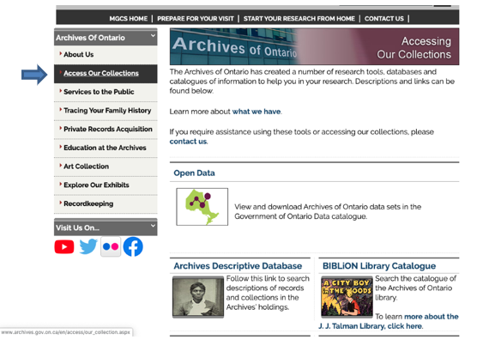

1. Scroll down to the ”Research Guide and Tools” page:

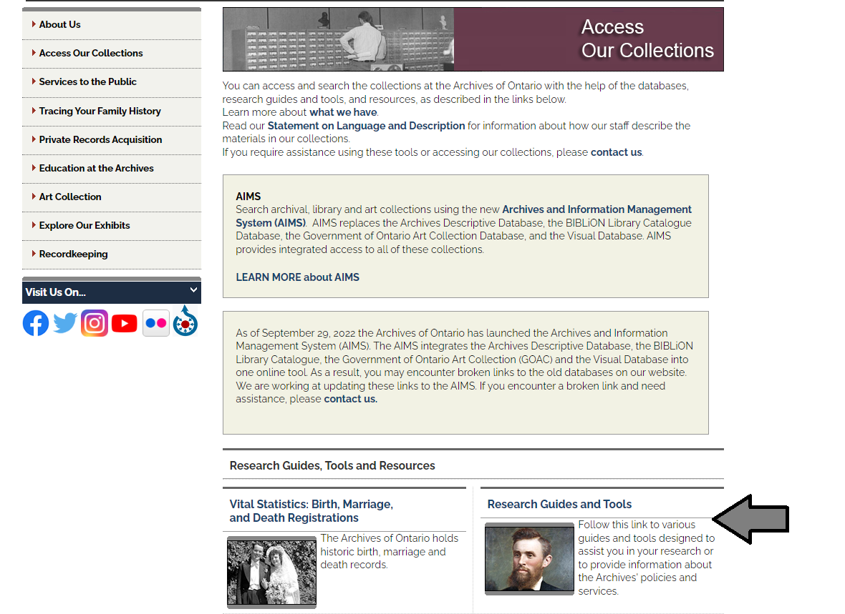

# Contact us

Although unable to do your research for you, our reference archivists are waiting to assist you.  You may telephone or write to them by mail or email or — best of all — visit the Archives of Ontario.

**Telephone: 416-327-1600 Toll free (Ontario): 1-800-668-9933**

**Email:** [Click here to email the Archives of Ontario](mailto:reference@ontario.ca).  The e-mail address is [reference@ontario.ca](mailto:reference@ontario.ca)

**Address: Archives of Ontario, 134 Ian Macdonald Blvd., Toronto, ON M7A 2C5**

**Website**

Visit our website for information about our collections and our services, our online exhibits and education programs, and links to our social media accounts. [Click here to visit our website](http://www.ontario.ca/archives).  The website is [www.ontario.ca/archives](http://www.ontario.ca/archives).

**Customer Service and Research Guides**

Our guides contain information about our services, freelance researchers available to do research for you, and some of most popular records.  [Click here to view our guides](http://www.archives.gov.on.ca/en/access/research_guides.aspx).  To find the “Research Guides and Tools” on our website, click on “Access our Collections”.

______________________________________________________________________

© King's Printer for Ontario, 2023

This information is provided as a public service.  Last update is shown at the beginning of this guide.  Readers should where possible verify the information before acting on it.