| **Archives of Ontario** |  |
| --- | --- |
| Research Guide 233  Criminal Justice Records  Last Updated: March 2023 | |

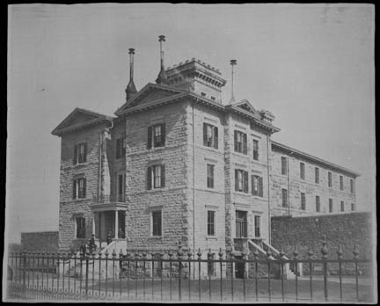

City and County Jail, Hamilton, circa 1890

RG 15-90-0-0-47

Public buildings – oversized photographs

In this guide 2

Where do I find these records? 3

Records not at the Archives 3

How can I access my own criminal court file? 4

What do I need to get started? 4

The Records 4

1. Investigation records 4

1.1 Ontario Provincial Police (OPP) records 4

1.2 Coroners’ records. 5

1.3 Other investigation records 7

2. Indictment files 8

3. Court records 8

3.1 Criminal courts 9

3.2 Types of court records 10

4. Judges’ records 12

4.1 Benchbooks 12

4.2 Judges’ judgments 12

5. Correctional records 13

6. Probation and parole records 13

Are there related records? 14

Glossary of terms related to criminal justice 15

How do I get to the online descriptions? 16

Contact us 18

# 

# In this guide

This guide provides information about criminal justice records at the Archives of Ontario, and how to access them.

These records include police and coroner records documenting investigations into crimes; indictment, trial, verdict and sentencing records created by the courts; jail records created both before the trial and after conviction; and parole and probation records for people convicted and sentenced to a jail term.

A glossary with some of the terms found in criminal justice records can be found at the end of this guide.

Please note: this guide contains links to information found in our online Archives and Information Management System (AIMS).  On our website, this database is found under “Access Our Collections”.  If you are using a print copy of this guide, see page 15 for more information on how to access online descriptions.

# Where do I find these records?

We have the following records, up to the 1980s (with some gaps):

* Ontario Provincial Police (OPP) and coroner records
* Criminal indictment, court and judges’ records
* Correctional, probation and parole records

Some of our records can be viewed in our reading room, but you may also be able to obtain copies from a distance. In some cases, you will first need to contact a courthouse or government office to get a file number.

Access to most records is governed by the Freedom of Information and Protection of Privacy Act, other legislation or privacy rules set by the courts. This means you will need to submit a Freedom of Information request or contact our Information and Privacy Unit to request access the records. Contact us for information on how to do this.

Only the individual named in the records or law enforcement agencies can request access to records of juvenile delinquents (1908 to 1984) and young offenders (1984 to present.

## Records not at the Archives

We do not have the records of municipal or regional police, or the Royal Canadian Mounted Police (RCMP). Please contact these institutions directly for information about their records and how to access them. For records of federal penitentiaries (individuals sentenced to two years or more), contact the Correctional Service of Canada (CSC). For records of the Parole Board of Canada and the Supreme Court of Canada, contact these institutions directly.

For information on how to obtain copies of records for years more recent than our holdings:

* **OPP records**, including incident reports, **coroner and Fire Marshal, correctional, probation and parole records for adult offenders**: visit the website of the Freedom of Information and Privacy Office, Ministry of the Solicitor General, <https://www.mcscs.jus.gov.on.ca/english/about_min/foi/foi.html>.
* **Court records (including indictment files)**: visit the website of the Ministry of the Attorney General, <https://www.attorneygeneral.jus.gov.on.ca/english/> to find contact information for each courthouse.
* **Correctional, probation and parole records for young offenders**: contact the Freedom of Information and Privacy Office, Ministry of Children, Community and Social Services, PO Box 978, Toronto, Ontario, M7A 1N3, 416-327-8262.

## How can I access my own criminal court file?

We have records from some (but not all courts) up to the late 1980s. If you are looking for your criminal record(s), or someone else’s on their behalf, contact us with the name, the location of where the court proceedings occurred, court type (if known), the year, the type of crime, and the file number (if known). Also mention if the record pertains to juvenile delinquents (1908 to 1984) and young offenders (1984 to present) After we receive this information, we will contact you about how to request copies of the records.

For records from 1990 to the present, contact the courthouse where your case was processed. For a list of courthouses, consult the Ministry of Attorney General website: <https://www.attorneygeneral.jus.gov.on.ca/english/courts/Court_Addresses/>

# What do I need to get started?

For all records, you need to know where and when the event took place and who was involved.

For specific records, you also need to know the following information:

* For coroner records: the name of the deceased
* For police records: the type of crime and the names of the accused or suspects and the victim(s)
* For court records (including indictment files): the type of crime and the name of the accused
* For jail, probation, and parole records: the location where the person was jailed and the individual’s name.

For more information about these records, see The Records section below.

# The Records

## Investigation records

### 1.1 Ontario Provincial Police (OPP) records

The OPP was formed in 1908. Some of the records we have pre-date 1908.

Table 1 below lists groups of records that document OPP investigations. Click on the links in the table for information about these records, and how to access them.

We also have administrative and operational records. For information about those records and how to access them, [click here to search the Archives and Information Management System (AIMS), "Archives Repository", Advance Search by Reference Code, and enter RG 23-* as the reference code](http://aims.archives.gov.on.ca).

Table 1: OPP investigation records

| **Title** | **Dates** | **Reference Code** |
| --- | --- | --- |
| Ontario Provincial Police criminal investigation records and reports | 1901 to 1977 | [click here to access the description for RG 23-26](https://aims.archives.gov.on.ca/scripts/mwimain.dll/144/DESCRIPTION_WEB/WEB_DESC_DET?SESSIONSEARCH&exp=sisn%207767) |
| Ontario Provincial Police major criminal investigation solved case files | 1922 to 1971 | [click here to access the description for RG 23-29](https://aims.archives.gov.on.ca/scripts/mwimain.dll/144/DESCRIPTION_WEB/WEB_DESC_DET?SESSIONSEARCH&exp=sisn%204375) |
| Ontario Provincial Police Special Investigations Branch crime reports | 1936 to 1984 | [click here to access the description for RG 23-49](https://aims.archives.gov.on.ca/scripts/mwimain.dll/144/DESCRIPTION_WEB/WEB_DESC_DET?SESSIONSEARCH&exp=sisn%208752) |
| Ontario Provincial Police criminal investigations reports and files | 1922 to 1970 | [click here to access the description for RG 23-50](https://aims.archives.gov.on.ca/scripts/mwimain.dll/144/DESCRIPTION_WEB/WEB_DESC_DET?SESSIONSEARCH&exp=sisn%208759) |
| Ontario Provincial Police major occurrence report files | 1969 to 1983 | [click here to access the description for RG 23-51](https://aims.archives.gov.on.ca/scripts/mwimain.dll/144/DESCRIPTION_WEB/WEB_DESC_DET?SESSIONSEARCH&exp=sisn%208768) |

### 1.2 Coroners’ records.

Coroners investigate:

* suspicious or unexplained deaths
* deaths that appear to be the result of an accident, a homicide, or a suicide
* deaths on construction sites, quarries, pits, or mines, or
* deaths that occurred while a person was detained, or use of force by a police officer was involved

Inquests are public hearings, which involve a jury reviewing evidence as to the cause of death. They sometimes result in recommendations to avoid similar deaths.

We have coroners’ records for most counties and districts, from 1821 to 1963, and records for a few counties up to 1974. These may include investigations and inquests case files, as well as registers and returns.

Table 2 below lists these records. Click on the links in the table for information about these records and how to access them.

Table 2: Coroner records

| **Title** | **Dates** | **Reference Code** |
| --- | --- | --- |
| Algoma District coroner investigations and inquests | 1959 to 1964 | [click here to view the description for RG 22-1095](https://aims.archives.gov.on.ca/scripts/mwimain.dll/144/DESCRIPTION_WEB/WEB_DESC_DET?SESSIONSEARCH&exp=sisn%2011117) |
| Brant County coroner inquest | 1931 (one file) | [click here to view the description for RG 22-1195](https://aims.archives.gov.on.ca/scripts/mwimain.dll/144/DESCRIPTION_WEB/WEB_DESC_DET?SESSIONSEARCH&exp=sisn%207693) |
| Bruce County coroner investigations and inquests | 1959 to 1962 | [click here to view the description for RG 22-1291](https://aims.archives.gov.on.ca/scripts/mwimain.dll/144/DESCRIPTION_WEB/WEB_DESC_DET?SESSIONSEARCH&exp=sisn%206543) |
| Carleton County coroner investigations and inquests | 1945 to 1946 | [click here to view the description for RG 22-1395](https://aims.archives.gov.on.ca/scripts/mwimain.dll/144/DESCRIPTION_WEB/WEB_DESC_DET?SESSIONSEARCH&exp=sisn%207694) |
| Durham Judicial District coroner investigations and inquests | 1971 to 1974 | [click here to view the description for RG 22-1697](https://aims.archives.gov.on.ca/scripts/mwimain.dll/144/DESCRIPTION_WEB/WEB_DESC_DET?SESSIONSEARCH&exp=sisn%205607) |
| Elgin County coroner investigations and inquests | 1928 to 1963 | [click here to view the description for RG 22-423](https://aims.archives.gov.on.ca/scripts/mwimain.dll/144/DESCRIPTION_WEB/WEB_DESC_DET?SESSIONSEARCH&exp=sisn%207692) |
| Essex County coroner investigations and inquests | 1845 to 1855 | [click here to view the description for RG 22-1895](https://aims.archives.gov.on.ca/scripts/mwimain.dll/144/DESCRIPTION_WEB/WEB_DESC_DET?SESSIONSEARCH&exp=sisn%206805) |
| Lambton County coroner inquests | 1912 to 1965 | [click here to view the description for RG 22-2795](https://aims.archives.gov.on.ca/scripts/mwimain.dll/144/DESCRIPTION_WEB/WEB_DESC_DET?SESSIONSEARCH&exp=sisn%207695) |
| Lambton County coroner investigations and returns | 1946 to 1959 | [click here to view the description for RG 22-2796](https://aims.archives.gov.on.ca/scripts/mwimain.dll/144/DESCRIPTION_WEB/WEB_DESC_DET?SESSIONSEARCH&exp=sisn%207696) |
| Leeds and Grenville United Counties coroner investigations and inquests | 1854 to 1893, 1947 to 1962 | [click here to view the description for RG 22-2995](https://aims.archives.gov.on.ca/scripts/mwimain.dll/144/DESCRIPTION_WEB/WEB_DESC_DET?SESSIONSEARCH&exp=sisn%207697) |
| Lennox and Addington United Counties coroner investigations and inquests | 1919 to 1951 | [click here to view the description for RG 22-3095](https://aims.archives.gov.on.ca/scripts/mwimain.dll/144/DESCRIPTION_WEB/WEB_DESC_DET?SESSIONSEARCH&exp=sisn%206400) |
| Lincoln County coroner investigations and inquests | 1834 to 1917, 1938 to 1951 | [click here to view the description for RG 22-3195](https://aims.archives.gov.on.ca/scripts/mwimain.dll/144/DESCRIPTION_WEB/WEB_DESC_DET?SESSIONSEARCH&exp=sisn%207699) |
| Middlesex County coroner fire investigations and inquests | 1861 to 1886 | [click here to view the description for RG 22-3396](https://aims.archives.gov.on.ca/scripts/mwimain.dll/144/DESCRIPTION_WEB/WEB_DESC_DET?SESSIONSEARCH&exp=sisn%2015777) |
| Middlesex County coroner investigations and inquests | 1831 to 1973 | [click here to view the description for RG 22-3395](https://aims.archives.gov.on.ca/scripts/mwimain.dll/144/DESCRIPTION_WEB/WEB_DESC_DET?SESSIONSEARCH&exp=sisn%207701) |
| Newcastle District coroner investigations and inquests | 1821 to 1848 | [click here to view the description for RG 22-3788](https://aims.archives.gov.on.ca/scripts/mwimain.dll/144/DESCRIPTION_WEB/WEB_DESC_DET?SESSIONSEARCH&exp=sisn%206808) |
| Norfolk County coroner investigations and inquests | 1912 to 1965 | [click here to view the description for RG 22-3695](https://aims.archives.gov.on.ca/scripts/mwimain.dll/144/DESCRIPTION_WEB/WEB_DESC_DET?SESSIONSEARCH&exp=sisn%207702) |
| Northumberland and Durham United Counties coroner investigations and inquests | 1931 to 1932 | [click here to view the description for RG 22-3795](https://aims.archives.gov.on.ca/scripts/mwimain.dll/144/DESCRIPTION_WEB/WEB_DESC_DET?SESSIONSEARCH&exp=sisn%207703) |
| Ontario County coroner register and inquest | 1896 to 1935 | [click here to view the description for RG 22-3895](https://aims.archives.gov.on.ca/scripts/mwimain.dll/144/DESCRIPTION_WEB/WEB_DESC_DET?SESSIONSEARCH&exp=sisn%207708) |
| Oxford County coroner investigations and inquests | 1957 to 1965 | [click here to view the description for RG 22-3995](https://aims.archives.gov.on.ca/scripts/mwimain.dll/144/DESCRIPTION_WEB/WEB_DESC_DET?SESSIONSEARCH&exp=sisn%207709) |
| Perth County coroner investigations and inquests | 1857 to 1933 | [click here to view the description for RG 22-4295](https://aims.archives.gov.on.ca/scripts/mwimain.dll/144/DESCRIPTION_WEB/WEB_DESC_DET?SESSIONSEARCH&exp=sisn%207710) |
| Peterborough County coroner investigations and inquests | 1859, 1877, 1903 to 1908, 1912 to 1913 | [click here to view the description for RG 22-4395](https://aims.archives.gov.on.ca/scripts/mwimain.dll/144/DESCRIPTION_WEB/WEB_DESC_DET?SESSIONSEARCH&exp=sisn%207711) |
| Prescott and Russell coroner investigations and inquests | 1928 to 1962 | [click here to view the description for RG 22-4495](https://aims.archives.gov.on.ca/scripts/mwimain.dll/144/DESCRIPTION_WEB/WEB_DESC_DET?SESSIONSEARCH&exp=sisn%207713) |
| Stormont, Dundas and Glengarry United Counties coroner investigations and inquests | 1870 to 1889, 1893 to 1896 | [click here to view the description for RG 22-4979](https://aims.archives.gov.on.ca/scripts/mwimain.dll/144/DESCRIPTION_WEB/WEB_DESC_DET?SESSIONSEARCH&exp=sisn%207153) |
| Thunder Bay District coroner investigations and inquests | 1940 to 1963 | [click here to view the description for RG 22-5295](https://aims.archives.gov.on.ca/scripts/mwimain.dll/144/DESCRIPTION_WEB/WEB_DESC_DET?SESSIONSEARCH&exp=sisn%207717) |
| Timiskaming District coroner investigations and inquests | 1947 to 1962 | [click here to view the description for RG 22-5195](https://aims.archives.gov.on.ca/scripts/mwimain.dll/144/DESCRIPTION_WEB/WEB_DESC_DET?SESSIONSEARCH&exp=sisn%207716) |
| Wellington County coroner investigations and inquests | 1914 to 1963 | [click here to view the description for RG 22-5695](https://aims.archives.gov.on.ca/scripts/mwimain.dll/144/DESCRIPTION_WEB/WEB_DESC_DET?SESSIONSEARCH&exp=sisn%205269) |
| Western District coroner investigations and inquests | 1835 to 1836, 1852, 1856 | [click here to view the description for RG 22-1826](https://aims.archives.gov.on.ca/scripts/mwimain.dll/144/DESCRIPTION_WEB/WEB_DESC_DET?SESSIONSEARCH&exp=sisn%206807) |
| Western District coroner returns | 1847 to 1858 | [click here to view the description for RG 22-1896](https://aims.archives.gov.on.ca/scripts/mwimain.dll/144/DESCRIPTION_WEB/WEB_DESC_DET?SESSIONSEARCH&exp=sisn%206806) |
| [York County coroner investigations and inquests](http://server1.minisisinc.com/minisa.dll/849/1/1/1372?RECORD) | 1877 to 1907 | [click here to view the description for RG 22-5895](https://aims.archives.gov.on.ca/scripts/mwimain.dll/144/DESCRIPTION_WEB/WEB_DESC_DET?SESSIONSEARCH&exp=sisn%201372) |
| York County register of coroner’s inquests | 1857 to 1960 | [click here to view the description for RG 22-5897](https://aims.archives.gov.on.ca/scripts/mwimain.dll/144/DESCRIPTION_WEB/WEB_DESC_DET?SESSIONSEARCH&exp=sisn%201374) |
| York County registers of coroners | 1848 to 1955 | [click here to view the description for RG 22-5896](https://aims.archives.gov.on.ca/scripts/mwimain.dll/144/DESCRIPTION_WEB/WEB_DESC_DET?SESSIONSEARCH&exp=sisn%201373) |

We also have a card index created by the Chief Coroner, for investigations between 1948 and 1965. For information about these records and how to access them, [click here to view the description for RG 33-25.](https://aims.archives.gov.on.ca/scripts/mwimain.dll/144/DESCRIPTION_WEB/WEB_DESC_DET?SESSIONSEARCH&exp=sisn%2013131)

Additionally, we have Major accident inquest files, 1949 to 1980. For information about these records and how to access them,[click here to view the description for RG 33-26.](https://aims.archives.gov.on.ca/scripts/mwimain.dll/144/DESCRIPTION_WEB/WEB_DESC_DET?SESSIONSEARCH&exp=sisn%2013130)

Records after 1963, except those mentioned in this guide, are with the Chief Coroner’s Office. For information on how to access these records, visit the website of the Freedom of Information and Privacy Office, Ministry of the Solicitor General, <https://www.mcscs.jus.gov.on.ca/english/about_min/foi/foi.html>.

### 1.3 Other investigation records

**Centre for Forensic Sciences case files**, 1931 to 1961

This office provides forensic services to police forces across Ontario. The files usually contain a police report describing the crime scene and the evidence found, the notes taken by laboratory staff, and the laboratory's report to the police. For information on these records and how to access them, [click here to view the description for RG 33-28](https://aims.archives.gov.on.ca/scripts/mwimain.dll/144/DESCRIPTION_WEB/WEB_DESC_DET?SESSIONSEARCH&exp=sisn%2013127).

**Office of the Fire Marshall investigation case files**, 1929 to 2001

These files document investigations into fires resulting in death, explosions, and major damage. They usually contain a preliminary investigation report, witness statements, correspondence, schematic site drawings and plans, and a final report summarising the findings. For information about these records and how to access them, [click here to view the description for RG 33-30](https://aims.archives.gov.on.ca/scripts/mwimain.dll/144/DESCRIPTION_WEB/WEB_DESC_DET?SESSIONSEARCH&exp=sisn%204640).

## Indictment files

Indictment files were created when the accused was formally charged in court. They may include a bill of indictment laying out the charge, a copy of the police information (investigation records) and a copy of the verdict. Files may also include copies of other documents created during the trial and lists of witnesses and evidence. We mostly have indictment files for major crimes.

**Supreme Court Central Office Criminal Assize Clerk criminal indictment case files**, 1853 to 1929

These records document indictments for offences such as murder, rape, arson, theft, and fraud, tried before the Supreme Court of Ontario or its predecessors. These records are available on microfilm in our reading room, and libraries that offer interloan services can borrow the reels for you.

For more information about these records, [click here to view the description for RG 22-392](https://aims.archives.gov.on.ca/scripts/mwimain.dll/144/DESCRIPTION_WEB/WEB_DESC_DET?SESSIONSEARCH&exp=sisn%202470). To find if there is a file for a specific person, [click here to do an Advance Search in the Archives and Information Managment System (AIMS), Archives Repository](http://aims.archives.gov.on.ca). Note: Search results may include other records.

**Supreme Court Registrar’s criminal indictment files**, 1930 to 1979

These records document indictments for major crimes tried before the Supreme Court of Ontario. For information about these records and how to access them, [click here to view the description for RG 22-517](https://aims.archives.gov.on.ca/scripts/mwimain.dll/144/DESCRIPTION_WEB/WEB_DESC_DET?SESSIONSEARCH&exp=sisn%202679).

**Other indictment files**

We have some indictment files from lower courts in Lambton, Lanark, Lincoln, Peel and York Counties, Sudbury, and Thunder Bay Districts. We also have indictment case files for the Supreme Court of Ontario, Sudbury District, 1927 to 1975 and 1981 to 1986.

For information about these records and how to access them, [click here to search the Archives and Information Management System (AIMS), Archives Repository by groups of records, and enter the word indictment and the name of the county or district in the title field](http://aims.archives.gov.on.ca).

## Court records

In addition to the indictment files, courts created various types of records to document the proceedings. Please note: Records usually do not include transcripts of the proceedings.

### Criminal courts

See below for basic information about the courts that dealt with criminal cases. For more information about these courts and the records they created, click on the name of the court, or search the online Archives and Information Management System (AIMS), Archives Repository by Organization Search and enter the name of the court in the keyword(s) field.

Note: The dates below are the dates of existence of the courts, not the dates of the records we have.

**Courts of inferior jurisdiction**

[Magistrates' Courts](https://aims.archives.gov.on.ca/scripts/mwimain.dll/144/ORGANIZATION_VAL/WEB_ORG_DET_OPAC?SESSIONSEARCH&exp=ORG_ID%20O729) - existed from 1849 to 1968

These courts existed in many municipalities with a population over 5,000. They dealt with “petty” offences and by-law infractions. This was where minor criminals would first appear in court. Before 1934, these courts were also known as Police Magistrates' Courts, Police Courts, or Mayor's Courts. Few records from these courts have survived.

[Provincial Court (Criminal Division)](https://aims.archives.gov.on.ca/scripts/mwimain.dll/144/ORGANIZATION_VAL/WEB_ORG_DET_OPAC?SESSIONSEARCH&exp=ORG_ID%20O754) - existed from 1968 to 1989

This court existed in all counties and districts. It dealt with criminal matters previously handled by Magistrates’ Courts.

[Courts of General Sessions of the Peace](https://aims.archives.gov.on.ca/scripts/mwimain.dll/144/ORGANIZATION_VAL/WEB_ORG_DET_OPAC?SESSIONSEARCH&exp=ORG_ID%20O646) - existed from 1777 to 1984

[CountyandDistrict Court Judges’ Criminal Courts](https://aims.archives.gov.on.ca/scripts/mwimain.dll/144/ORGANIZATION_VAL/WEB_ORG_DET_OPAC?SESSIONSEARCH&exp=ORG_ID%20O638) - existed from 1869 to 1984

These three courts existed in all counties and districts, and dealt with minor crimes, such as assault, misdemeanours, and “petit larceny” (minor theft). Before 1841, the Sessions were also responsible for local administration.

Starting in 1869, the Sessions only held trials where the accused had chosen to be tried by a jury. The Judges’ Criminal Courts held trials before a judge only (no jury).

[District Court -](https://aims.archives.gov.on.ca/scripts/mwimain.dll/144/ORGANIZATION_VAL/WEB_ORG_DET_OPAC?SESSIONSEARCH&exp=ORG_ID%20O660) existed from 1984 to 1989

This court existed in all counties and districts. It dealt with the criminal matters previously assigned to the Court of General Sessions of the Peace and the County or District Judges’ Criminal Courts. It also dealt with some civil issues.

[Ontario Court of Justice](https://aims.archives.gov.on.ca/scripts/mwimain.dll/144/ORGANIZATION_VAL/WEB_ORG_DET_OPAC?SESSIONSEARCH&exp=ORG_ID%20O644) - exists since 1989 (called the Ontario Court of Justice, Provincial Division until 1999)

This court exists at various locations throughout the provinces. It deals with minor criminal and family issues, as well as provincial offenses.

**Family and young offender courts**

[Juvenile and Family Courts](https://aims.archives.gov.on.ca/scripts/mwimain.dll/144/ORGANIZATION_VAL/WEB_ORG_DET_OPAC?SESSIONSEARCH&exp=ORG_ID%20O721) - existed from 1910 to 1968  
[Provincial Court (Family Division)](https://aims.archives.gov.on.ca/scripts/mwimain.dll/144/ORGANIZATION_VAL/WEB_ORG_DET_OPAC?SESSIONSEARCH&exp=ORG_ID%20O755) - existed from 1968 to 1989

These courts existed in all counties and districts. They dealt with criminal and civil issues including juvenile delinquents (later known as young offenders), as well as various domestic and family law matters (excluding divorces).

[Unified Family Court](https://aims.archives.gov.on.ca/scripts/mwimain.dll/144/ORGANIZATION_VAL/WEB_ORG_DET_OPAC?SESSIONSEARCH&exp=ORG_ID%20O865) - existed from 1977 to 1994  
[Court of Justice (General Division). Family Court](https://aims.archives.gov.on.ca/scripts/mwimain.dll/144/ORGANIZATION_VAL/WEB_ORG_DET_OPAC?SESSIONSEARCH&exp=ORG_ID%20O1189) - exists since 1994

The Unified Family Court was created in 1977 in the Judicial District of Hamilton-Wentworth. It dealt with all criminal and civil family law issues, including young offenders. In 1994, it was replaced with the Family Court, which is part of the Ontario Court of Justice. The Family Court exists in parts of the province; elsewhere, family law responsibilities are divided between the Ontario Court of Justice (including young offenders) and the Superior Court of Justice.

**Courts of superior jurisdiction**

[Court of Queen’s (or King’s) Bench](https://aims.archives.gov.on.ca/scripts/mwimain.dll/144/ORGANIZATION_VAL/WEB_ORG_DET_OPAC?SESSIONSEARCH&exp=ORG_ID%20O645) - existed from 1794 to 1881

[Court of Common Pleas](https://aims.archives.gov.on.ca/scripts/mwimain.dll/144/ORGANIZATION_VAL/WEB_ORG_DET_OPAC?SESSIONSEARCH&exp=ORG_ID%20O642) - existed from 1849 to 1881

[Common Pleas Division](https://aims.archives.gov.on.ca/scripts/mwimain.dll/144/ORGANIZATION_VAL/WEB_ORG_DET_OPAC?SESSIONSEARCH&exp=ORG_ID%20O1062) - existed from 1881 to 1913

[Queen’s Bench Division](https://aims.archives.gov.on.ca/scripts/mwimain.dll/144/ORGANIZATION_VAL/WEB_ORG_DET_OPAC?SESSIONSEARCH&exp=ORG_ID%20O1590) - existed from 1881 to 1913

[High Court of Justice](https://aims.archives.gov.on.ca/scripts/mwimain.dll/144/ORGANIZATION_VAL/WEB_ORG_DET_OPAC?SESSIONSEARCH&exp=ORG_ID%20O680) - existed from 1881 to 1989

[Supreme Court (Ontario)](https://aims.archives.gov.on.ca/scripts/mwimain.dll/144/ORGANIZATION_VAL/WEB_ORG_DET_OPAC?SESSIONSEARCH&exp=ORG_ID%20O848) - existed from 1881 to 1989

These courts had jurisdiction over all criminal offences, but they primarily dealt with major indictable offenses, such as murder, manslaughter, sexual assault, and fraud. They also dealt with the most important civil cases. These courts were based in Toronto. Four times a year, judges and court personnel travelled to various locations in Ontario to hold sittings known as “assizes”.

[Superior Court of Justice](https://aims.archives.gov.on.ca/scripts/mwimain.dll/144/ORGANIZATION_VAL/WEB_ORG_DET_OPAC?SESSIONSEARCH&exp=ORG_ID%20O643) - exists since 1989 (called the Ontario Court of Justice, General Division until 1999)

This court has locations throughout the province. It deals with major criminal issues, most civil issues, and some family issues.

[Court of Appeal](https://aims.archives.gov.on.ca/scripts/mwimain.dll/144/ORGANIZATION_VAL/WEB_ORG_DET_OPAC?SESSIONSEARCH&exp=ORG_ID%20O640) - exists since 1794

This court hears appeals of both criminal and civil decisions from other courts. Case files from this court are very detailed and may include full transcripts of the original trial.

### Types of court records

See below for information about the main types of records created by the court when dealing with both criminal and civil cases.

To access these records, you will first need to search the procedure books or indexes to get the case year and file number. Please note: Many procedure books, indexes, judgment books and order books are still with the courthouse that created them. In some cases, you will need to contact the courthouse to obtain a file number. Also, many early records no longer exist.

For information about these records and how to access them, [click here to search the Archives and Information Management System (AIMS), "Archives Repository" by groups of records](http://aims.archives.gov.on.ca); enter the name of the county or district and the court (if known) in the keyword(s) field and the type of records in the title field. For judgments and orders, enter judgment* or order*.

**Procedure books and indexes**

Procedure books are used to track cases. They include the case file number, so they serve as a form of index to the case files. Information is added at each stage of the process. Entries for criminal cases may include dates of hearings, names of accused, counsels and witnesses, and the outcome of the hearing

Some of the larger courts use indexes to help locate files. Entries include the case file number, and they may be limited to the names of the parties, the type of case, and the date it started in court.

**Minute books**

They provide a brief chronological outline of all cases heard before a court. The volumes usually record: the date and location of the trial, the name of the presiding judge, the name of the defendant(s), the name of the prosecuting and defending counsel, the charge(s), the plea(s), the names of witnesses and jurors (if any), the verdict, and the sentence (if applicable).

**Criminal case files**

These are the main records of a court case. They may include:

* an indictment and/or police information
* the jury verdict or judgement and sentence
* a warrant of committal to jail or prison
* a statement by the accused choosing trial by judge or jury
* a transcript of the preliminary hearing
* documentary evidence submitted by the defence and/or prosecution

**Docket books**

They list in chronological order all criminal court cases heard, either during that spring or autumn Assizes or, for the larger courthouse with multiple courtrooms, the trials held on a particular day. The volumes usually record the date of trial, the name of the presiding judge, and the name of the defendant(s).

**Judgment books** and **order books**

These include judgments and orders issued by a judge related to a case.

Entries in judgment books include:

* the type of action
* whether judgement was entered by verdict, by cognovit (a confession by the defendant of their crime), or upon non-appearance of the defendant
* a copy of summons, orders, and dispositions
* the signature of the Judge or Clerk.

Entries in order books consist of a transcription of the order, which includes:

* the names of the parties
* a summary of the nature of the application
* an outline of the court decision
* the name of the presiding judge or master
* the date of the sitting and the date of entry in the book

Some courts microfilmed their judgment and orders, and we have those microfilm reels for some years.

## Judges’ records

We have benchbooks and judges’ judgments from some judges. For information about these records and how to access them, [click here to search the Archives and Information Management System (AIMS), "Archives Repository" by groups of records, and enter the name of the judge](http://aims.archives.gov.on.ca).

Please note: Some judges donated their records to the Law Society of Ontario Archives. For more information, visit <https://lso.ca/about-lso/osgoode-hall-and-ontario-legal-heritage>.

### Benchbooks

Benchbooks are the handwritten notes taken by a Justice during a trial or while in chambers (their office). They usually include:

* the place and date of trial
* name of the defendant(s) and their charge(s)
* names of the witnesses and the evidence they gave
* details of any motions or objections raised during the trial
* the verdict and, if applicable, the sentence.

Some judges also included comments about the accused and witnesses, the testimony, and their decisions.

### Judges’ judgments

Judges’ judgments, or Reasons for Judgment, are detailed explanations of the legal reasoning behind a ruling in a civil or criminal case. They are often filed in the case file, but judges usually kept their own copy for future reference. Some judges annotated those copies, for example, if the case was appealed.

## Correctional records

The Government of Ontario is responsible for incarcerating individuals awaiting trial, those sentenced to a prison term of less than two years, and most young offenders.

The following records contain information about the incarceration history of adult inmates, from 1920 to 1991:

* [click here to view the description for RG 20-200, Indexes to the Adult inmates main office case files](https://aims.archives.gov.on.ca/scripts/mwimain.dll/144/DESCRIPTION_WEB/WEB_DESC_DET?SESSIONSEARCH&exp=sisn%2010591)
* [click here to view the description for RG 20-201, Adult inmate main office case files and profiles](https://aims.archives.gov.on.ca/scripts/mwimain.dll/144/DESCRIPTION_WEB/WEB_DESC_DET?SESSIONSEARCH&exp=sisn%2010596)

We also have records of provincial institutions, from the 1830s to the 1980s (varies by institution). These records include:

* registers: contain information about the inmates, including reasons for incarceration
* case files: contain additional correctional and medical information
* other records, including daily logs, punishment registers, surgeon’s registers, and administrative records

For information about these records and how to access them, [click here to search the Archives and Information Management System (AIMS), "Archives Repository" by groups of records, and enter the name of the facility](http://aims.archives.gov.on.ca).

## Probation and parole records

We have some case files from probation and parole offices throughout the province, and the Ontario Board of Parole, from the 1950s to the 1980s. These files usually include:

* information about the convicted individual, such as name, age, gender, crime committed and sentence
* background information on the convict’s upbringing and previous criminal behaviour
* their rehabilitation prospects
* the terms for their probation or parole
* ongoing progress reports.

For information about these records and how to access them, [click here to search the Archives and Informaiton Management System (AIMS), "Archives Repository" by groups of records, and enter the words probation or parole in the title field](http://aims.archives.gov.on.ca).

We also have the following records from the Ontario Board of Parole:

* **Ontario Board of Parole minute books**, 1910 to 1932:Information recorded in these books includes names of inmates appearing before the Board and Board decisions. [Click here to view the description for RG 8-53](https://aims.archives.gov.on.ca/scripts/mwimain.dll/144/DESCRIPTION_WEB/WEB_DESC_DET?SESSIONSEARCH&exp=sisn%202250)
* **Ontario Board of Parole ticket of leave register**.1910 to 1917: This register documents“Tickets of leave” (an early term used to refer to parole).[Click here to view the description for RG 8-55](https://aims.archives.gov.on.ca/scripts/mwimain.dll/144/DESCRIPTION_WEB/WEB_DESC_DET?SESSIONSEARCH&exp=sisn%202252)
* **Extra-mural employment permit register**, 1921 to 1922**:** This register documents individuals who could work and live outside the prison while still officially serving their sentence. [Click here to view the description for RG 8-57](https://aims.archives.gov.on.ca/scripts/mwimain.dll/144/DESCRIPTION_WEB/WEB_DESC_DET?SESSIONSEARCH&exp=sisn%202254)
* **Ontario Board of Parole register**, 1917 to 1921**:** This register was used by the Board of Parole to document all prisoners committed to penal institutions in Ontario. [Click here to view the description for RG 8-59](https://aims.archives.gov.on.ca/scripts/mwimain.dll/144/DESCRIPTION_WEB/WEB_DESC_DET?SESSIONSEARCH&exp=sisn%202256).

# Are there related records?

**Attorney General Central registry criminal and civil files**, 1871 to 1980

These files include correspondence and documentation about criminal and civil cases reviewed by the Attorney General’s Office or the Ministry’s Crown Law Offices in Toronto. For information about these records and how to access them, [click here to view the description for RG 4-32](https://aims.archives.gov.on.ca/scripts/mwimain.dll/144/DESCRIPTION_WEB/WEB_DESC_DET?SESSIONSEARCH&exp=sisn%205499).

These files are listed online for the years 1871 to 1948. To find a specific file, [click here to search in the Archives and Information Management System (AIMS), Archives Repository, and view the partial online listing in the Description Hierarchy or click the link to "Ask about our records" and submit an Inquiry.](https://aims.archives.gov.on.ca/scripts/mwimain.dll/144/DESCRIPTION_WEB/WEB_DESC_DET?SESSIONSEARCH&exp=sisn%205499) Enter the keywords you are looking for, and reference code RG 4-32.

These records are also indexed (up to 1977) in the **Attorney General Central registry indexes.** For information about these indexes and how to access them, [click here to view the description for RG 4-30](https://aims.archives.gov.on.ca/scripts/mwimain.dll/144/DESCRIPTION_WEB/WEB_DESC_DET?SESSIONSEARCH&exp=sisn%205497).

**Department of Justice (federal) capital case files**

Death sentences in Canada were subject to an automatic review by the federal Department of Justice to determine if the sentence should be carried out or commuted to imprisonment. Files may include copies of documents from the investigation and the trial, correspondence, reports, and recommendations.

These files are with Library and Archives Canada. We do not have a copy of these files. We have a copy of a published index to these files in our reading room. Copies of that published index may also be available at some libraries. For more information about these files, visit the Library and Archives Canada website, [www.collectionscanada.gc.ca](http://www.collectionscanada.gc.ca/).

**Newspapers**

These often include information about criminal cases of major or local interest. For information about our newspaper collections, [click here to view our Research Guide 212: Newspaper Holdings of the Archives of Ontario](http://www.archives.gov.on.ca/en/access/research_guides.aspx). On our website, you will find this and other research guides on the “Research Guides and Tools” page, under “Access Our Collection”.

# Glossary of terms related to criminal justice

Below are a few terms you may find in current or older criminal justice records. For other terms used in the Ontario justice system, visit the Ministry of the Attorney General’s glossary of legal terms, at <https://www.attorneygeneral.jus.gov.on.ca/english/glossary/>.

**Assizes**: Local sittings of courts of superior jurisdiction. These courts were located in Toronto, but judges and court staff would travel to various locations in the province so that cases could be heard locally.

**Coroner’s inquest**: Public inquiry into the causes of a death, involving a jury.

**Correctional centre**: Correctional facility housing people sentenced to a term of two years or less.

**Indictment**: Formal document containing the crimes a person has been charged with committing.

**Jail**: Correctional facility housing people awaiting trial, sentencing or transfer or sentenced to a term of 90 days or less.

**Judgment**: Final decision by a court in a court case (the Archives of Ontario uses this term in the titles of its series that include judgments as well as when referring to the documents in the series descriptions). This is different from **judgement**, which refers to an opinion or criticism of a given issue, including court decisions (the Archives of Ontario uses this term in its series descriptions when describing the process of rendering a decision).

**Juvenile delinquent**: Minor who had committed a crime or who had violated federal or provincial laws or municipal statutes. This term was replaced in 1984 with **Young offender**.

**Order:** A direction by the court to do or refrain from doing something, or to submit certain documents.

**Parole**: Early release of a prisoner from imprisonment, under supervision and conditions.

**Penitentiary**: Federal correctional facility housing people sentenced to a term of 2 years or more.

**Probation**: Order authorizing a person found guilty of a crime to be in the community instead of being imprisoned, under certain conditions.

**Youth Centres**: Correctional facilities for young offenders.

**Young Offender**: A person aged between 12 and 17 who has committed a crime.

# How do I get to the online descriptions?

1. On our website’s main page, click on “Access Our Collections”, and click on “Archives and Information Management System”, as shown in the image below:

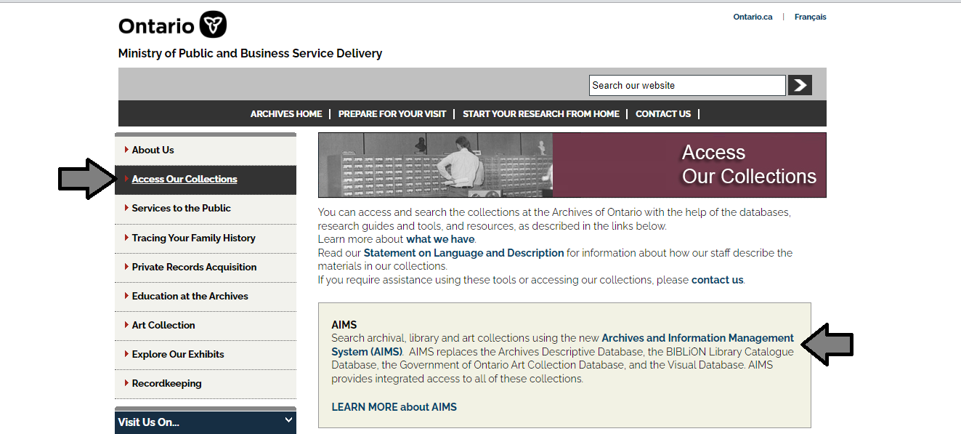

1. In the Archives and Information Management System (AIMS), click on “Archives repository (only)” button”:

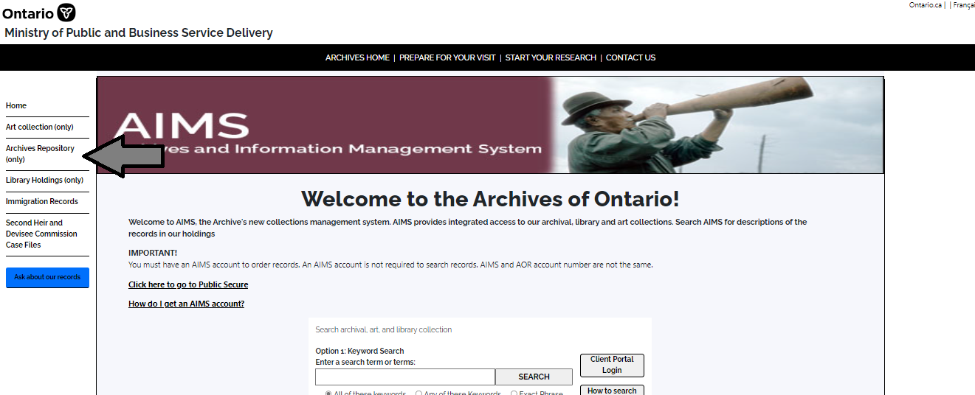

1. On the “Welcome to the Archival Collection” search page, click “Advanced Search”:

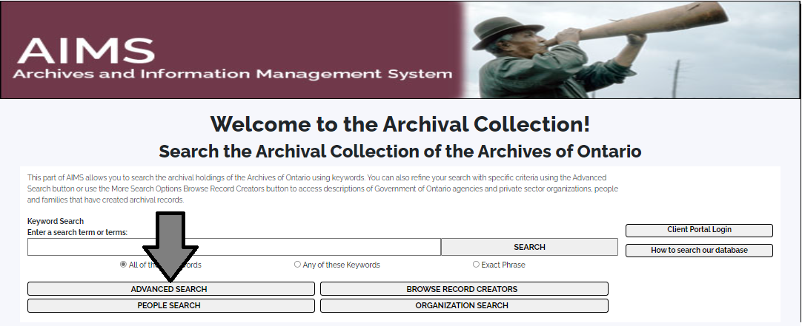

1. On the “Archives Advanced Search” page enter the reference code (that’s the number starting with C, F or RG) in the Reference Code field and click “Search” (at the bottom of the page.

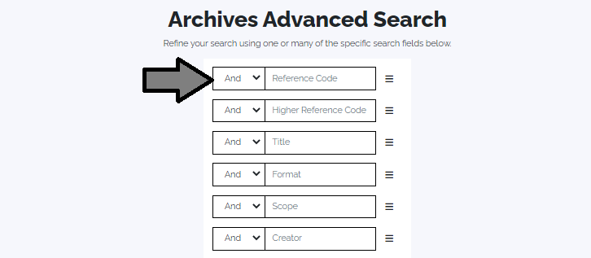

# Contact us

Although unable to do your research for you, our reference archivists are waiting to assist you.  You may call or write to them by mail or email or — best of all — visit the Archives of Ontario.

**Telephone: 416-327-1600 Toll free (Ontario): 1-800-668-9933**

**Email:** [Click here to email the Archives of Ontario](mailto:reference@ontario.ca).  The e-mail address is [reference@ontario.ca](mailto:reference@ontario.ca)

**Address: Archives of Ontario, 134 Ian Macdonald Blvd., Toronto, ON M7A 2C5**

**Website**

Visit our website for information about our collections and our services, our online exhibits and education programs, and links to our social media accounts. [Click here to visit our website](http://www.ontario.ca/archives).  The website is [www.ontario.ca/archives](http://www.ontario.ca/archives).

**Customer Service and Research Guides**

Our guides contain information about our services, freelance researchers available to do research for you, and some of most popular records.  [Click here to view our guides](http://www.archives.gov.on.ca/en/access/research_guides.aspx).  To find the “Research Guides and Tools” on our website, click on “Access our Collections”.

______________________________________________________________________

© King's Printer for Ontario, 2023

This information is provided as a public service.  Last update is shown at the beginning of this guide.  Readers should where possible verify the information before acting on it.