| **Archives of Ontario** |  |
| --- | --- |
| Research Guide 236  Property Assessment Records  Last Updated: March 2023 | |

Image is: Old City Hall, Toronto, 
RG 9-7-5-0-62, Ontario House promotional photographs


Old City Hall, Toronto  
RG 9-7-5-0-62  
Ontario House promotional photographs

In this guide 2

Where do I find these records? 2

What do I need to get started? 3

The Records 3

1. Pre-1981 records 3

2. Records from 1981 to 1997 4

Are there related records? 6

Table 1: Assessment Regions 6

How do I get to the online descriptions? 7

Contact us 9

# In this guide

This guide has information on how to find property assessment records at the Archives of Ontario. These records include information about a property’s assessed value for municipal and school taxation purpose, as well information about property ownership. Early records may include detailed description of the property and buildings.

Starting in the 1850’s assessment records include information about people who chose to pay the school portion of their property taxes to separate (Roman Catholic or Protestant) school boards. Starting in 1988, they include information about people who chose to pay the school portion of their property taxes to French-language school boards or sections.

*Please note: this guide contains links to information found in our online Archives and Information Management System (AIMS).  On our website (ontario.ca/archives), this database is found under “Access Our Collections”.  If you are using a print copy of this guide, go to page 7 for more information on how to find the online descriptions.

# Where do I find these records?

We have property assessment records for some municipalities, from the early 1800’s to the 1970’s. We also have records for the whole province from 1981 to 1996, and for some regions for 1997. To view these records, you will need to request them in advance and visit our reading room. If you have enough information for us to find the records, you may be able to obtain copies at a distance.

Pre-1971 assessment records that we do not have, and copies of assessment records after 1970, may be with the local municipality, or with local or regional archives.

For assessment rolls after 1997, contact:

Municipal Property Assessment Corporation

P.O. Box 9808

Toronto, Ontario, M1S 5T9

1 866 296-MPAC (6722)

[www.mpac.ca](http://www.mpac.ca)

# What do I need to get started?

To find assessment records, you need the address (or lot and concession) and the name of the municipality at the time, as well as the name of the owner. For records after 1970, you also need the 15 or 19-digit assessment roll number. You will find the assessment roll number on the property tax notice sent by the municipality, or you can get it by contacting the Municipal Property Assessment Corporation (contact information noted above).

# The Records

## Pre-1981 records

Pre-1981 assessment record we have include:

* assessment rolls: information about the property, ownership and assessed property value
* collector’s rolls: information about taxes owed and paid
* combined rolls

To find if we have assessment records for a municipality and year, do the following:

* [click here to search the Archives and Information Management System (AIMS), "Archives Repository" by groups of archival records](http://aims.archives.gov.on.ca); to find the “Search Groups of Archival Records” page in the AIMS, click on “Advanced Search”;
* enter the name of the municipality and the word assessment in the “keyword(s)” field

To view these records or to get a copy, contact us with the name of the municipality, the year, the type of records (assessment, collector’s or combined tolls), and the reference code. To get a copy, also include the address (or concession and lot), the name of the owner and (after 1970) the 15 or 19-digit assessment roll number.

**Note:** assessment rolls before 1970 are usually in large volumes for each year and may conservation review prior to viewing. If you plan to visit us to view records for a lengthy time period you may want to consider ordering the records for every tenth year (for example, 1870, 1880, 1890, etc.).

## Records from 1981 to 1997

We have the following records for the whole province for 1981 to 1996, and for some regions for 1997:

* assessment rolls, containing the assessed value and ownership information
* name indexes
* street indexes
* school indexes (identifying owners who chose to direct the school portion of their taxes to separate schools or, starting in 1988, French-language schools)

**How do I access these records?**

You need the 15 or 19-digit assessment roll number. You will find this information on the property tax notice sent by the municipality, or you can get it by contacting the Municipal Property Assessment Corporation (contact information found on page 3).

Example of a roll number is: **43-74-020-005-05200-0000**. The parts of the number represent:

County (43)  
Municipality (74)  
Map division (020)  
Map subdivision (005)

Parcel (05200)

Primary/Subordinate (0000)

You also need the address (or lot and concession), the name of the municipality at the time, the name of the owner, and the assessment region number. If you do not have that number, see table 1 at the end of this guide.

Once you have this all this information, [click here to view the description and file list for RG 26-46](https://aims.archives.gov.on.ca/scripts/mwimain.dll/144/DESCRIPTION_WEB/WEB_DESC_DET?SESSIONSEARCH&exp=sisn%204080). On the file list, find the entry that matches the region and year you are looking for. To view the records, request RG 26-46 and the container number. If you want copies, also mention the assessment roll number, the name of the municipality at the time, and the name of the owner.

##### What is on the assessment roll?

The rolls are on microfiche. Image 1 below is an example of an assessment roll page (names of property owners have been anonymized). See below for an explanation of the contents.

**Image 1: Assessment roll page**

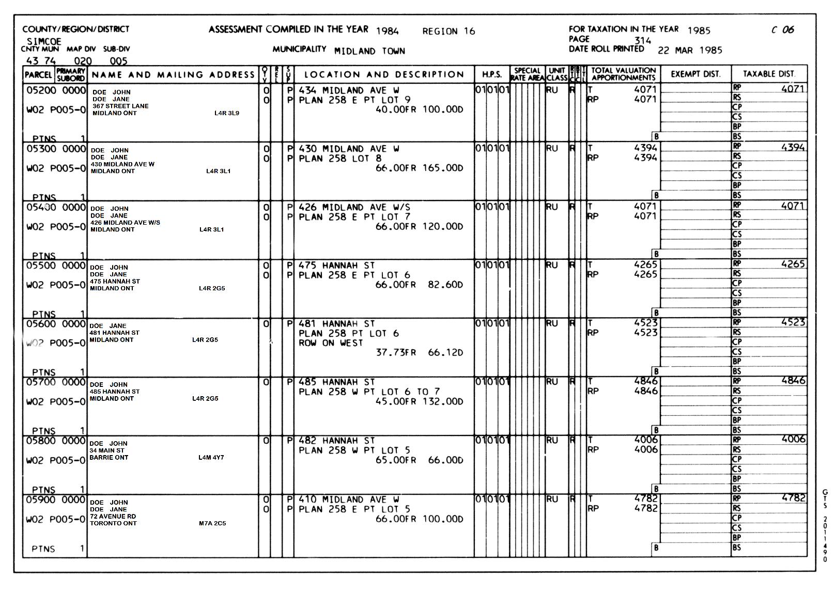

The first ten digits of the roll number (in the example above, 43 74 020 005) appear at the top of each page. The first column on the left contains the last nine digits (5200 0000), the ward and poll numbers for the property (W02 P005-0) and an indication of how many portions the property consists of (PTNS: in this sample all the properties have 1 portion).

The next column contains the name and address of the property’s owner or tenant.

* The “OTV” column shows whether the person is the Owner (‘O’), a Tenant (‘T’) or the property is vacant. (‘V’).
* If the owner/tenant is Roman Catholic, the ‘REL’ (religion) column will be marked ‘R’.
* The next column (‘SUP’) is used to indicate the owner/tenant’s school support (‘P’ for public, ‘S’ for separate, ‘B’ for both in cases of split support).

The location and description column provides the address of the assessed property and information on the land, including the frontage ( ‘FR’) and depth (‘D’) of the property, in feet.

The assessed value of the property is found in the ‘Total Valuation Apportionments’ column (third from the right).

* The letter ‘T’ indicates the total assessment for all portions of the property. If the assessment of the property consists of various portion, they are listed below the total assessment.

### What is the assessed value?

The assessed value of a property in these assessment records is often different from its market value at the time. It is because most municipalities used assessment methodologies not based on market value. Also, some municipalities did not re-assess properties every year. Since 1998, assessment is based on market value. If you need to determine the market value at a certain time, an accountant or the local real estate board may be able to help.

##### What can I do if I do not find the property I am looking for?

The assessment roll number is based, in part, on the municipality where the property is located. If the municipality has changed (for example as a result of a merger), the assessment roll number may be different now from what it was in the year(s) you are looking for.

If you have the address (or lot and concession) and the name of the municipality at the time, you case use the name or street indexes to get the assessment role number at that time. To find what container has the index you need, [click here to view the description and file list for RG 26-46](https://aims.archives.gov.on.ca/scripts/mwimain.dll/144/DESCRIPTION_WEB/WEB_DESC_DET?SESSIONSEARCH&exp=sisn%204080). On the file list, find the entry that matches the region and year you are looking for. To view the records, request RG 26-46 and the container number.

# Are there related records?

For information about other Research Guides that include Municipalities and Municipal Planning Records, [click here to see Research Guide 209, Finding Municipal Records](http://www.archives.gov.on.ca/en/access/research_guides.aspx).

For information on other Research Guides that include property information:

* [click here to see Research Guide 225, Researching Crown Land records](http://www.archives.gov.on.ca/en/access/research_guides.aspx)
* [click here to see Research Guide 232, Ministry of Natural Resources Aerial Photographs](http://www.archives.gov.on.ca/en/access/research_guides.aspx)

On our website, you will find these and other research guides on the “Research Guides and Tools” page, under “Access Our Collections”.

# Table 1: Assessment Regions

Note: there is no assessment region 8.

| **Region Number** | **Counties/Regions/Cities** |
| --- | --- |
| Region 1 | Prescott, Russell, Stormont Dundas and Glengarry Counties |
| Region 2 | Lanark, Leeds and Grenville Counties |
| Region 3 | City of Ottawa |
| Region 4 | Renfrew County |
| Region 5 | Frontenac, Lennox and Addington Counties |
| Region 6 | Hastings, Northumberland and Prince Edward, Counties |
| Region 7 | Haliburton and Peterborough Counties, City of Kawartha Lakes |
| Region 9 | City of Toronto (pre-1998 borders) |
| Region 10 | City of Toronto (pre-1998, City of North York) |
| Region 11 | City of Toronto (pre-1998, City of Scarborough and Borough of East York) |
| Region 12 | Part of the City of Toronto (pre-1998, cities of Etobicoke and York) |
| Region 13 | Regional Municipality of Durham |
| Region 14 | Regional Municipality of York |
| Region 15 | Regional Municipalities of Halton and Peel |
| Region 16 | Simcoe County |
| Region 17 | District Municipality of Muskoka |
| Region 18 | Regional Municipality of Niagara |
| Region 19 | Regional Municipality of Hamilton |
| Region 20 | City of Brantford, Brant, Haldimand and Norfolk Counties |
| Region 21 | Regional Municipality of Waterloo |
| Region 22 | Wellington and Dufferin Counties |
| Region 23 | Elgin, Middlesex and Oxford Counties |
| Region 24 | Huron and Perth Counties |
| Region 25 | Bruce and Grey Counties |
| Region 26 | Municipality of Chatham-Kent, Lambton County |
| Region 27 | Essex County |
| Region 28 | Districts of Nipissing and Parry Sound |
| Region 29 | Districts of Cochrane and Timiskaming |
| Region 30 | City of Greater Sudbury and Districts of Sudbury and Manitoulin |
| Region 31 | District of Algoma |
| Region 32 | District of Kenora, Rainy River and Thunder Bay |

# How do I get to the online descriptions?

1. On our website’s main page, click on “Access Our Collections”, and click on “Archives and Information Management System”, as shown in the image below:

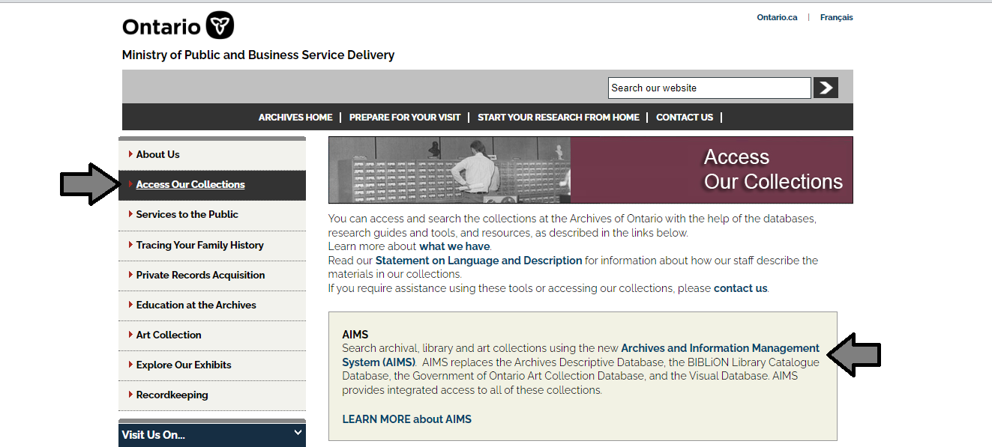

1. In the Archives and Information Management System (AIMS), click on “Archives repository (only)” button:

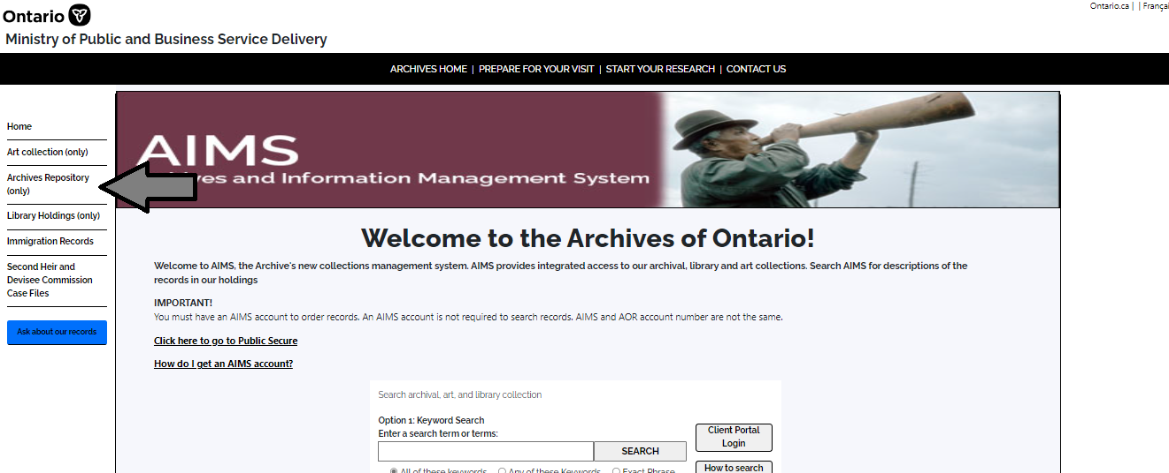

1. On the “Welcome to the Archival Collection” search page, click “Advanced Search”.

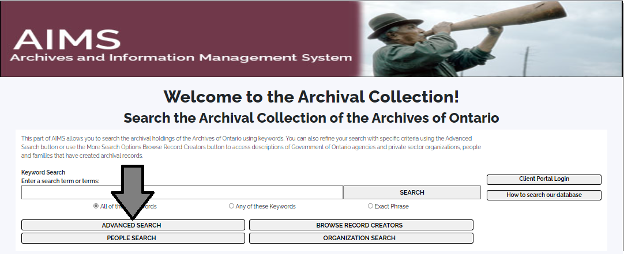

1. On the “Archives Advanced Search” page enter the reference code (that’s the number starting with C, F or RG) in the Reference Code field and click “Search” (at the bottom of the page.

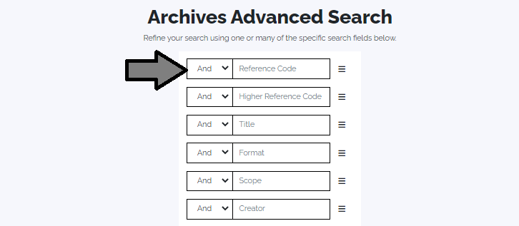

# Contact us

Although unable to do your research for you, our reference archivists are waiting to assist you.  You may telephone or write to them by mail or email or — best of all — visit the Archives of Ontario.

**Telephone:** 416-327-1600 **Toll free (Ontario):** 1-800-668-9933

**Email:** [Click here to email the Archives of Ontario](mailto:reference@ontario.ca).  The e-mail address is [reference@ontario.ca](mailto:reference@ontario.ca)

**Address:** Archives of Ontario, 134 Ian Macdonald Blvd., Toronto, ON M7A 2C5

**Website**

Visit our website for information about our collections and our services, our online exhibits and education programs, and links to our social media accounts. [Click here to visit our website](http://www.ontario.ca/archives).  The website is [www.ontario.ca/archives](http://www.ontario.ca/archives).

**Customer Service and Research Guides**

Our guides contain information about our services, freelance researchers available to do research for you, and some of most popular records.  [Click here to view our guides](http://www.archives.gov.on.ca/en/access/research_guides.aspx).  To find the “Research Guides and Tools” on our website, click on “Access our Collections”.

______________________________________________________________________

© King's Printer for Ontario, 2023

This information is provided as a public service.  Last update is shown at the beginning of this guide.  Readers should where possible verify the information before acting on it.