Lesson Resource Kit:
Black Canadian Migration Experiences
Grade 8: Creating Canada, 1850–1890,
Canada, 1890–1914: A Changing Society

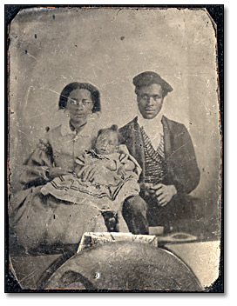
Unidentified Black family portrait
Alvin D. McCurdy fonds
Reference Code: F 2076-16-4-8
Archives of Ontario, I0024785

Introduction

Designed to fit into teachers’ practice, this resource kit provides links, activity suggestions, primary source handouts and worksheets to assist you and your students in applying, inquiring, and understanding Canada between 1850-1914.

Topic

Escape from slavery and establishment of the Black community in Ontario

Sources

- Click here to visit The Black Canadian Experience in Ontario 1834-1914 online exhibit
- Click here to visit the Images of Black History: Exploring the Alvin McCurdy Collection online exhibit
- Click here to visit the Letter of Tom Elice (Ellis) to Mary Warner online exhibit
Use the Archives of Ontario’s online exhibits on Black Canadian experiences:
- As a learning resource for yourself
- As sites to direct your students for inquiry projects
- As places to find and use primary sources related to the curriculum

Themes that can be addressed
- Use of Primary Sources
- The forced migration of African slaves to New France and British North America and the Abolition of Slavery Act of 1833
- The Underground Railroad and migration of former slaves to Ontario

Curriculum Links
Strand A. Creating Canada, 1850–1890
Overall Expectations | Historical Thinking Concepts | Specific Expectations
A1. Application: Colonial and Present-day Canada | Continuity and Change; Historical Perspective | A1.1, A1.2, A1.3
A2. Inquiry: From New France to British North America | Historical Perspective;  Historical Significance | A2.1, A2.2, A2.4, A2.5, A2.6
A3. Understanding Historical Context: Events and Their Consequences | Historical Significance;  Cause and Consequence | A3.4, A3.5

Strand B. Canada, 1890–1914: A Changing Society
Overall Expectations | Historical Thinking Concepts | Specific Expectations
B1. Application: Changes and Challenges | Continuity and Change;  Historical Perspective | B1.1, B1.2,
B2. Inquiry: Perspectives in British North Americans | Historical Perspective;  Historical Significance | B2.1, B2.2, B2.4, B2.5, B2.6
B3. Understanding Historical Context: Events and Their Consequence | Historical Significance;  Cause and Consequence | B3.1, B3.2, B3.4,

Assignment & Activity Ideas

Inquiring into Black Canadian Migration Experiences
- The historical inquiry process involves five steps:
- Formulating a question
- Gathering and organizing information or evidence
- Interpreting and analysing information or evidence
- Evaluating information or evidence and drawing conclusions
- Communicating findings
- The curriculum highlights that these steps do not have to be completed sequentially nor together. You may wish to explore specific steps based on your students’ readiness and prior knowledge or your own resources and time. See pages 22-24 in the 2013 revised Ontario Social Studies and History curriculum for more details by clicking here.
- Using a primary source handout from this kit, introduce your students to the topics of slavery and Black Canadian settlement in Canada. Ask students to ask questions of the primary source provided. Use these questions as a jumping off point to explore these historical topics in more depth.
- Click here to access the Black Canadian Experience in Ontario 1834-1914 online exhibit , click here to access the Images of Black History: Exploring the Alvin McCurdy Collection online exhibit, and click here to access the Letter of Tom Elice (Ellis) to Mary Warner online exhibit to use as a source to point your students for their own inquiry project. Here, they can view primary sources and secondary information to gather and organize historical information that they can interpret, evaluate, and communicate for different end products.

Creating First-Person Narratives with Research
- We have very few first-hand accounts of slavery from the words of the people who were enslaved. We can encourage our students to research and imagine the words of those who were enslaved from the primary source left behind.
- For example, using the Excerpt from the Emancipation Papers of Susan Holton (1848) or the photograph of Levi Veney (1898) in this kit, your students can create backstories for people who words are lost to history
  - Using these two primary sources as inspiration, have your students do research on the history of slavery, the Underground Railroad, and Canadian settlement and create a back story for these two individuals
- Have them write diary entries for major points of their life or create a graphic narrative highlighting these major points in their life. You can use the Graphic Narrative Cells handout in this kit to support you in this task.

Exploring Primary Sources at Different Archives
- Give your students a chance to review the Canadian primary sources that we have made available in this Kit and on the online exhibits. Click here to access the exhibit for the Black Canadian Experience in Ontario 1834-1914, click here to access the Images of Black History: Exploring the Alvin McCurdy Collection online exhibit, and click here to access the Letter of Tom Elice (Ellis) to Mary Warner online exhibit.
- Have a discussion about the primary sources and what your students find useful about them for learning more about history of slavery, the Underground Railroad, and Canadian settlement. Create a list of criteria about what makes a useful primary source for studying history.
- As a class, generate a list of questions your students have about this topic and, based on the criteria you created, have students identify what other primary sources they may want or need for learning about these topics.
- For homework or in a computer lab period, have students explore other archives and the primary sources they have. Each student chose one primary source to bring to class that fits the criteria you developed as a class. If a student likes a primary source that doesn’t fit the criteria, ask them to modify the criteria to account for their primary source.
- Following this exploration, see if students can answer their predetermined questions using the class set of primary sources.

Letters in Response
- Give your student the Letter from Tom Elice to Mary Warner (1854) and S. Wickham’s Warning of Slave-Catchers in the United States (1850) handouts.
- Have your students to a Think-Pair-Share about the contents of the letters and the implications of what they letters are discussing.
- Have your students write a response letter to Tom or S. Wickham asking for clarification, and describing their own (fictionalized) situation.

Writing for the Voice of the Fugitive
- The Provincial Freeman and The Voice of the Fugitive were important publications for spreading information and community-building.
- Give your students these primary sources to examine and discuss the possible content that would be featured in these newspapers.
- Based on research they completed on history of slavery, the Underground Railroad, and Canadian settlement, ask your students to write a featured article for the Voice of the Fugitive. Use the Writing for the Voice of the Fugitive as a worksheet.

Handouts & Worksheets
Introduction to Primary Sources 7
Excerpt from the Emancipation Papers of Susan Holton (1848) 8
Voice of the Fugitive (1851) 9
Voice of the Fugitive – Introduction (1851) 10
The Provincial Freeman (1853) 11
The Provincial Freeman – The Duties of Colored Men in Canada (1857) 12
Levi Veney (1898) 13
Map of Canada West (1855) 14
Letter from Tom Elice to Mary Warner (1854) 15
S. Wickham’s Warning of Slave-Catchers in the United States (1850) 16
An Act for the Abolition of Slavery throughout the British Colonies (1833) 17
Remains of Old Mission House (1895) 18
Graphic Narrative Cells 19
Writing for the Voice of the Fugitive 20
Organizing Your Thoughts 21

Introduction to Primary Sources
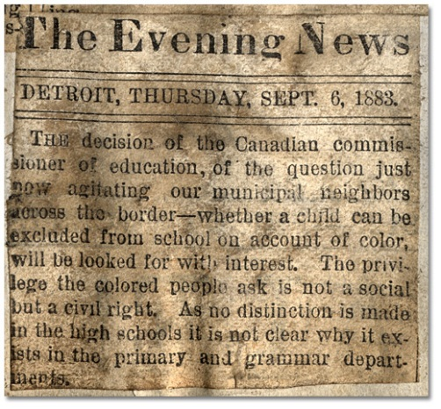
The Evening News of Detroit reported on the Dunn segregated schooling case, September 6, 1833
Alvin D. McCurdy fonds
Reference Code: F 2076-14-0-3, page 18
Archives of Ontario
A primary source is a document or object from the past created by people who lived during that time. Primary sources provide a view into an event or experience that only people living during that time could have experienced.
Archives collect and preserve primary sources so that students can learn history from the experiences of people who were there. At an archive, primary sources are called records. At a museum, primary sources are called artifacts.
Have you ever used a primary source before?
Primary Sources | Secondary Sources
Original material from the past | Material people today write about the past
Example:  Letters  Diaries  Photographs  Paintings and other art work  Graphs  Maps | Example:  Textbooks  Reference books  Websites such as Wikipedia  Current news articles  Documentaries and films
What are some other examples of primary and secondary sources?
Can sources be both primary and secondary?

Excerpt from the Emancipation Papers of Susan Holton (1848)
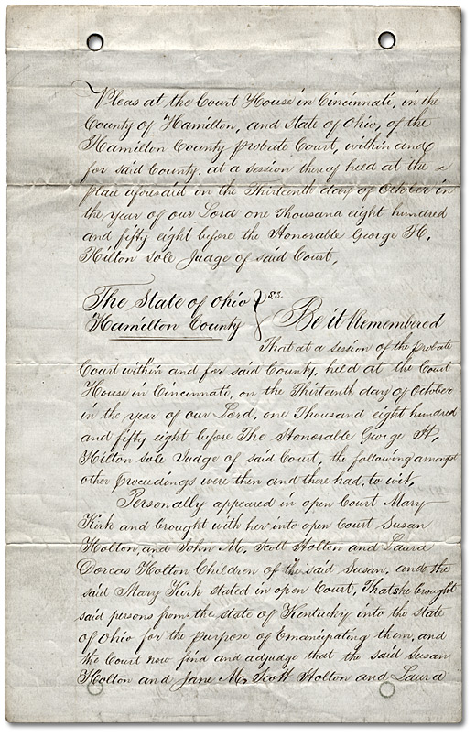
Excerpt from the emancipation papers of Susan Holton, Ohio, 1848
Reference Code: F 2076-1-0-15
Archives of Ontario

Voice of the Fugitive (1851)
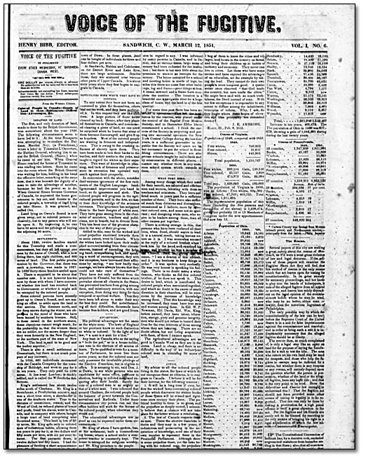
Voice of the Fugitive, March 12, 1851
Alvin D. McCurdy fonds, Reference Code: F 2076-16-9-35
Archives of Ontario

Voice of the Fugitive – Introduction (1851)
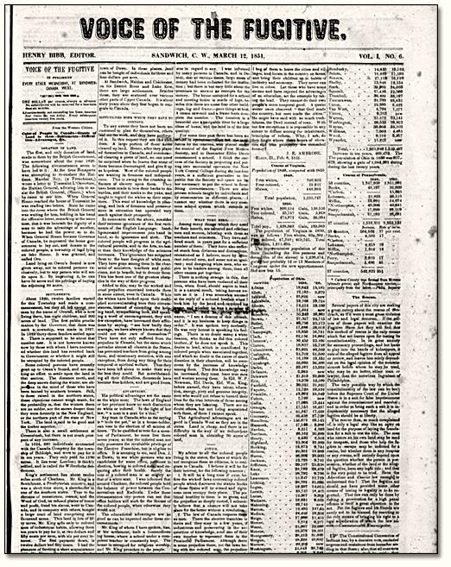
Transcription from March 12, 1851
In introducing the Voice of the Fugitive to its patrons, the rules of propriety, as well as a long established custom, make it our duty to set forth some avowal of the principles by which we shall be governed in its editorial management…
We expect... to advocate the cause of human liberty in the true meaning of that term. We shall advocate the immediate and unconditional abolition of chattel slavery everywhere, but especially on American soil. We shall also persuade... every oppressed person of color in the United States to settle in Canada, where the laws make no distinction among men, based on completion, and upon whose soil “no slave can breathe”...

We shall oppose the annexation of Canada to the United States to the fullest extent of our ability, while that Government continues to tolerate the abominable system of human slavery.
We shall from time to time endeavor to lay before our readers the true condition of our people in Canada, of their hopes and prospects for the future - and while we intend this to be a mouth piece for the refugees, yet we mean to speak out our sentiments as a freeman upon all subjects that come within our sphere...

The Provincial Freeman (1853)
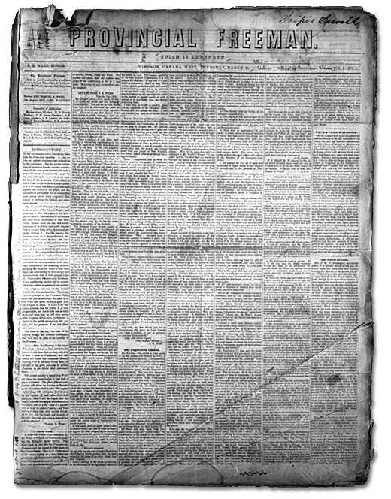
The Provincial Freeman, March 24, 1853
Microfilm Reel N 40
Archives of Ontario
Original held by Rare Book & Manuscript Library, University of Pennsylvania

The Provincial Freeman – The Duties of Colored Men in Canada (1857)
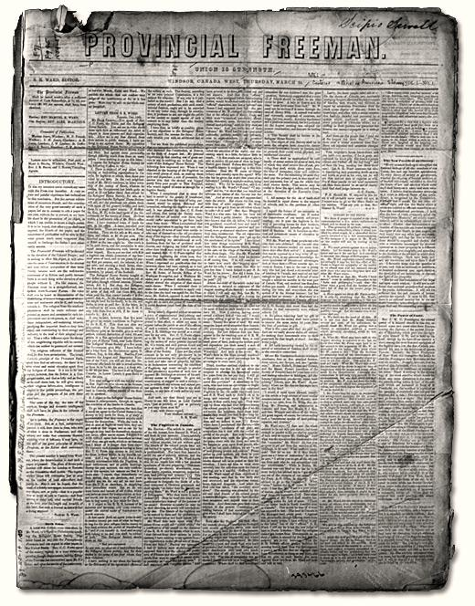
Transcription from April 25, 1857
What are the duties of colored men in these Provinces, who have been forced here from American despotism and oppression? We shall answer this question as frankly and at the same time, as sincere (sic) as we think its importance demands. Well then! we live in a government that knows no caste in its political organization. All men stand on the broad platform of equality before the laws, and are alike cared for by Her Majesty's government. It is as true now as it was when Curran spoke those immortal words.
No matter what complexion incompatible with Liberty, an Indian or an African man may have burnt upon him, the moment he sets his foot upon British soil he is free.
...From this pleasing picture we turn to its contrast, the Republican government of the United States.
And what are its recent decisions upon questions involving the liberty of her entire colored population. Why? that none but white men were intended to be recognized as citizens in the political structure of the government. That negroes constitute the exceptions; that they have no rights under her laws; are aliens and outcasts on her shores...We owe everything to the country of our adoption and nothing to that miserable, contemptible, despotism the government of the United States.

Levi Veney (1898)
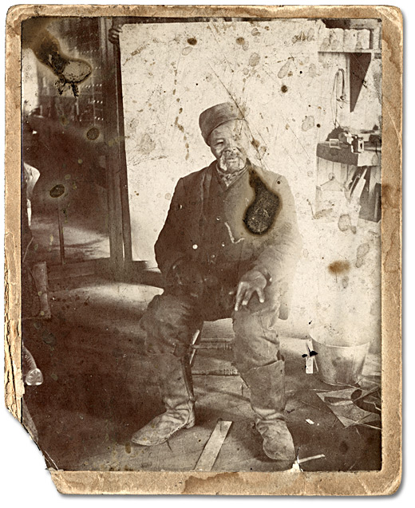
Levi Veney, ex-slave who lived in Amherstburg, taken at J. D. Burkes’ store, 1898
Alvin D. McCurdy fonds
Reference Code: F 2076-16-3-5
Archives of Ontario, I0024830

Map of Canada West showing the principal stations of the free colored population (1855)
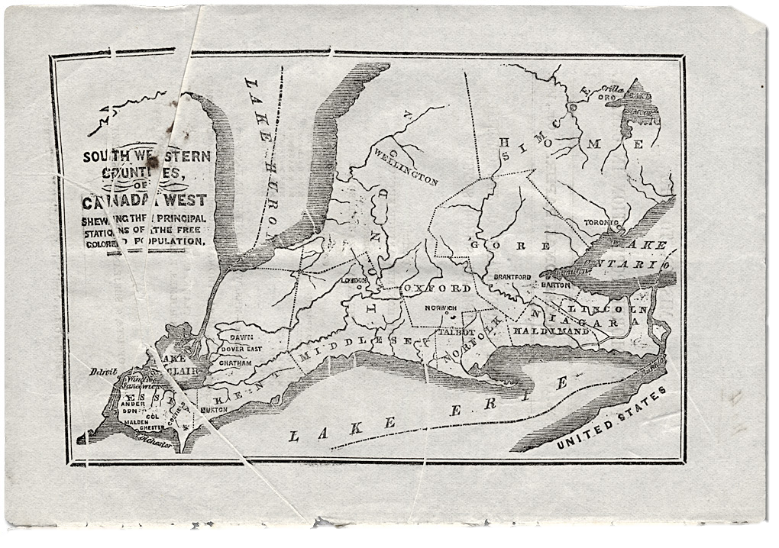
Southwestern Counties of Canada West showing the principal stations of the free colored population, 1855
Reference Code: Pamphlet no. 41
Archives of Ontario

Letter from Tom Elice to Mary Warner (1854)
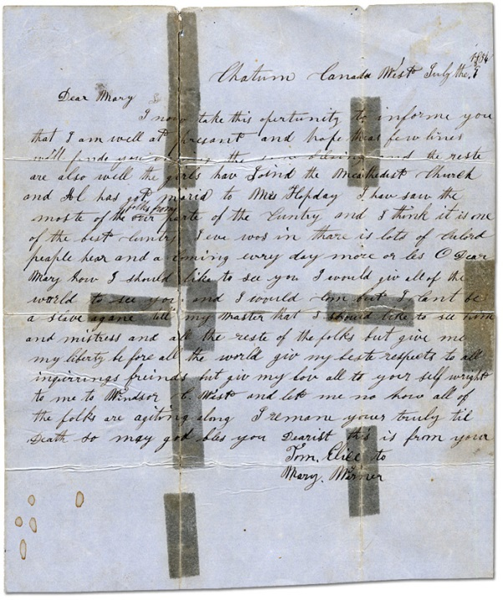
Letter from Tom Elice to Mary Warner dated July 9, 1854
Reference Code: F 4536
Archives of Ontario, I0029559

Transcription (edited for clarity):
Chatum Canada West July the 9 1854
Dear Mary,
I now take this opportunity to inform you that I am well at present and hope these few lines will find you and the rest are also well. The girls have joined the Methodist Church and Al has gotten married to Mrs Hopday. I have saw the most of the folks from our part of the country and I think it is one of the best country I ever was in. There is lots of coloured people here and coming every day more or less. O Dear Mary how I should like to see you. I would give the entire world to see you and I would come but I can’t be a slave agent tell my master that I should like to see him and mistress and all the rest of the folks. But give me my liberty before all the world. Give my best respects to all inquiring friends but give my love all to yourself. Write to me in Windsor, Canada West and let me know how all of the folks are getting along. I remain your truly till Death, so may God bless you Dearest, this is from your
Tom Elice to
Mary Warner

S. Wickham’s Warning of Slave-Catchers in the United States (1850)
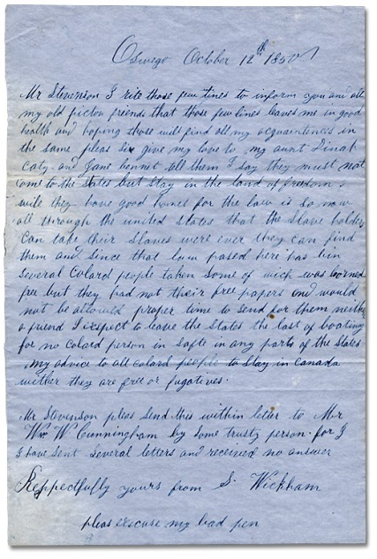
Letter dated Oct. 12, 1850 from S. Wickham
D. B. Stevenson fonds
Reference Code: F 499 MU 2885
Archives of Ontario
Transcription (edited for clarity):
Oswego, October 12th 1850
Mr Stevenson, I write these few lines to inform you and all my old picton friends that these few lines leaves me in good health and hoping these will find all my acquaintances in the same. Please sir, give my love to my Aunt Dinah Caty and Jane Bennet. Tell them I say they must not come to the States but stay in the land of freedom while they have good homes, for the law is so now all through the United States that the slave holders can take their slaves were ever they can find them, and since that law passed here there has been several colored people taken some of which was borne free but they had not their free papers and would not be allowed proper time to send for them. Neither a friend I expect to leave the States the last for no colored person is safe in any part of the States. My advice to all colored people to stay in Canada wither they are free or fugitives.
Mr Stevenson, please send this within letter to Mr William W. Cunningham by some trusty person for I have sent several letters and received no answer.
Respectfully yours from S. Wickham
Please excuse my bad pen

An Act for the Abolition of Slavery throughout the British Colonies (1833)

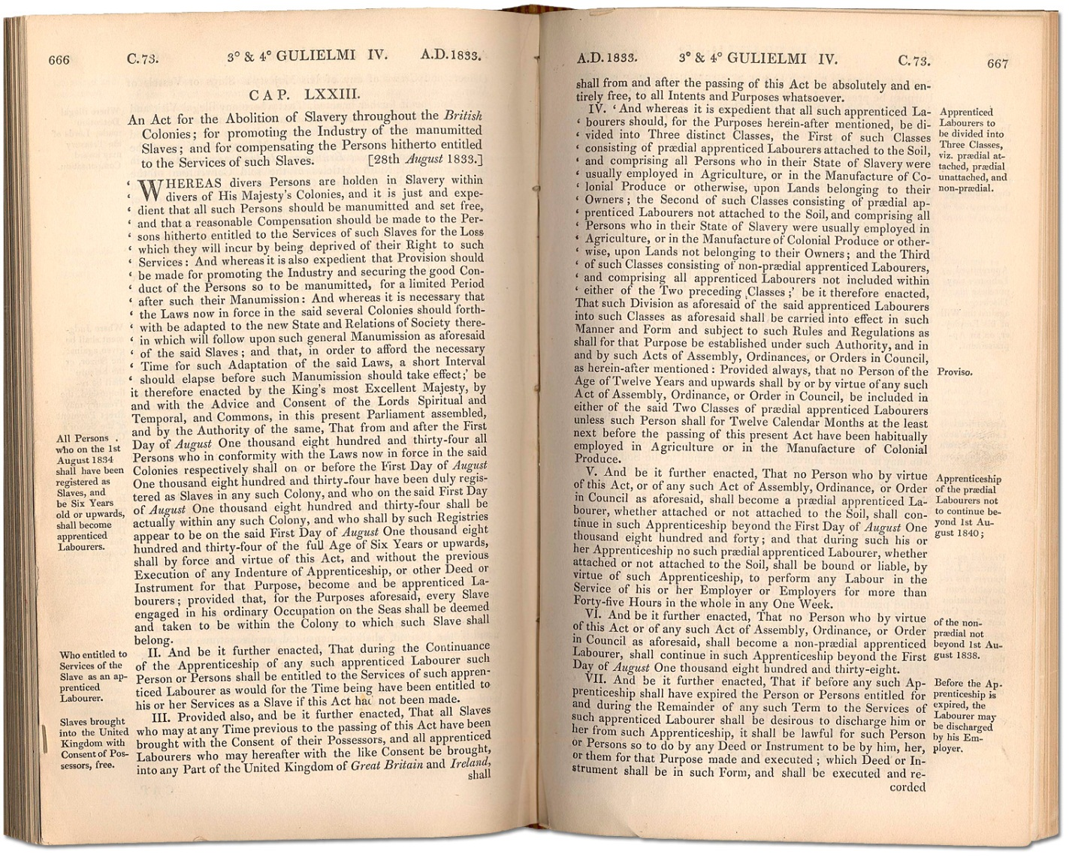
1833 British Imperial Act Passed in 1833
Courtesy of Parliamentary Archives, U. K

Remains of Old Mission House (1895)
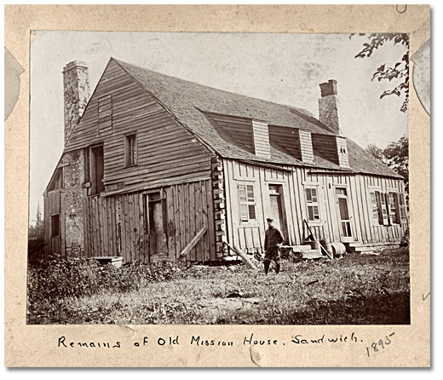
Remains of Old Mission House, Sandwich, 1895
Alvin D. McCurdy fonds, Reference Code: F 2076, Box D-4
Archives of Ontario, I0027877

Graphic Narrative Cells
Title: _________________________________________________________________
By:___________________________________________________________________
Comic Strip blank cells | Comic Strip blank cells
Comic Strip blank cells | Comic Strip blank cells

Writing for the Voice of the Fugitive

Organizing Your Thoughts
What you know

What you want to know

What you are going to research

