# Diary of a World War I Soldier

Grade 10: Canadian History since World War I

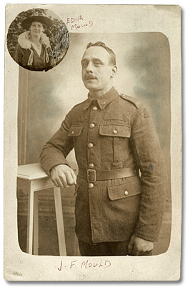

## Overview

All of the Archives of Ontario lesson plans have two components:

* The first component introduces students to the concept of an archive and why the Archives of Ontario is an important resource for learning history
* The second component is content-based and focuses on the critical exploration of a historical topic that fits with the Ontario History and Social Studies Curriculum for grades 3 to 12. This plan is specifically designed to align with the Grade 10: Canadian History Since World War I curricula.

We have provided archival material and an activity for you to do in your classroom. You can do these lessons as outlined or modify them to suit your needs. Feedback or suggestions for other lesson plans are welcome.

**In this plan**, students will take notes from the on-line exhibit featuring the diaries of First World War veteran John Mould, a British immigrant who served with the 2nd Canadian Expeditionary Force, to create a dramatic presentation about life during and after World War I. Students will use research, analytic, and communication skills to respond to the question: what was life like during World War I and how did soldiers remember it?

## Curriculum Connections

**Overall Expectations – Academic (CHC2D)**

Communities: Local, National, and Global

* explain how local, national, and global influences have helped shape Canadian identity;
* analyse the impact of external forces and events on Canada and its policies since 1914;
* assess Canada’s participation in war and contributions to peacekeeping and security.

Citizenship and Heritage

* assess how individual Canadians have contributed to the development of Canada and the country’s emerging sense of identity.

Methods of Historical Inquiry and Communication

* formulate questions on topics and issues in the history of Canada since 1914, and use appropriate methods of historical research to locate, gather, evaluate, and organize relevant information from a variety of sources;
* interpret and analyse information gathered through research, employing concepts and approaches appropriate to historical inquiry;
* communicate the results of historical inquiries, using appropriate terms and concepts and a variety of forms of communication.

**Overall Expectations – Applied (CHC2P)**

Communities: Local, National, and Global

* describe some of the major local, national, and global forces and events that have influenced Canada’s policies and Canadian identity since 1914;
* evaluate Canada’s participation in war and contributions to peacekeeping and security.

Citizenship and Heritage

* describe how individual Canadians have contributed to the development of Canada and its emerging sense of identity.

Methods of Historical Inquiry and Communication

* formulate questions on topics and issues in the history of Canada since 1914, and use appropriate methods of historical research to locate, gather, evaluate, and organize relevant information from a variety of sources;
* interpret and analyse information gathered through research, employing concepts and approaches appropriate to historical inquiry;
* communicate the results of historical inquiries, using appropriate terms and concepts and a variety of forms of communication.

## Getting Organized

To prepare for this lesson, you can:

* Book a computer lab for students to research material for their skit
* Make overheads or create a PowerPoint with the introductory information found on: **Overhead 1: Exploration Through the Archives, Overhead 2: Research Question**, and Overhead 3: Scenarios
* Print out and make individual copies of **Student Worksheet: Diary of a World War I Soldier – Notes page and Student Worksheet: Diary of a World War I Soldier – Personal Reflection**. Print out and make one copy per group of **Student Worksheet: Diary of a World War I Soldier – Presentation Summary**.

## Lesson Plan

* This lesson is planned for a three to four class arc, however it can be lengthened or shortened based on your students’ needs.
* Begin by introducing the concept of an archive and how the Archives of Ontario can help answer research questions related to history.
* See **Overhead 1: Exploration Through the Archives** to introduce this to your students and the following text to prepare yourself:

Over the course of a lifetime, most people accumulate a variety of records. It starts with a birth certificate and expands into awards, bank statements, receipts, letters, photographs – anything that documents important events and relationships in one’s life. These records comprise an individual’s personal archives. Governments, businesses, schools, associations and organizations of all types do the same, keeping records as evidence of their activities and accomplishments.

These documents provide a fascinating view into the past. Like a detective investigating a case, a researcher using these records can get a sense of what a place looked like, what people were thinking, what life was like, and what happened and why. Anyone with an interest in the past, whether it is delving into local history, tracing a family tree, or probing decisions and events, will find answers in archives.

Some examples are:

* letters, manuscripts, diaries often from famous people
* notes or recordings of interviews
* photographs, sketches and paintings
* birth, death and marriage records
* land registries, titles to property, and maps
* court records
* audio, video and film records

Archives are important resources for answering our questions about the past. Records may be used to settle legal claims, they may clarify family history, they are grist for historians, and they impart to filmmakers and authors a sense of the ways things were. Whatever the reason, archives have a story to tell.

The first step is to identify your research question and what you are hoping to find in the Archives to provide support to that question

* Following this introduction, use **Overhead 2: Research Question** to introduce the lesson’s research question, the archival collection that the class will be using to answer this question, and the directions for the activity.
* Find attached the primary sources, handouts, and rubric for facilitating this activity.
* Students should be organized into no more than seven groups and each group should be assigned one of the seven scenarios listed on **Overhead 3: Scenarios.**
* In the computer lab, students should explore **The Story of an Ontario Veteran - Excerpts from the John Mould Diaries** online exhibit found on the Archives of Ontario's website and take notes on the **Student Worksheet: Diary of a World War I Soldier – Notes page** related to the topic of their particular scenario. Encourage students to look through the whole exhibit so that their scenario can reflect on other aspects of Mould’s life.
* In the following class, students should transform their notes into a small dramatic presentation using **Student Worksheet: Diary of a World War I Soldier – Presentation Summary** to organize what and how they will present. Encourage students to use props (for example the letters and pictures found in the online exhibit) and costumes to fully immerse themselves in the task
* Depending on the amount of preparation time your students need or want, schedule the presentations for the next class. Encourage students to create a personal reflection of the activity and their learning by using **Student Worksheet: Diary of a World War I Soldier – Personal Reflection** after theirs and their peers’ presentations

## Extension/Accommodation

* The elements of this assignment can be rearranged for a different deliverable. Students can be asked to write an essay, make a timeline collage, or create a comic strip that explores the seven scenarios
* Resources for the skits can be researched at home by the students or printed out ahead of time by you
* Commit to the skits! Ask students to create a tableau that summarizes their scenario and take a picture to send Archives!

# Handouts & Worksheets

Overhead 1: Exploration Through the Archives………………………………....……….……5

Overhead 2: Research Question…………………………………………………..…………...6

Overhead 3: Scenarios………………………………………………………………...………...7

Student Worksheet: Diary of a World War I Soldier – Notes page 10

Student Worksheet: Diary of a World War I Soldier – Presentation Summary 11

Student Worksheet: Diary of a World War I Soldier – Personal Reflection 12

Marking Rubric 14

### Exploration through the Archives

Over the course of a lifetime, most people accumulate a variety of records.

Taken together, these records can provide a fascinating view into someone’s life and into the past.

Like a detective investigating a case, a researcher using these records can get a sense of what a place looked like, what people were thinking, what life was like, and what happened and why.

Some examples of records that a historian may look at are:

* birth, death, and marriage records
* letters or diaries
* photographs, sketches, and paintings
* court records
* audio, video and film records

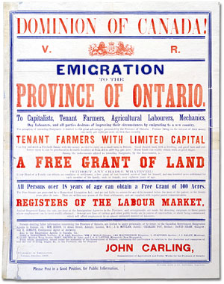A picture of a solider with the motivational quote below saying "Make us as proud of you as we are of him!"
Archives of Ontario
I0016379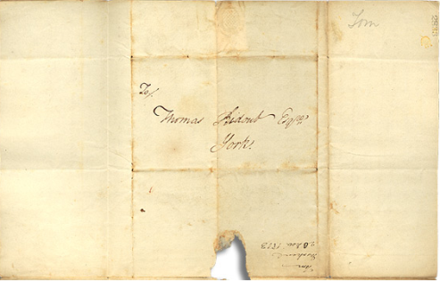

An **archive** is a place where these records and historical documents are preserved. The **Archives of Ontario** collects and preserves records with relevance to the history of Ontario.

Using primary sources from the Archives of Ontario’s collections, you too can be an investigator exploring the past and understanding the present.

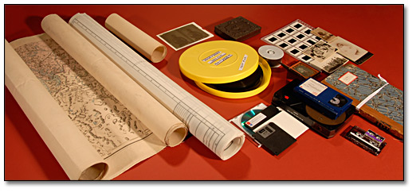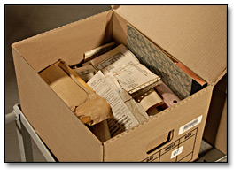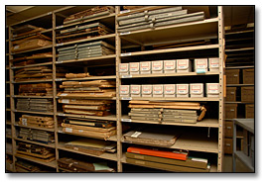

### Diary of a World War I Soldier

To begin using the records found at an archive, it is best to begin with a research question that can guide your search.

For this lesson, your research question could be:

**What were experiences of a World War I solider during and after the war?**

The Archives of Ontario have identified a “fond” or record collection, to help you answer that question. Today you’ll be working with **The John Mould fonds**.



**Directions**

1. With your group, pick one of the possible seven scenarios.
2. Research John Mould’s experiences during World War I on the Archives of Ontario’s website.
3. Prepare a small skit to present to the class

### Diary of a World War I Soldier - Scenarios

| A group of troops gather in front of Government Building, C.N.E. (Canadian National Exhibition), Toronto | **Joining Up**  Convincing his wife to co-sign his enlistment papers and his departure from home.  The endless drills of basic training at Toronto’s Exhibition Grounds.  Disembarking by ship to a welcome from cheering crowds of well-wishers.  Rest camp in France, which featured hot baths and the distant sound of battle. |
| --- | --- |
|  | **The Battle of the Somme**  Marching through Courcelette en route to the front line past hundreds of dead soldiers lying beside the road.  Leaving the safety of the trenches and entering No Man’s Land. |
| A photograph of a group of three statues at the Vimy Memorial in France. | **Return to Vimy**  The return to the battlefields 18 years after the war to listen to King Edward VIII commemorating the sacrifices made by the Canadian soldiers. |

### Student Worksheet: Diary of a World War I Soldier Notes page

Looking at *The Story of an Ontario Veteran – Excerpts from the John Mould Diaries* online exhibit found on the Archives of Ontario’s website, take notes to inform your skit.

**Scenario**: _____________________________________________________________

**Interesting Ideas:**

| **Source** | **Notes** | **Direct Quotes** |
| --- | --- | --- |
|  |  |  |
|  |  |  |
|  |  |  |
|  |  |  |
|  |  |  |
|  |  |  |

**Other Notes:**

### Student Worksheet: Diary of a World War I Soldier Presentation Summary

Based on the notes your took while looking at the The Story of an Ontario Veteran – Excerpts from the John Mould Diaries online exhibit found on the Archives of Ontario’s website, create a skit for your group to present to the class. Use this sheet to summarize your work.

Be clear about the sources you are using and note what is imagined and what is taken from the primary sources. Hand this sheet in at the end of the period.

| **Scenario**: |
| --- |
| **People In the Scene:** |
| **Setting:** |
| **Props or Costumes needed**: |
| **Sources Used:** |
| **Outline:** |
| **What do I want people to take away from our presentation?** |

### Student Worksheet: Diary of a World War I Soldier

### Personal Reflection

While watching your classmates present, take notes about their skit: how they chose to interpret their scenario, what you learnt from it, what sources they used to tell their story, and what further questions you have.

Following all the skits, reflect on how your group communicated your scenario:

| **Scenario /**  **Summary** | **What did you learn?** | **What do you have questions about** | **Sources used** |
| --- | --- | --- | --- |
|  |  |  |  |
|  |  |  |  |
|  |  |  |  |
|  |  |  |  |
|  |  |  |  |
|  |  |  |  |

**Our Presentation:**

What did we do?

What did we want people to learn from our presentation?

Did we succeed in communicating these objectives?

We could have done better by:

### Marking Rubric

| **Criteria** | **Level 1** | **Level 2** | **Level 3** | **Level 4** |
| --- | --- | --- | --- | --- |
| Knowledge and Understanding  Interpret and communicate ideas and feelings drawn from primary and secondary sources | Demonstrates a limited understanding of the elements of drama and the historical details from the research. | Demonstrates some understanding of the elements of drama and the historical details from the research. | Demonstrates a considerable understanding of the elements of drama and the historical details from the research. | Demonstrates a thorough understanding of the elements of drama and the historical details from the research. |
| Thinking/Inquiry  Write in role in various forms, showing understanding of the complexity of a dramatic situation. | Analyzes and uses primary source material for the drama sequence with limited effectiveness. | Analyzes and uses primary source material for the drama sequence with some effectiveness. | Analyzes and uses primary source material for the drama sequence with considerable effectiveness. | Analyzes and uses primary source material for the drama sequence with a high degree of effectiveness. |
| Communication  Create drama pieces, selecting and using a variety of techniques. | Creates with limited effectiveness, a drama composition based on the themes and issues explored | Creates with some effectiveness, a drama composition based on the themes and issues explored | Creates with considerable effectiveness, a drama composition based on the themes and issues explored | Creates with a high degree of effectiveness, a drama composition based on the themes and issues explored |
| Application  Dramatize material that they have researched from primary sources, and use it effectively in presenting scenes | Presents a drama sequence based on improvisational work and primary sources with limited effectiveness and insight. | Presents a drama sequence based on improvisational work and primary sources with some effectiveness and insight. | Presents a drama sequence based on improvisational work and primary sources with considerable effectiveness and insight. | Presents a drama sequence based on improvisational work and primary sources with a high degree of effectiveness and insight. |