The War of 1812: Interpreting Evidence

Grade 7: British North America

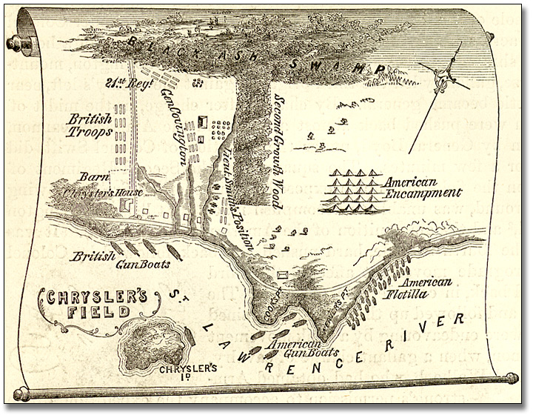
Overview
All of the Archives of Ontario lesson plans have two components:
- The first component introduces students to the concept of an archive and why the Archives of Ontario is an important resource for learning history
- The second component is content-based and focuses on the critical exploration of a historical topic that fits with the Ontario History and Social Studies Curriculum for grades 3 to 12. This plan is specifically designed to align with the Grade 7: British North America curricula.
We have provided archival material and an activity for you to do in your classroom. You can do this lesson as outlined or modify it to suit your needs. Feedback or suggestions for other lesson plans are welcome.
In this two-part lesson, students will interpret primary and secondary sources to learn more about a specific battle and then apply these skills to learning about another battle of their choice.
A computer lab will be needed for the second part of the lesson unless you print off the needed documents from the website ahead of time

Curriculum Connections
This plan meets the following expectations for Grade 7: British North America:
Overall Expectations
- Explain and outline the causes, events, and results of the War of 1812
- Identify some themes and personalities from the period, and explain their relevance to contemporary Canada
Specific Expectations
Knowledge and Understanding
- Describe the major causes and personalities of the War of 1812;
- Identify the achievements and contributions of significant people
Inquiry/Research and Communication Skills
- Formulate questions to facilitate research on specific topics
- Analyse, synthesize, and evaluate historical information
- Construct and use a wide variety of graphs, charts, diagrams, maps, and models to organize and interpret information
- Communicate the results of inquiries for specific purposes and audiences, using media works, oral presentations, written notes and reports, drawings, tables, charts, and graphs
- Use appropriate vocabulary to describe their inquiries and observations.

Getting Organized
To prepare for this lesson, you can:
- Make overheads or create a PowerPoint with the introductory information found on Overhead 1: Exploration Through the Archives!
- Print out a set of primary sources for each student or for each group of students
- Print out copies of the Interpreting Evidence and Reflection handouts and the Examining Evidence handout for the following class
- Book a computer lab or print out materials from the Archives of Ontario’s online exhibit on the War of 1812 for the Class 2 period

Directions
Class 1
- Introduce the War of 1812 and determine what questions the students would like to ask about the various battles. As a class or individually have the students use a W5H strategy to formulate questions that could be used to focus on one of the battles.
      - Following this activity, introduce the concept of an archive and how it can help answer the research questions the students drafted. See Overhead 1: Exploration through the Archives! to introduce this to your students and the following text to prepare yourself:
Over the course of a lifetime, most people accumulate a variety of records. It starts with a birth certificate and expands into awards, bank statements, receipts, letters, photographs – anything that documents important events and relationships in one’s life. These records comprise an individual’s personal archive. Governments, businesses, schools, associations and organizations of all types do the same, keeping records as evidence of their activities and accomplishments.
These documents provide a fascinating view into the past. Like a detective investigating a case, a researcher using these records can get a sense of what a place looked like, what people were thinking, what life was like, and what happened and why. Anyone with an interest in the past, whether it is delving into local history, tracing a family tree, or probing decisions and events, will find answers in archives.
Some examples are:
- letters, manuscripts, diaries often from famous people
- notes or recordings of interviews
- photographs, sketches and paintings
- birth, death and marriage records
- land registries, titles to property, and maps
- court records
- architectural plans and engineering drawings
- audio, video and film records
Archives are important resources for answering our questions about the past. Records may be used to settle legal claims, they may clarify family history, they are grist for historians, and they impart to filmmakers and authors a sense of the ways things were. Whatever the reason, archives have a story to tell.
The first step is to identify your research question and what you are hoping to find in the Archives to provide support to that question.
      - Following this introduction, discuss how you will be using archival material to answer the questions you have formulated about the War of 1812.
      - With a copy of the four primary sources provided, encourage students to use Student Handout: Interpreting Evidence to take notes related to their research question. Emphasize the importance of referencing the material they are using.
      - After discussing the results of their research, ask students to fill out the Student Handout: Reflecting on Interpreting Evidence to reflect on their learning
Class 2
- In class 2, students will use the skills they developed in the previous class to research another battle in the War of 1812
- Book a computer lab or print out materials from the Archives of Ontario’s online exhibit on the War of 1812
- You will notice that under “Battlegrounds” four geographic areas are identified: Detroit Frontier, Niagara Frontier and York, Kingston and the St. Lawrence, and The War Beyond Upper Canada. It is here where students will be able to find the battles they can use to complete the next part of the assignment. You may want to encourage students to concentrate on the higher profile battles such as the Battle of Queenston Heights (Death of General Brock), the Battle of Lundy’s Lane, the Battle of Beaver Dams (Laura Secord), the burning of York, the Battle of Bladensburg (burning of the White House) and the Battle of New Orleans.
- Using the handout Student Handout: Interpreting Evidence, Battle of ______ to assist students in the task of researching one of the battles using sources from the on-line exhibit and at least one or two other sources. The Canadian Encyclopedia at http://www.thecanadianencyclopedia.com is a good source of secondary information.
- Once their research is complete, have the students prepare a presentation that could be submitted for assessment or presented to the class. The finished product could be a written or oral eyewitness account of the battle by a soldier or a reporter and should include an explanation of why the battle was significant.

Extension/Accommodation
Lesson can be abbreviated to one class with a specific battle of your choice. This battle could reflect the local area and fit the Specific Expectation of “Illustrating the historical development of their local community.”
Students could work in small, preformed groups for each part of the activity to mix visual learners with textual learners and strong readers with progressing readers.
All student research could be mapped on a large class map to create their own exhibit of War of 1812 battles.

Resources
Overhead: Exploration Through the Archives!..................………………………………….5
Student Handout: Interpreting Evidence 6
Source 1: Map of the Chrysler’s Field, 1869 8
Source 2: Letter from Nathan Ford to his brother David Ford 9
Source 3: Letter from Thomas G. Ridout to his father Thomas Ridout 10
Source 4: “Chrysler’s Farm” 11
Student Handout: Reflecting on Interpreting Evidence 12
Student Handout: Examining the Evidence 13
Rubric: Presentation Evaluation 15

Exploration through the Archives!
Overhead 1

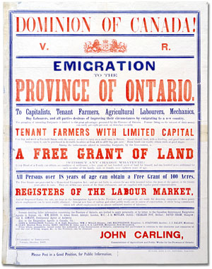
Over the course of a lifetime, most people accumulate a variety of records.
Taken together, these records can provide a fascinating view into someone’s life and into the past.
Like a detective investigating a case, a researcher using these records can get a sense of what a place looked like, what people were thinking, what life was like, and what happened and why.
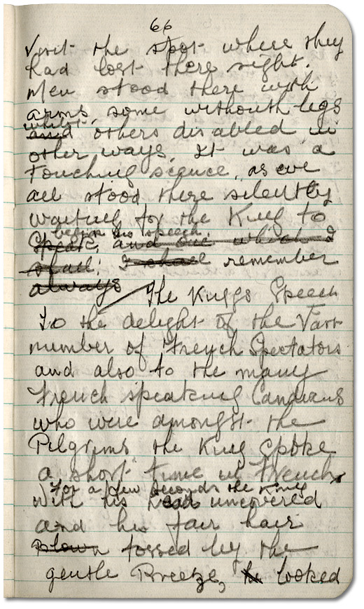
Some examples of records that a historian may look at are:
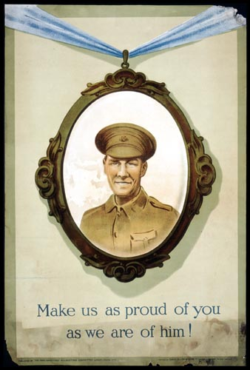
- birth, death, and marriage records
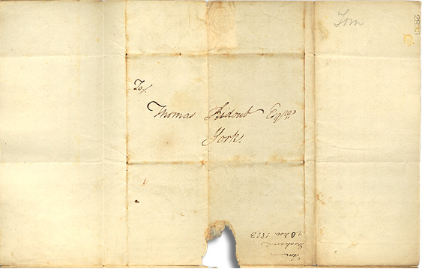
- letters or diaries
- photographs, sketches, and paintings
- court records
- audio, video and film records

An archive is a place where these records and historical documents are preserved. The Archives of Ontario collects and preserves records with relevance to the history of Ontario.
Using primary sources from the Archives of Ontario’s collections, you too can be an investigator exploring the past and understanding the present.
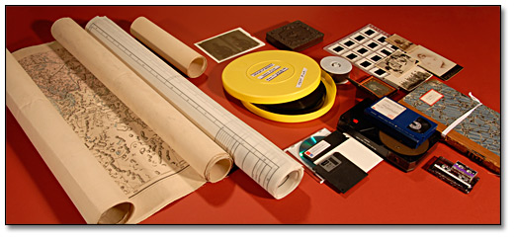
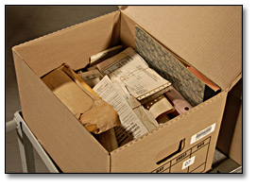
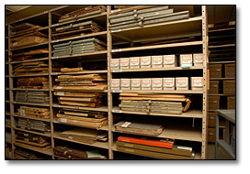

Student Handout: Interpreting Evidence
Examine each of the provided research sources and answer the questions in the chart.

Source 1: |  | Reference Information:  (eg. Reference code)
Is this a primary or secondary source? | Who created it? |  | When was it created?
Why do you think it was created? For whom was it created?

What point of view/side does the creator represent?
What does this source tell us about this battle at Chrysler’s Farm?

What does it not tell us? What questions do you still have about the battle?

Source 2: |  | Reference Information:  (eg. Reference code)
Is this a primary or secondary source? | Who created it? |  | When was it created?
Why do you think it was created? For whom was it created?

What point of view/side does the creator represent?
What does this source tell us about this battle at Chrysler’s Farm?

What does it not tell us? What questions do you still have about the battle?

Source 3: |  | Reference Information:  (eg. Reference code)
Is this a primary or secondary source? | Who created it? |  | When was it created?
Why do you think it was created? For whom was it created?

What point of view/side does the creator represent?
What does this source tell us about this battle at Chrysler’s Farm?

What does it not tell us? What questions do you still have about the battle?

Source 4: |  | Reference Information:  (eg. Reference code)
Is this a primary or secondary source? | Who created it? |  | When was it created?
Why do you think it was created? For whom was it created?

What point of view/side does the creator represent?
What does this source tell us about this battle at Chrysler’s Farm?

What does it not tell us? What questions do you still have about the battle?

Source 1:

Map of the Chrysler’s Field, 1869
The Pictorial Field-Book of the War of 1812
Benson J. Lossing
Reference Code: 971 .034 LOS, page 654
Archives of Ontario

Source 2:

Letter from Nathan Ford to his brother David Ford

November 13, 1813

Ford family fonds

Reference Code: F483, box MU 1054

Archives of Ontario
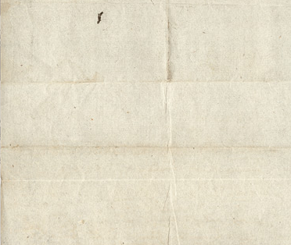
“Gen[era]l Boyd with 2500 men was ordered to disperse the pursuing army which Gen[era]l Wilkinson estimated at 900 men. Wilkinson with the raiders prepared to decend (sic) the Long Sault. Gen[era]l Boyd found the British drawn up in order of battle & the engagement lasted with obstinancy (sic) upon both sides for three hours & an half. When our troops gave way and retreated, our loss is stated by the officers to be 500 killed, wounded & missing.”
- Nathan Ford

Source 3:

Letter from Thomas G. Ridout to his father Thomas Ridout
November 20, 1813
Thomas Ridout family fonds
Reference Code: F 43, box MU 2390

Archives of Ontario
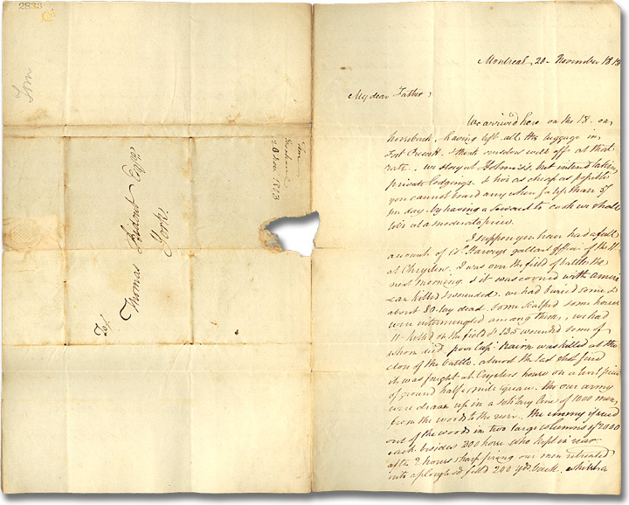

“My dear father, … I suppose you have had a full account of Col. Harveys gallant affair of the 11 at Chrysler. I was on the field of battle the next morning & it was covered with American killed & wounded. We had buried some & about 80 lay dead, some scalped some horses were intermingled among them. We had 11 killed on the field and 135 wounded some of them whom died. Poor Capt. Naime was killed at the close of the battle almost the last shot fired. It was fought at Chryslers house on a burnt piece of ground half a mile square. Our army were drawn up in a solitary line of 1,000 men from the woods to the river. The enemy is send out of the woods in two large columns of 2,000 each besides 300 horses…” - Thomas G. Ridout

Source 4:

“Chrysler’s Farm”
Ronald J. Dale
Canadian Encyclopaedia
2009

The Battle of Chrysler’s Farm was fought in a farmer's field on the banks of the St Lawrence River near Morrisburg, Ont, on 11 November 1813. An American force under the command of Major General James Wilkinson had sailed down the St Lawrence River with plans to capture Montréal and thereby complete the conquest of Upper Canada. A small corps of British regulars, Mohawk warriors and Canadian militia under Lieutenant-Colonel Joseph Wanton Morrison of the 89th Regiment harassed the Americans as they moved downriver, forcing Wilkinson to land over 3000 men on the Canadian shore to attack Morrison's smaller force of 1169 men. | While the Canadian militia and Mohawk warriors guarded the woods on either side of John Chrysler's field, the British regulars were drawn up in 2 lines to await the American assault. The Americans attacked the British lines without success and were forced to retreat from the battlefield after suffering severe losses. Wilkinson continued down the St Lawrence with the remnant of his demoralized army but before reaching Montréal he learned of a similar defeat of American General Hampton’s army, at the Battle of Châteauguay a few weeks earlier. The Americans were forced to call off the attack on Montréal.

Student Handout: Reflecting on Interpreting Evidence
Reflect upon your learning using the questions provided.
- Why is it important to use more than one source when researching a topic?

- Why is it important to record the sources you use?

- What do you learn from primary sources that you don’t learn from secondary sources?

- When the Archives of Ontario provided extracts from their original documents they typed the text exactly as it was originally written (e.g. not correcting any spelling and grammar errors). How does this help us understand the event and time period?

- We use the W5H to help us focus our research. Go back over your research findings to determine if all of these types of questions were answered. Circle each type of question answered adequately.

Who? What? When? Where? Why? How?

- What other sources do you think you might search out to answer any unanswered questions and/or learn even more about the battle?

- Why was this battle significant (important) during the War of 1812? Is it still important today? Why?

Student Handout: Examining the Evidence
For the Battle of _________________________

Source 1: |  | Reference Information:  (eg. Reference code)
Is this a primary or secondary source? | Who created it? |  | When was it created?
Why do you think it was created? For whom was it created?

What point of view/side does the creator represent?
What does this source tell us about this battle at Chrysler’s Farm?

What does it not tell us? What questions do you still have about the battle?

Source 2: |  | Reference Information:  (eg. Reference code)
Is this a primary or secondary source? | Who created it? |  | When was it created?
Why do you think it was created? For whom was it created?

What point of view/side does the creator represent?
What does this source tell us about this battle at Chrysler’s Farm?

What does it not tell us? What questions do you still have about the battle?
Battle of _________________________

Source 3: |  | Reference Information:  (eg. Reference code)
Is this a primary or secondary source? | Who created it? |  | When was it created?
Why do you think it was created? For whom was it created?

What point of view/side does the creator represent?
What does this source tell us about this battle at Chrysler’s Farm?

What does it not tell us? What questions do you still have about the battle?

Source 4: |  | Reference Information:  (eg. Reference code)
Is this a primary or secondary source? | Who created it? |  | When was it created?
Why do you think it was created? For whom was it created?

What point of view/side does the creator represent?
What does this source tell us about this battle at Chrysler’s Farm?

What does it not tell us? What questions do you still have about the battle?

Rubric: Presentation Evaluation
1 – limited 2 – some 3 – good 4 – thorough, superior

Category | Level | Comments
Thinking  Demonstrates skills of inquiry and research  - uses and documents a variety of sources  - uses analysis, synthesis and evaluation  - presentation is organized and demonstrates planning  - presentation shows unity and coherence  - presentation includes one or more  connections/comparisons/conclusions about the significance of their battle | 1 2 3 4
Communication  Demonstrates through effective presentation a clear understanding of his/her topic | 1 2 3 4

