Lesson Resource Kit: Youth & Conflict in 1960s Toronto
Grade 10: Canada, 1945-1982
Albert Warson, “Rising Tensions and Conflict in the City Streets” page 5
Human Relations, vol. 9 no. 17, Apr-May 1969, pp. 3-6
Daniel G. Hill fonds
Reference Code: F 2130-2-1
Archives of Ontario

Introduction
Designed to fit into teachers’ practice, this resource kit provides links, activity suggestions, primary source handouts and worksheets to assist you and your students in applying, inquiring, and understanding Canada between 1945 and 1982.

Topic
- Youth and Ethnic Conflict in 1960s Toronto

Themes that can be addressed
- Racial discrimination
- The civil rights movement
- Social welfare programs
- Immigration
- Urbanization

Curriculum
Strand D. Canada, 1945-1982
Overall Expectations | Historical Thinking Concepts | Specific Expectations
D1. Social, Economic, and Political Context | Historical Significance;  Historical Perspective | D1.1, D1.4, D1.5
D2. Communities, Conflict, and Cooperation | Historical Significance; Cause and Consequence | D2.1, D2.2
D3. Identity, Citizenship, and Heritage | Continuity and Change; Historical Perspective | D3.1, D3.6

Assignment & Activity Ideas

Read for comprehension
- This resource kit provides one four-page primary source article about ‘rising tension’ in urban centres because of perceived ethnic conflict. Have students read this article for comprehension either individually or in groups.
- Following reading, have a discussion in the class to ensure students understood the article and invite them to ask questions for clarification.

Perspectives – first-person response or rewrite
- Have students take the perspective of an individual affected by the issues raised in this article and write a response to this article from their point of view.
- Encourage students to communicate these perspectives either to the class or in small groups through presentations, a gallery walk, or through new media.

Research other sources to complement
- This article was written by and for professionals in the field of human rights law. Have students think about what other primary sources could complement this article. For example, what other perspectives could be uncovered in a diary entry or a photograph?
- As a class, create a wish list of primary sources students would like to investigate to complement this article, and encourage them to find these sources or sources like them to create a fuller picture of this topic.

Today and then – Continuity and change
- The issues explored in this article are not issues that have been completely resolved. Use this article to discuss issues of continuity and change regarding multiculturalism, immigration, and urban centres.

Inquiry into the OHRC and other work
- This primary source article was published in Human Relations, a publication by the Ontario Human Rights Commission (OHRC). The OHRC was directed by Daniel G. Hill and this publication was found in his archived collection. Use the introduction handout to Daniel G. Hill found in this resource kit as a way to introduce the role OHRC played in this case.
- Invite students to develop questions about the OHRC and the other work that they have done and have them bring one example to share with the class. The OHRC has a great Facebook page as a way to get started: Ontario Human Rights Commission Facebook page

Handouts & Worksheets

Introduction to Primary Sources 5
“Rising Tensions and Conflict in the City Streets” part 1 6
“Rising Tensions and Conflict in the City Streets” part 2 7
“Rising Tensions and Conflict in the City Streets” part 3 8
“Rising Tensions and Conflict in the City Streets” part 4 9
Who is Daniel G. Hill? 10
Statement to the Legislative Assembly, by the Honourable John P. Robarts, page 1 12
Statement to the Legislative Assembly, by the Honourable John P. Robarts, page 2 13

Introduction to Primary Sources
Albert Warson, “Rising Tensions and Conflict in the City Streets” page 5 [detail]
Human Relations, vol. 9 no. 17, Apr-May 1969, pp. 3-6
Daniel G. Hill fonds
Reference Code: F 2130-2-1
Archives of Ontario

A primary source is a document or object from the past created by people who lived during that time. Primary sources provide a view into an event or experience that only people living during that time could have experienced.
Archives collect and preserve primary sources so that students can learn history from the experiences of people who were there. At archives, primary sources are called records. At museums, primary sources are called artefacts.
Have you ever used a primary source before?
Primary sources | Secondary Sources
Original material from the past | Material people today write about the past
Example:  Letters  Diaries  Photographs  Paintings and other art work  Graphs  Maps | Example:  Textbooks  Reference books  Websites such as Wikipedia  Current news articles  Documentaries  Movies

What are some other examples of primary and secondary sources?
Can sources be both primary and secondary?

“Rising Tensions and Conflict in the City Streets” part 1, (1969)
Albert Warson, “Rising Tensions and Conflict in the City Streets”
Human Relations, vol. 9 no. 17, Apr-May 1969, pp. 3-6
Daniel G. Hill fonds; Reference Code: F 2130-2-1, Archives of Ontario

“Rising Tensions and Conflict in the City Streets” part 2, (1969)
Albert Warson, “Rising Tensions and Conflict in the City Streets”
Human Relations, vol. 9 no. 17, Apr-May 1969, pp. 3-6
Daniel G. Hill fonds; Reference Code: F 2130-2-1, Archives of Ontario

“Rising Tensions and Conflict in the City Streets” part 3
Albert Warson, “Rising Tensions and Conflict in the City Streets” page 5
Human Relations, vol. 9 no. 17, Apr-May 1969, pp. 3-6
Daniel G. Hill fonds; Reference Code: F 2130-2-1, Archives of Ontario

“Rising Tensions and Conflict in the City Streets” part 4
Albert Warson, “Rising Tensions and Conflict in the City Streets” page 6
Human Relations, vol. 9 no. 17, Apr-May 1969, pp. 3-6
Daniel G. Hill fonds; Reference Code: F 2130-2-1, Archives of Ontario

Who is Daniel G. Hill?
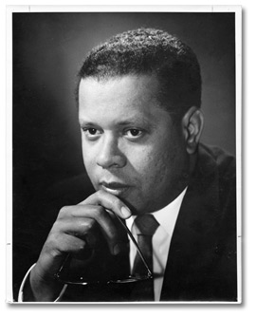 | Daniel G. Hill, [ca. 1960]  Daniel G. Hill fonds (F 2130)  Archives of Ontario, I0027960

Daniel G. Hill, human rights specialist, historian, and public servant, was prominent in the movement to overturn racial discrimination in Canada. He came to this country for graduate studies but committed himself to the quest for justice.
As an activist in the 1950s, Hill used public awareness as a tool to combat prejudice. With a PhD in sociology from the University of Toronto and a decade of experience with social causes, he became the first director of the Ontario Human Rights Commission in 1962, a position he held until 1971. Under his management, the commission evolved innovative tactics, widely copied in Canada and other countries. In 1971, he became the first full-time chairman of the Ontario Human Rights Commission and, in 1973, he established a consulting firm in human rights with an international clientele.
In 1978, Daniel Hill, Donna Hill, Wilson Brooks and other educators co-founded the Ontario Black History Society. It became the first major public organization in Canada focused on the history of people of African descent in the country. He headed the organization for six years.
As Provincial Ombudsman from 1984 to 1989, Hill strove to make that office reflect the "new Ontario," with a forceful outreach program aimed at traditionally excluded groups, particularly Canada's Aboriginal people. Following his retirement, he became a member of the Canadian Human Rights Tribunal.
Source: Historic Canada’s Black History Canada

What were Daniel G. Hill’s responsibilities as the first director of the Ontario Human Rights Commission (OHRC)?
As Director of the OHRC in 1962, Hill travelled across Ontario in his Volkswagen Beetle, setting up regional offices and striving to make the Commission and its services available to ordinary Ontarians.
He also travelled across Canada and to conferences in various countries (including Iran) to promote human rights and to build the effectiveness of the Commission.
See also: Archives of Ontario’s The Freedom Seeker: The life and times of Daniel G. Hill online exhibition.

Statement to the Legislative Assembly – Page 1
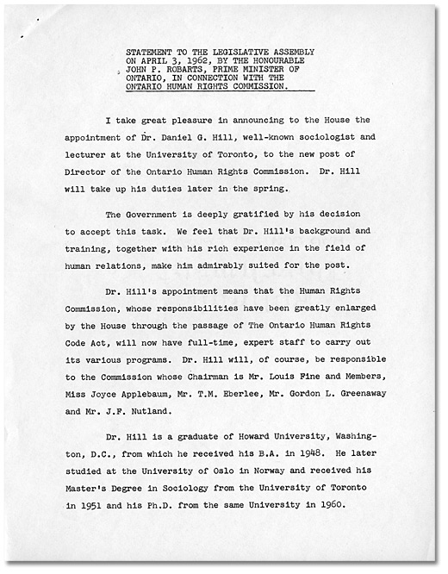
Statement to the Legislative Assembly on April 3, 1962, by the Honourable John P. Robarts,
Prime Minister of Ontario, in connection with the Ontario Human Rights Commission
John P. Robarts speeches and statements
Reference Code: RG 3-103
Archives of Ontario

Statement to the Legislative Assembly, page 2
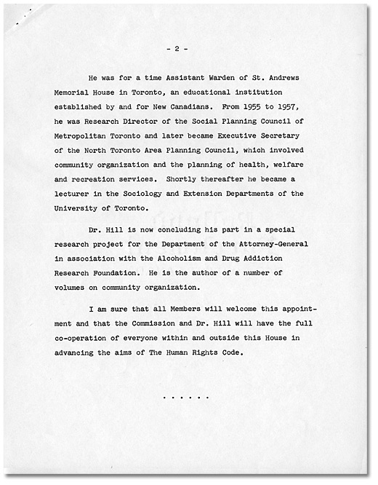
Statement to the Legislative Assembly on April 3, 1962, by the Honourable John P. Robarts,
Prime Minister of Ontario, in connection with the Ontario Human Rights Commission
John P. Robarts speeches and statements
Reference Code: RG 3-103
Archives of Ontario

