# An Interview with an Archivist

Interested in knowing about the Archives of Ontario? So was Rui the Reporter!

Read the interview below to learn more about the Archives of Ontario.

| Rui, la journaliste, qui porte une chemise bleue et elle parle dans un microphone. | Ici, l'archiviste au nom d'Annie, est assise à son bureau.  Elle porte des lunettes.  Elle est entreint d'écrire sur son ordinateur portatif. |
| --- | --- |
| **Rui the Reporter:**  Excuse me.  Are you an Archivist? Can you answer some questions for me? | **Annie the Archivist:**  Yes I am an Archivist! I work at the Archives of Ontario and I would be happy to answer some questions for you. |
| Thank you, Annie. Can you first tell us what an archive is? | **Annie the Archivist:**  An important question!  An archive is a place where historical documents are collected and preserved.  At the Archives of Ontario, we help preserve Ontario’s memory by storing and making available documents, books, photographs, maps, and other records that may be needed in the future. |
| **Rui the Reporter:**  The Archives of Ontario looks like a really cool building.  Why does the Archives need a special building? | **Annie the Archivist:**  It takes a lot of work to keep documents that are 100 or 200 years old safe.  Our building is designed to keep our collections clean and well-preserved. |

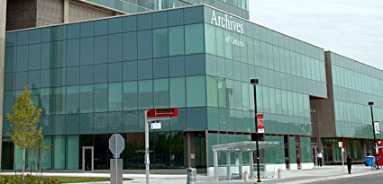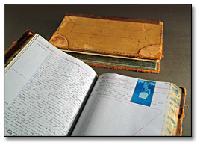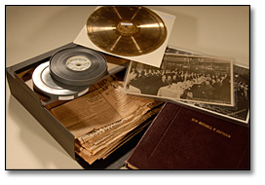 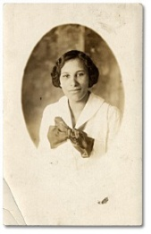

| Rui, la journaliste, qui porte une chemise bleue et elle parle dans un microphone. | MC900446380[1] |
| --- | --- |
|  | **Annie the Archivist:**  For example, we have a vault on the inside of the building that has special controls for light and temperature. We also have a lab for cleaning up messes left by bugs, moulds, or rodents. |
| **Rui the Reporter:**  That machine looks really cool!  How many historical documents are at the Archives? | **Annie the Archivist:**  The Archives of Ontario has a collection that includes over 4 MILLION photographs, 85,000 maps, and 30,000 HOURS of audio, video and film.  Most of the Archives’ collection is made up of documents from the Ontario government. Stacked up, these documents alone would be 100 kilometres high — taller than 192 CN Towers! |
| **Rui the Reporter:**  Wow! I can hardly imagine!  Thanks so much, Annie. That was really interesting! | **Annie the Archivist:**  No problem Rui!  If you have any other questions, you can email us and ask: [Reference@Ontario.ca](mailto:Reference@Ontario.ca). |

**DO YOU HAVE ANY QUESTIONS FOR ANNIE?**

