Making Treaty Lesson Kit

Grade Level: 6
Subject Area: Social Studies
Time Required: 1 class or 60-90 minutes

In this Lesson Kit:
Lesson Overview 2
Curriculum Connections & Specific Expectations 2
Responding to the Calls to Action 3
Materials/Resources 4
Lesson Plan 4
Assessment 8
Appendix I: Information about Treaty No. 9 10
Background Information – The James Bay Treaty 11
Glossary 13
Appendix II: Primary / Secondary Sources and Worksheet 14
Primary Source – Photograph 1 15
Primary Source – Photograph 2 16
Primary Source – Photograph 3 17
Primary Source – Photograph 4 18
Secondary Source: Excerpt from Online Exhibit 19
Primary Source - Supreme Court of Canada Ruling 20
Worksheet: Oral and Written - What Do I Think? 21
Worksheet: Primary Source Analysis 22

The Archives of Ontario would like to thank Lorraine Sutherland and Christina Nielsen of Omushkego Education for their guidance, input, and support throughout the development of this lesson kit, as part of their work with Mushkegowuk Council to revise The James Bay Treaty (Treaty No. 9) online exhibit in 2019-20.

Kiskinohamakewi Wichihitowin Working Together in Education
Ininiw Pimatisiwin Kiskanahamakewina Teaching with Omushkego Culture

Lesson Overview

Summary: using the James Bay Treaty (Treaty No. 9) as an example, students will learn how treaties can involve both written and oral agreements.

Key Question: how can oral and written promises be remembered?

Big Ideas:

- Different groups may experience the same development/event in different ways

- Primary sources reflect the biases, values, and prejudices of their creators; in the same way we examine the information they provide, we must carefully take note of the details they omit and obscure.

Historical Thinking Concepts

- Establish historical significance
- Use primary source evidence
- Take historical perspectives

Curriculum Connections & Specific Expectations

Social Studies:

- Grade 6, Strand A - after this lesson, students will:

- A2.1 formulate questions to guide investigations into different perspectives on the historical and/or contemporary experiences of a few distinct communities in Ontario, including First Nations, Métis, and/or Inuit communities

- A2.2 gather and organize information from a variety of primary and secondary sources that present different perspectives on the historical and/or contemporary experience of a few communities in Ontario, including First Nations, Métis, and/or Inuit communities

- A2.4 interpret and analyse information and evidence relevant to their investigations, using a variety of tools

- A2.5 evaluate evidence and draw conclusions about perspectives on the historical and/or contemporary experience of a few distinct communities in Ontario, including First Nations, Métis, and/or Inuit communities

- A3.10 identify and describe fundamental elements of Canadian identities

Responding to the Calls to Action

This lesson kit has been developed to support responses to the following Calls to Action made by the Truth and Reconciliation Commission of Canada:

- We call upon the Government of Canada, on behalf of all Canadians, to jointly develop with Aboriginal peoples a Royal Proclamation of Reconciliation to be issued by the Crown. The proclamation would build on the Royal Proclamation of 1763 and the Treaty of Niagara of 1764, and reaffirm the nation-to-nation relationship between Aboriginal peoples and the Crown. The proclamation would include, but not be limited to, the following commitments:

iii. Renew or establish Treaty relationships based on principles of mutual recognition, mutual respect, and shared responsibility for maintaining those relationships into the future.

- We call upon the Council of Ministers of Education, Canada to maintain an annual commitment to Aboriginal education issues, including:

i. Developing and implementing Kindergarten to Grade Twelve curriculum and learning resources on Aboriginal peoples in Canadian history, and the history and legacy of residential schools.

Materials/Resources

Note: This lesson kit is designed for use online or in-person, with the following optional resources:

- Computer(s), tablet(s), or smart device(s) with internet access (optional)
- Paper for printing activity sheets
- Blackboard, whiteboard, or chart paper with writing tools

Lesson Plan

Detailed Summary: students will learn about the role of written and oral agreements in the creation of Treaty No. 9 in 1905 in Northern Ontario by assessing their own knowledge about treaties, analyzing primary sources, and creating a blended agreement about behaviour in their own classroom/virtual class space.

Background/Preparation

- Students should be familiar with the concept of treaties.
- Students should be familiar with the location of James Bay in Northern Ontario.
- Review the “Glossary” page found in Appendix II of this lesson kit with students, to ensure they know and understand the language they will encounter while examining the primary sources used in this lesson.
- Teacher preparation: begin by reading “Background Information” in Appendix I of this lesson kit.

Activation (5-10 min.)

- Hold a group discussion using the following question:

What kinds of promises do you make?

- Have students discuss as a class—help them think about examples of oral agreements and promises they, their families, or individuals can make during their lifetime (ie: an promise between friends, an oath of office, marriage vows in some faith-based wedding ceremonies, etc.). Ask students:

How do you mark, honour, or celebrate those promises?

- Introduce students to the signing of the James Bay Treaty (Treaty No. 9) by showing them “Primary Source – Photograph 2” from Appendix II of this lesson kit. Ask students to identify what they think is happening in the picture, and provide them with the following context:
Feasting is (and has been for generations) an important aspect to agreements among the Ojibwe and Cree peoples, and:

- can be a conclusion to and celebration of the agreement,
- allows all parties to take part in the generous act of sharing,
- provides an opportunity for the negotiators to speak to the larger group assembled.

Use this knowledge as an opportunity to emphasize to students that agreements can take many forms and include many ways of understanding.

Minds-On Activity (20-25 min.)

Instructions:

- Ask students to watch Historica Canada’s Naskumituwin (Treaty) Heritage Minute. Discuss as a class:

What are the differences between an oral agreement and a written agreement?

Have students complete responses to the first column of questions on the “Worksheet: Oral and Written - What Do I Think?” handout found in Appendix II of this lesson kit.

- Working in small groups, ask students to examine one of the four archival photographs included Appendix II of this lesson kit.

  - Ask each student to make observations about what they see in the photograph, using the “Primary Source Analysis” worksheet found in Appendix II of this lesson kit.

    - Students should be encouraged to answer as many of the questions on the worksheet as they can—answering some questions will require inference, while responding to others will depend on students’ prior knowledge. The goal of the exercise is not total completion or accuracy, but rather to get students thinking about using their senses while analyzing primary sources.

    - Accommodate students’ needs by offering them options for reporting their findings using other means than the worksheet—including (but not limited to) discussion, a group chat, a word cloud, a poster, or any another method that meets their abilities.

    - Optional extension activity: ask students to draw a picture of their experience at the location of the photograph on the day it was made, including as much detail as possible. Have students then share, post, or present their illustrations for their classmates to view and discuss.

- After students have completed the worksheet, help them expand on their observations with the following prompts and questions:

      - What kinds of information would have been present at the time the photograph was made, but not recorded by the camera? Ask students to think back to the worksheet they’ve just completed using their five senses (i.e.: smells, textures, sounds, etc.), and ask the following additional prompt questions:

        - Did the photographs seem natural, or staged?

        - Who do the students think would have taken the photographs, and does this change what they think about the photos?

        - How does a photographer’s bias shape the images they make? Do the students see evidence of that bias in these photographs?

Making Treaty activity (25-30 min.)

- Working as a class, or in small groups, ask students to create a list of ten rules for expected behaviour in the classroom/virtual class space and select a spokesperson.

  - Write the rules for the entire group to see—however, do not write down the last five rules (alternatively, you can randomly omit several of the rules submitted).

  - Take a poll of the class: who would feel comfortable signing this agreement?

  - When students point out that you omitted certain rules from the written list, ask: do rules need to be written down to be followed, if they are also spoken?

- Bring students’ attention back to thinking about Treaty No. 9, and the different approaches to agreements between the commissioners and Indigenous signatories. As a class, in small groups, or independently, read excerpts from the James Bay Treaty online exhibit found in Appendix II of this lesson kit.

        - Turn students’ attention to the following text in the exhibit: “they maintain that the words spoken by commissioners during the ceremonies are part of the treaty made on behalf of the King.” (emphasis added)

        - Ask students: why would the words spoken be different than what was written?

      - Have students then read this summary of the Supreme Court of Canada’s judgment in R v Marshall (2019) that oral agreements are part of treaties (also found in Appendix II of this lesson kit).

      - Discuss as a class: why did the commissioners of the James Bay Treaty and the Indigenous leaders not have the same way of making an agreement?

        - Inform students about Indigenous oral traditions and storytelling as fundamental aspects of sharing history and traditional knowledge—you can refer to Our Voices, an Omushkego oral history project documenting hundreds of traditional stories, legends, and histories as audio files, or use On Path of the Elders, a virtual game helping young learners explore Treaty No. 9 as understood by Cree Elders.

        - Remind students of the deficit of understanding during the treaty signings—that Indigenous leaders who took part in the Treaty No. 9 signing ceremonies did not speak, read, or write English, and Commissioners could neither speak Anishinaabemowin, Ininiimowin/Ililiimowin/Mushkegowiimowin, and Anishininiimowin, nor read syllabics. The treaty was written in English only, and, during the signing events, translation of the written text between English and Cree was flawed at best.

Summative (10-15 min.)

- Have students complete responses to the second column of questions on the “Worksheet: Oral and Written - What Do I Think? Worksheet” found in Appendix II of this lesson kit.

- As a class, discuss the following reflection question:

How can cultures with oral and written traditions make and uphold treaties together?

Assessment
Categories | Level 1 | Level 2 | Level 3 | Level 4
Knowledge and Understanding: subject-specific content acquired in each course (knowledge), and the comprehension of its meaning and significance (understanding)
 | The student:
Knowledge of content  (i.e.: facts, terms, definitions) | -demonstrates limited knowledge of content | -demonstrates some knowledge of content | -demonstrates considerable knowledge of content | -demonstrates thorough knowledge of content
Understanding of content  (i.e.: concepts, ideas, theories, interrelationships, processes, methodologies, spatial technologies) | -demonstrates limited understanding of content | -demonstrates some understanding of content | -demonstrates considerable understanding of content | -demonstrates thorough understanding of content
Thinking: the use of critical and creative thinking skills and/or processes
 | The student:
Use of planning skills  (i.e.: organizing an inquiry; formulating questions; gathering evidence and information; setting goals, focusing research) | -uses planning skills with limited effectiveness | -uses planning skills with some effectiveness | -uses planning skills with considerable effectiveness | -uses planning skills with a high degree of effectiveness
Use of processing skills  (i.e.: interpreting, analyzing, synthesizing, and evaluating data, evidence, and information; analyzing maps; detecting point of view and bias; formulating conclusions) | -uses processing skills with limited effectiveness | -uses processing skills with some effectiveness | -uses processing skills with considerable effectiveness | -uses processing skills with a high degree of effectiveness
Use of critical/creative thinking processes and strategies  (i.e.: applying concepts of disciplinary thinking; using inquiry, problem-solving, and decision-making processes) | -uses critical/creative thinking processes with limited effectiveness | -uses critical/creative thinking processes with some effectiveness | -uses critical/creative thinking processes with considerable effectiveness | -uses critical/creative thinking processes with a high degree of effectiveness
Communication: the conveying of meaning through various forms
 | The student:
Expression and organization of ideas and information (i.e.: clear expression, logical organization) in oral, visual, and written forms | -expresses and organizes ideas and information with limited effectiveness | -expresses and organizes ideas and information with some effectiveness | -expresses and organizes ideas and information with considerable effectiveness | -expresses and organizes ideas and information with a high degree of effectiveness
Communication for different audiences and purposes (i.e.: to inform, to persuade) in oral, visual, and written forms | -communicates for different audiences and purposes with limited effectiveness | -communicates for different audiences and purposes with some effectiveness | -communicates for different audiences and purposes with considerable effectiveness | -communicates for different audiences and purposes with a high degree of effectiveness
Use of conventions (i.e.: mapping and graphing conventions, communication conventions), vocabulary, and terminology of the discipline oral, visual, and written forms | -uses conventions, vocabulary, and terminology of the discipline with limited effectiveness | -uses conventions, vocabulary, and terminology of the discipline with some effectiveness | -uses conventions, vocabulary, and terminology of the discipline with considerable effectiveness | -uses conventions, vocabulary, and terminology of the discipline with a high degree of effectiveness
Application: the use of knowledge and skills to make connections within and between various contexts
 | The student:
Application of knowledge and skills  (i.e.: concepts, procedures, spatial skills, processes, technologies) in familiar contexts | -applies knowledge and skills in familiar contexts with limited effectiveness | -applies knowledge and skills in familiar contexts with some effectiveness | -applies knowledge and skills in familiar contexts with considerable effectiveness | -applies knowledge and skills in familiar contexts with a high degree of effectiveness
Transfer of knowledge and skills  (i.e.: concepts of thinking, procedures, spatial skills, methodologies, technologies) to new contexts | -transfers knowledge and skills to new contexts with limited effectiveness | -transfers knowledge and skills to new contexts with some effectiveness | -transfers knowledge and skills to new contexts with considerable effectiveness | -transfers knowledge and skills to new contexts with a high degree of effectiveness
Making connections within and between various contexts (i.e.: between topics/issues being studied and everyday life; between disciplines; between past, present, and future contexts; in different spatial, cultural, or environmental contexts; in proposing and/or taking action to address related issues; in making predictions) | -makes connections within and between various contexts with limited effectiveness | -makes connections within and between various contexts with some effectiveness | -makes connections within and between various contexts with considerable effectiveness | -makes connections within and between various contexts with a high degree of effectiveness

Appendix I: Information about Treaty No. 9

Background Information – The James Bay Treaty

Source: The James Bay Treaty Online Exhibit

The James Bay Treaty (Treaty No. 9) is an agreement between Ojibway (Anishinaabe), Cree (including the Omushkegowuk) and other Indigenous communities (Algonquin), and the Crown (represented by two commissioners appointed by Canada and one commissioner appointed by Ontario). The treaty, first entered into in 1905-1906, covers the James Bay and Hudson Bay watersheds in Ontario, about two thirds of the province’s total landmass. The treaty embodies the nation-to-nation relationship between First Nations and the Crown.

Why was the James Bay Treaty (No. 9) created?

In 1870, Canada acquired Rupert’s Land, a territory that had previously been claimed by the Hudson’s Bay Company (HBC) since the late 1600s, along with the North-Western Territory. The government sought to extinguish title to large swaths of Indigenous land in order to enable settlement and resource development in Western and Northern Canada. From 1871 to 1921, eleven “numbered treaties” were created.

In 1902, Ontario incorporated the Temiskaming and Northern Ontario Railway, which added further pressures of mining, forestry, and hydroelectricity development and commercial activities in the Moose River basin.

Railroads had led to non-Indigenous poachers, prospectors and threatened hunting resources, along with growing hunger and sickness. Indigenous communities were concerned that they would lose their traditional way of life, as encroachment led to the loss of livelihood from traditional harvesting, a lack of food resources, and disease.

The Omushkegowuk and the Anishinaabe living north of the height of land believed a treaty might ensure protection and economic security in the wake of impending Euro-Canadian settlement and development, and so they began to petition the Government of Canada. Some of these communities, like that of Sahquakegick (also known as Louis Espagnol), had relatives who had been signatories to the Robinson Treaties of 1850, which guaranteed hunting and fishing rights to Indigenous communities to lands north of Lakes Superior and Huron, along with reserves and annual payments.

Although not all Indigenous leaders wanted a treaty, the impact of diseases like measles, tuberculosis, and smallpox, and starvation caused by declining traditional food resources, forced others to see a treaty as a way to protect their peoples. The James Bay Treaty, the ninth of the numbered treaties, was made during this era.

Leaders petitioned the Crown for a treaty to receive the same assistance and protection that signatories of the Robinson Treaties had received. Indian Agents, HBC Factors, and church missionaries also sent petitions.

By April 1904, the discovery of minerals in Northwestern Ontario added urgency to Canada’s desire to extinguish Indigenous title and develop the territory’s mining potential. Further expansion of the rail network, timber development, and hydro-electric production were also on the horizon.

How was the James Bay Treaty negotiated?

After nearly a year of delay from Ontario, in May 1905 both governments began negotiating the terms of the treaty’s written document. Ontario had a series of demands, including that one of the three commissioners would represent the province and that no Indigenous reserves in the treaty territory would be located in areas with hydro-electricity development potential greater than 500 horsepower.

Canada and Ontario agreed to the terms by early July. Although ratification of the treaty required the agreement of Indigenous peoples living in the territory, neither were the Omushkegowuk and the Anishinaabe involved in creating the terms of the written document, nor were the terms permitted to change during the treaty expedition.

Over two summers in 1905-1906, a treaty delegation journeyed throughout the James Bay watershed to meet with Indigenous communities. Three commissioners represented the Crown: civil servants Duncan Campbell Scott and Samuel Stewart for the federal government, and miner Daniel G. MacMartin for Ontario. The commission team also included two police constables and a doctor; professor Pelham Edgar and artist Edmund Morris joined the 1906 expedition.

How was the James Bay Treaty understood by those who signed?

There are many ways of knowing the meaning of the James Bay Treaty, both then and now. The treaty commissioners could neither speak Anishinaabemowin, Ininiimowin (also known as Ililiimowin or Mushkegowiimowin), or Anishininiimowin, nor read syllabics. Many Indigenous signatories didn’t speak, read, or write in English, so interpreters were required at various stops and chosen by the commissioners. The main principles and beliefs (worldviews), language, culture, history and ways of knowing land ownership of both the Indigenous signatories and the commissioners were not the same.

Glossary

Cession: to give up or surrender control and ownership of a parcel of land.

Commissioner: person chosen to represent a community, organization, government, or group, often when making a decision or agreement with others.

Crown: in Canada’s constitutional monarchy, the “Crown” means the head of state – the monarch (since 1953, Queen Elizabeth II) – and their representatives. In a Canadian legal context, “the Crown” refers to the provincial and/or federal governments.

Indian: “Indian” is a term that is now considered outdated and offensive, but has been used historically to identify Indigenous peoples in South, Central and North America. In Canada, “Indian” also has legal significance. It is used to refer to legally defined identities set out in the Indian Act (1876), such as Indian Status, and appears in historical legal documents, like the James Bay Treaty (Treaty No. 9).

Note: when looking at archival records, you may encounter the word “Indian” used in original record titles or within records themselves. This term remains visible because archives do not change the words used in records in their care, so that researchers have an accurate sense of attitudes and language used in the past.

Interpreter: a person who translates speech from one language into another.

Nation: a particular group that has its own territory, culture, and government and is independent from other nations or countries. Indigenous communities are sovereign nations that continue to seek affirmation of their nation-to-nation relationship, in which their sovereignty and their rights to control their own people, lands, and resources are recognized and respected.

Signatory: an individual, group, organization, government, or party which signs an agreement (such as a treaty).

Treaty: an agreement made by two or more parties (i.e.: nations and international organizations), often to clarify how all parties will share and jointly manage resources based on a set of established principles and practices.

Appendix II: Primary / Secondary Sources

and Worksheet

Primary Source – Photograph 1

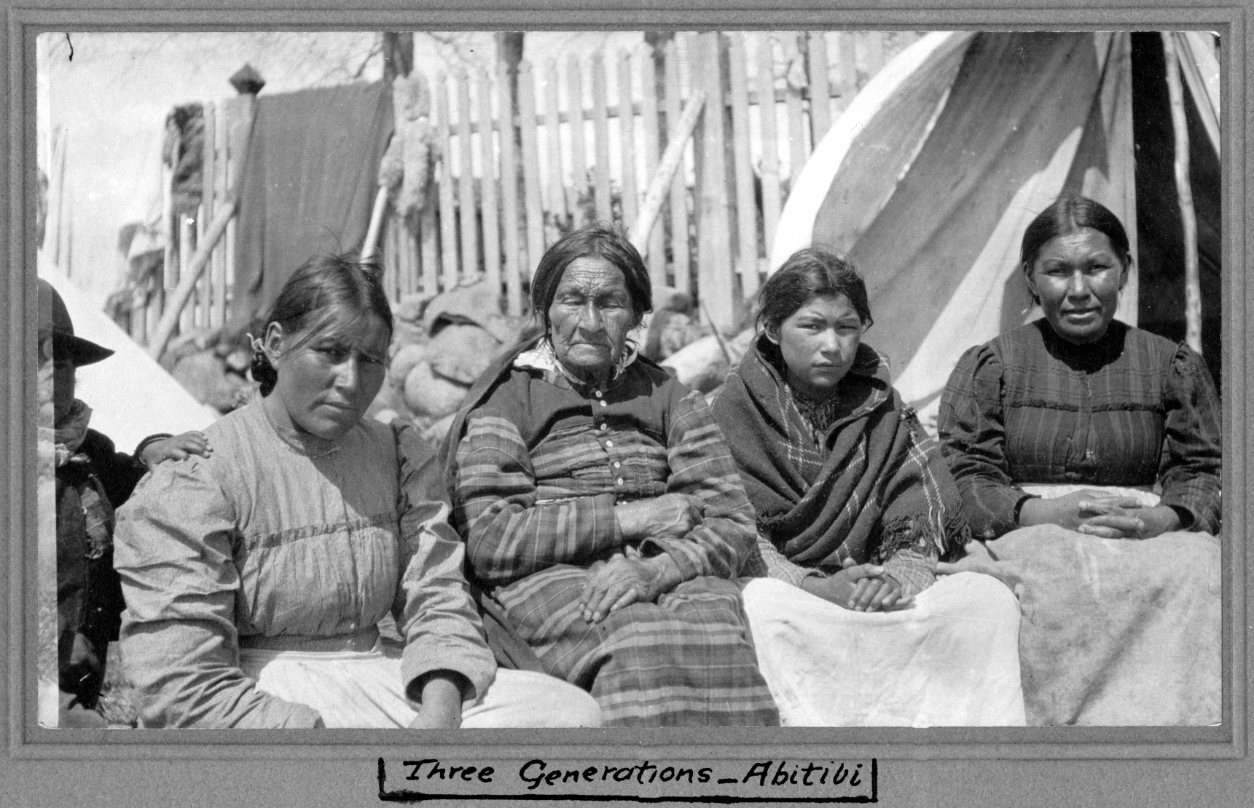

Three Generations – Abitibi, [ca. 1905]
Photographer unknown, Duncan Campbell Scott fonds
Archives of Ontario, I0010692

Primary Source – Photograph 2

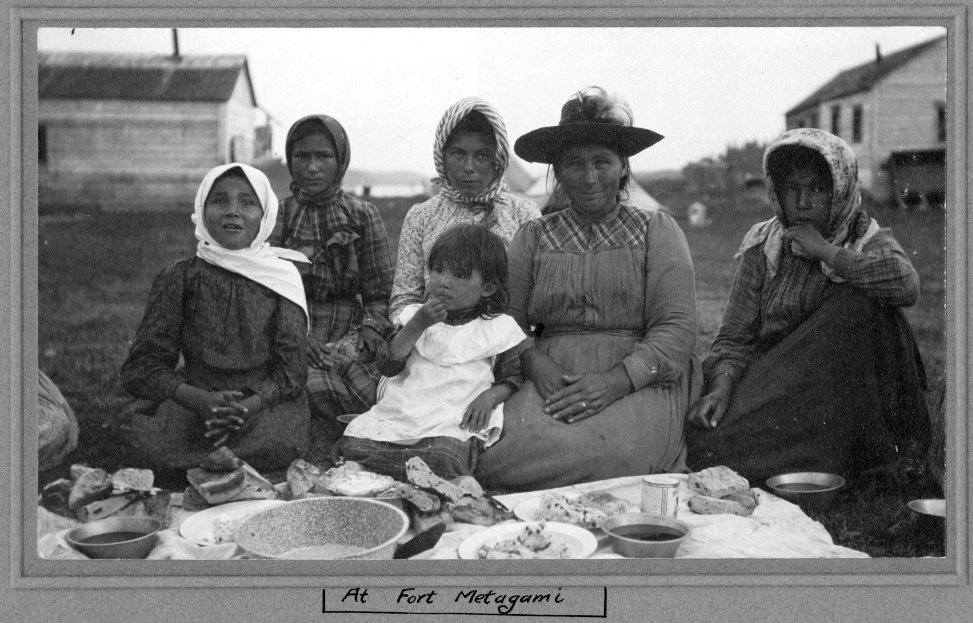

At Fort Metagami, [ca. 1905]
Photographer unknown, Duncan Campbell Scott fonds
Archives of Ontario, I0010709

Primary Source – Photograph 3

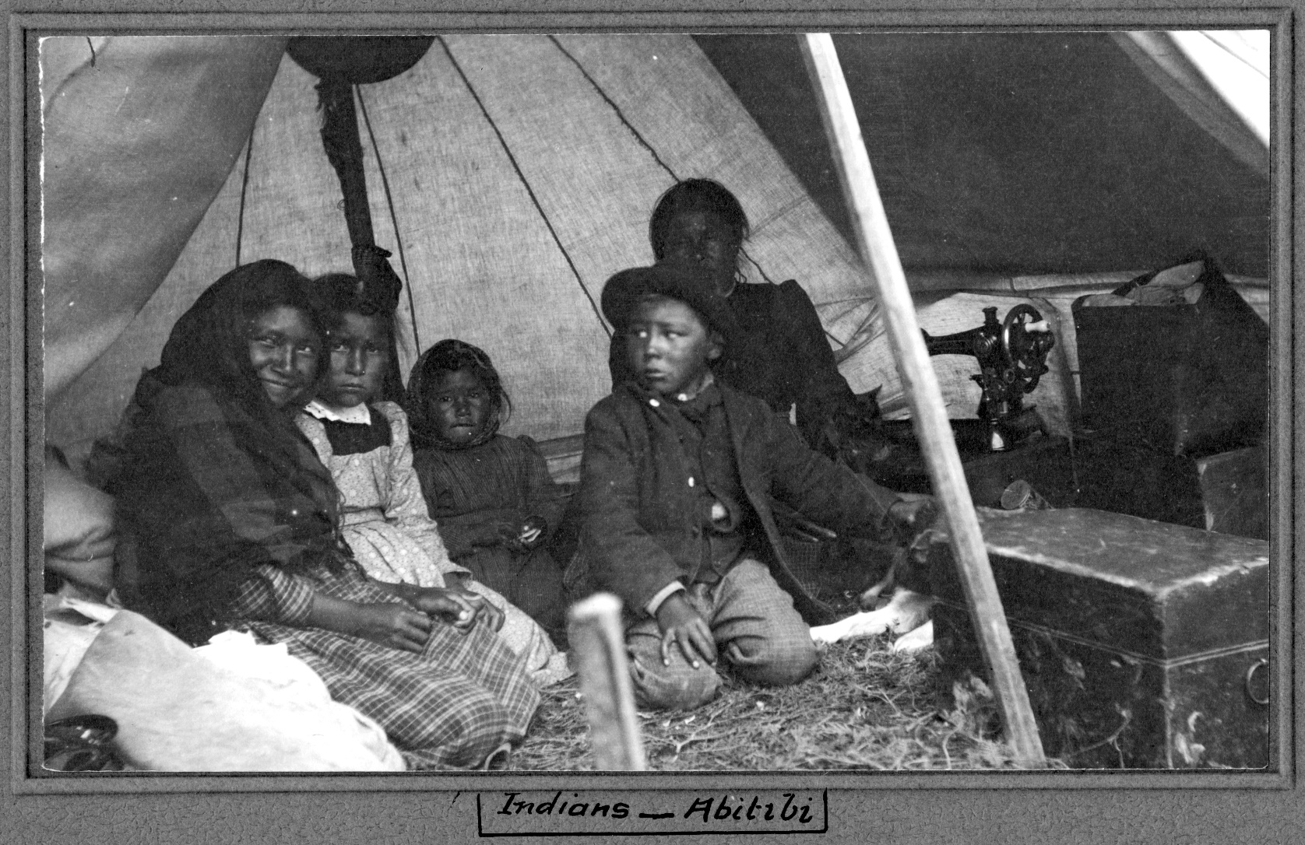

[Indigenous children and woman] - Abitibi, [ca. 1905]
Photographer unknown, Duncan Campbell Scott fonds
Archives of Ontario, I0010691

Primary Source – Photograph 4

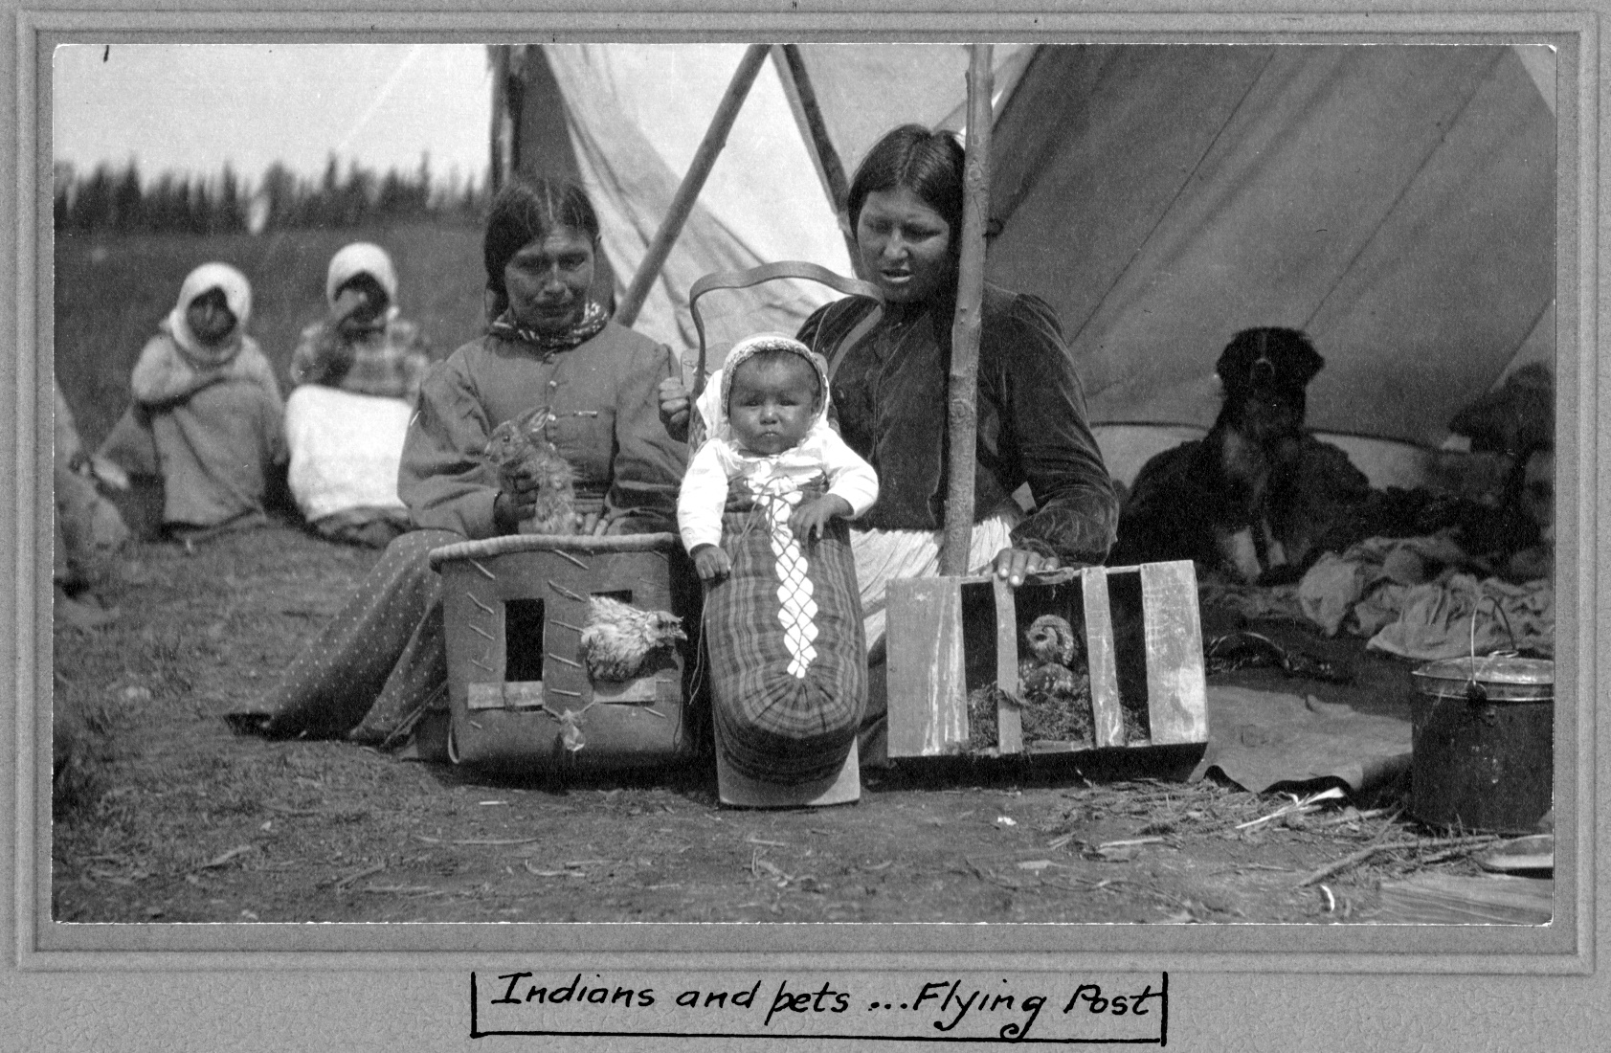

[Women, infant, and pets - Flying Post], [ca. 1905]
Photographer unknown, Duncan Campbell Scott fonds
Archives of Ontario, I0010719

Secondary Source: Excerpt from The James Bay Treaty (Treaty No. 9) Online Exhibit

Ways of Knowing

There are many ways of knowing the meaning of the James Bay Treaty, both then and now. The treaty commissioners could neither speak Anishinaabemowin, Ininiimowin (also known as Ililiimowin or Mushkegowiimowin), or Anishininiimowin, nor read syllabics. Many Indigenous signatories didn’t speak, read, or write in English, so interpreters were required at various stops and chosen by the commissioners. The main principles and beliefs (worldviews), language, culture, history and ways of knowing land ownership of both the Indigenous signatories and the commissioners were not the same.

For Canada and Ontario, the treaty was a major land cession, a contract with details outlined in the written document.

To Indigenous communities, the treaty was an agreement to share the land as long as the sun shines, the grass grows, the rivers flow, and the winds blow. They maintain that the words spoken by commissioners during the ceremonies are part of the treaty made on behalf of the King, including the Crown’s promise that people could hunt and fish as their ancestors had.

Self-Government

The concept of a treaty as a nation-to-nation agreement implies that all parties are equal partners. The signatories from Ojibway (Anishinaabe), Cree (including the Omushkegowuk) and other Indigenous Nations (Algonquin) expected to maintain their sovereignty and continue to self-govern after agreeing to Treaty No. 9.

Education

John Dick, an Indigenous representative present at treaty negotiations at Moose Factory in 1905, noted his people hoped a treaty would lead to the establishment of schools in which Indigenous children would receive an education. The treaty document outlines that the government would provide education facilities, equipment, and funds to pay teachers “as may seem advisable to His Majesty’s government of Canada.”

Provision of Care

The articles of Treaty No. 9 specifically state that Indigenous communities should “count upon and receive from His Majesty's bounty and benevolence.” Based on information gathered from their relations who had made treaty in other areas with the federal government, Ojibway (Anishinaabe), Cree (including the Omushkegowuk) and other Indigenous (Algonquin) signatories expected that “bounty and benevolence” to take the form of regular visits by doctors and annuity payments, which would help to offset the impacts of starvation faced by their peoples as settlers continued to spread into their traditional homelands.

Primary Source - Supreme Court of Canada Ruling

“R v Marshall
on August 28, 2019

Oral agreements are an integral part of treaties.

In Marshall, the Supreme Court of Canada considered whether Mi’kmaq treaties from 1760 extinguished an Aboriginal right to fish for sustenance. Marshall was charged with three fishing regulation violations for fishing without a license and with an illegal net in the close season. The court ruled that the Mi’kmaq treaties did not extinguish the right to fish, and that it was unconscionable that the Crown would rely only on the written treaty, when records of oral negotiations show a different set of agreed terms. The court ruled that modern fishing, hunting, and gathering rights do not need to exactly match historical activities, so long as the modern activity is a logical evolution of the traditional act. In addition, the court affirmed that where there are ambiguities in treaties, they must be interpreted to the benefit of the First Nation. Marshall is a critically important case that affirms that oral agreements are an integral part of treaties and that ensures modern treaty interpretation to accurately reflects the common intentions of both parties.” (emphasis added)

Source: Assembly of First Nations

Worksheet: Oral and Written - What Do I Think?

Question | Answer at Start of Lesson | Answer at End of Lesson
Do you have to write down a promise in order to keep it?

Why or why not?

Why do some communities speak their agreements, and some write them down?

If a spoken promise is written down, does it stay the same?

Why or why not?

How would you create an agreement that lasts a long time, and can be shared with the largest number of people?

Worksheet: Primary Source Analysis

Take a look at the photograph provided, and fill in your answers to as many of the questions below as you can in the spaces provided:

Question | Answer
Imagine you were there when this photo was taken – what would you hear?

What would you be able to see around you?

What kinds of food would you eat?

What do you imagine you would smell?

What kinds of textures would you be able to touch?

What kind of clothing would you wear?

How would you have travelled to that place?

What do you think you would do for fun?

Who would you have travelled with?

Long, John. Treaty No. 9: Making the Agreement to Share the Land in Far Northern Ontario in 1905. Montreal: McGill-Queen's Press, 2010, p. 349.
Mccue, Harvey A.. "Indian Status." The Canadian Encyclopedia, 15 October 2018, Historica Canada. https://www.thecanadianencyclopedia.ca/en/article/indian. Accessed 7 May 2020.

